TYPE vs ISINSTANCE
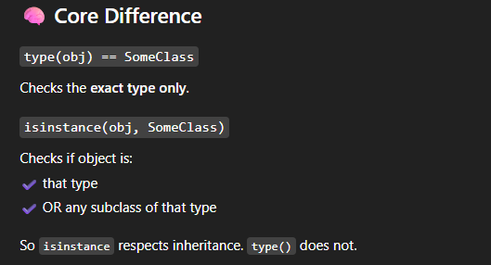
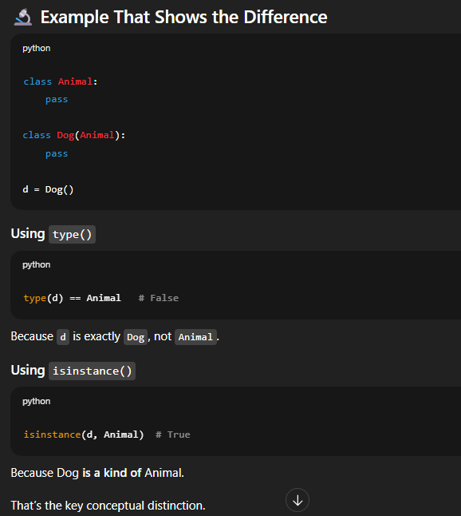
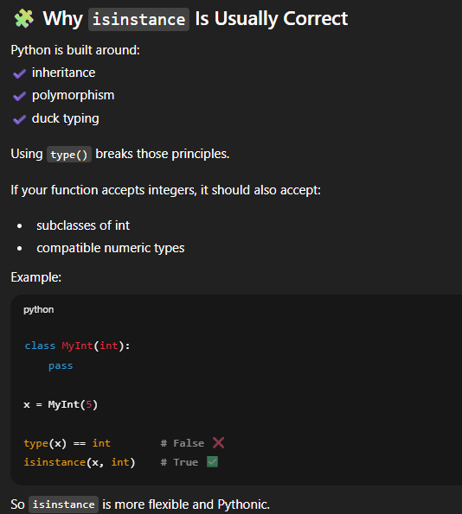
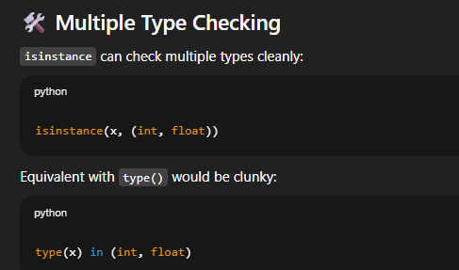
PYDANTIC MODEL
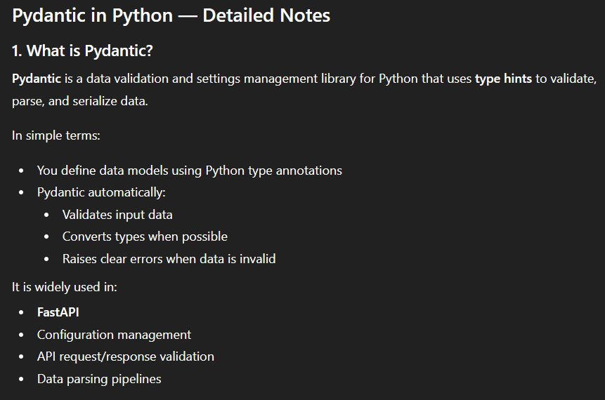
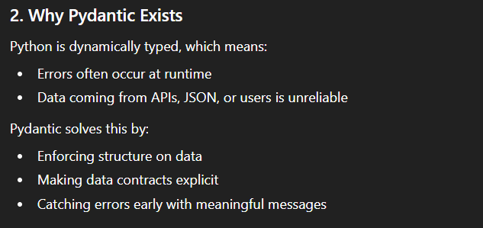
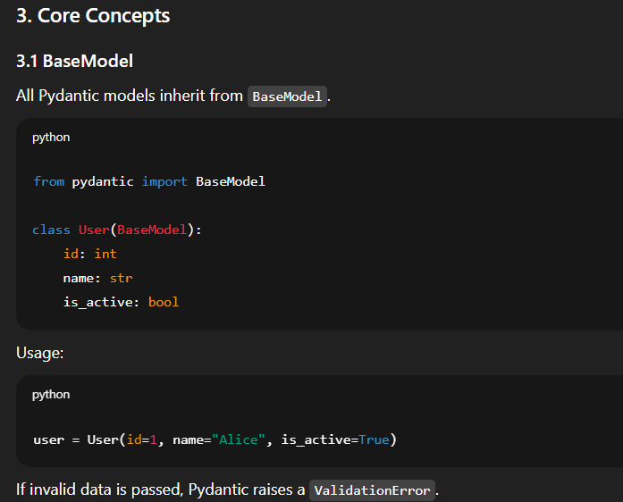
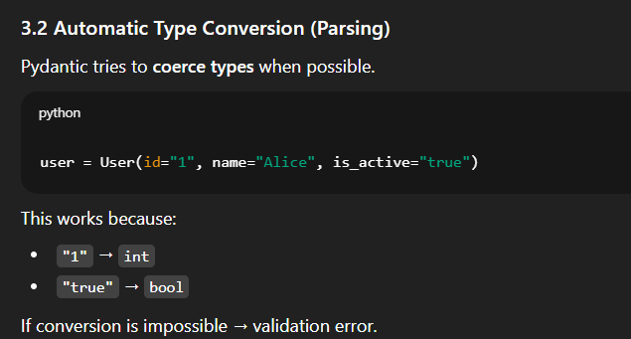
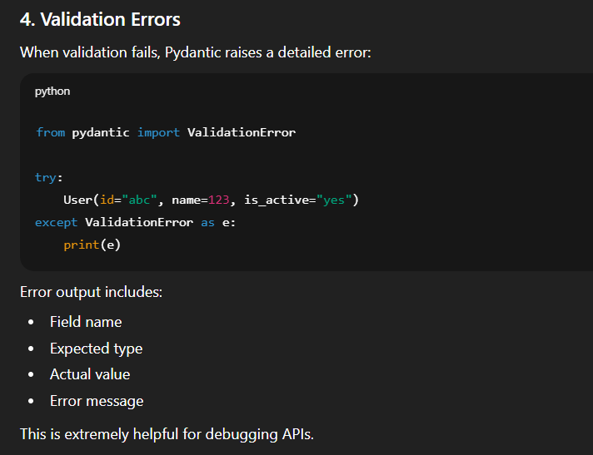
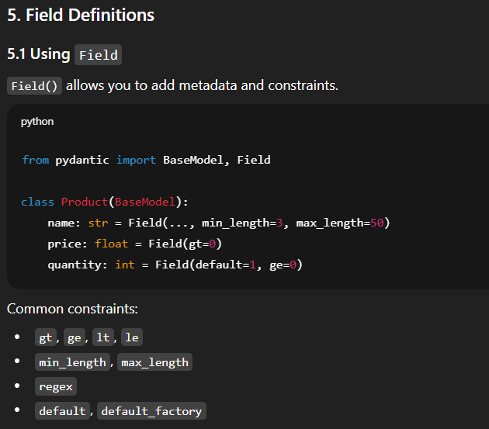
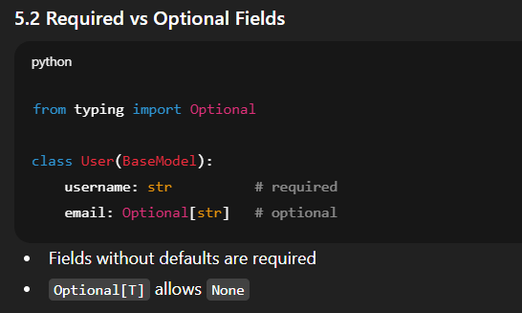
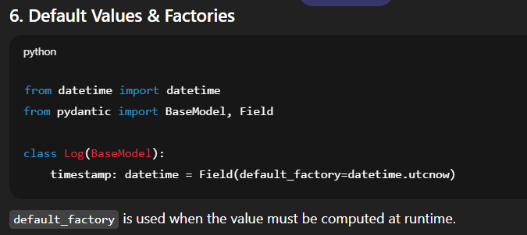
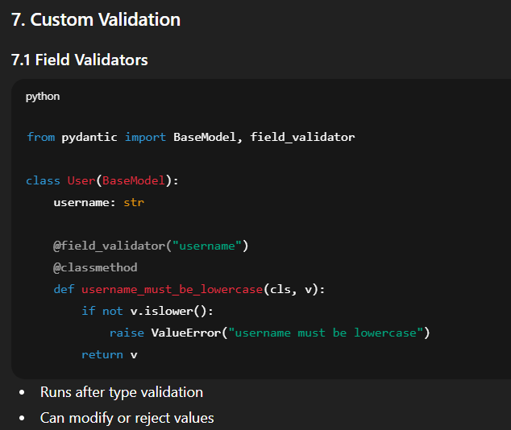
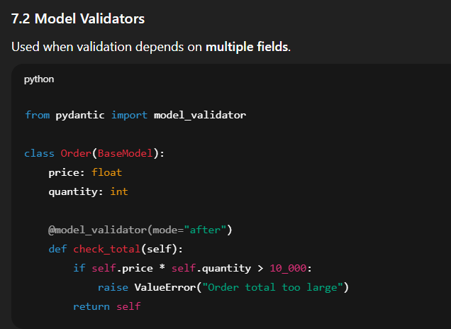
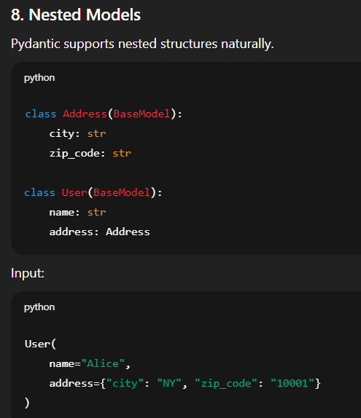
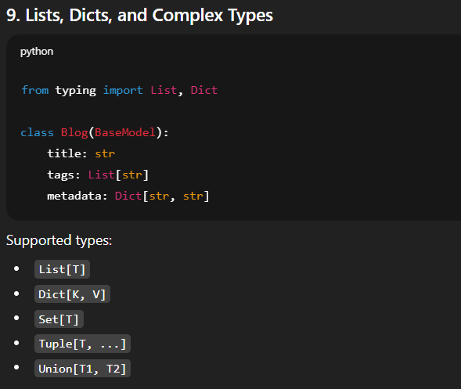
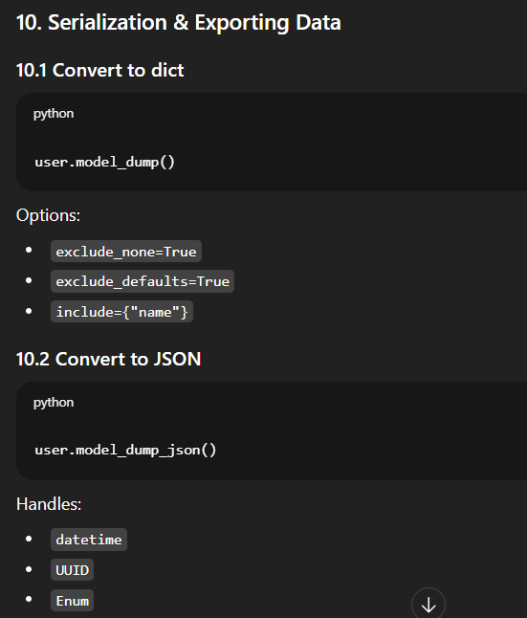
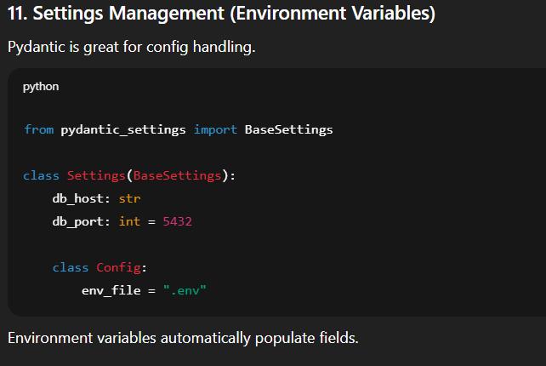
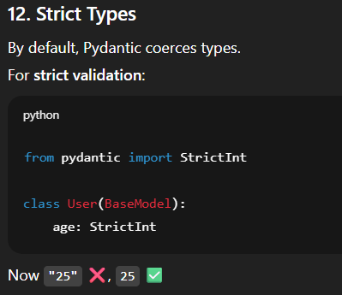

DATASTRUCTURES IN PYTHON
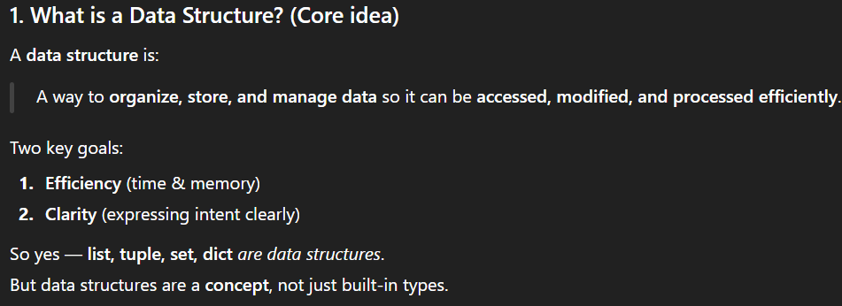
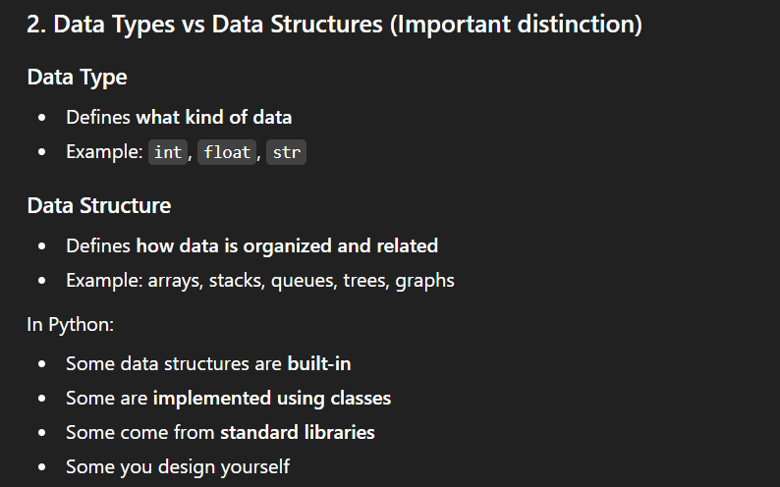
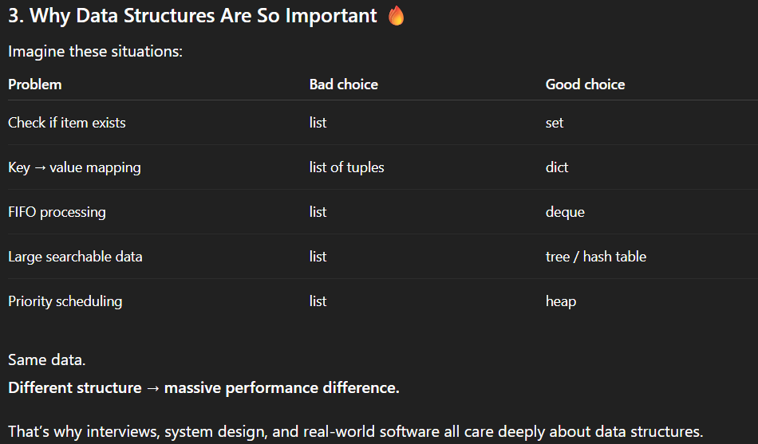

PACKAGE, LIBRARY AND FRAMEWORK IN PYTHON
A package is a way to organize Python modules using directories.
- It’s a structural concept
- Used for namespacing and organization
- A package doesn’t imply functionality or purpose
A package can be a small utility, a library, a framework or even empty scaffolding.
A library is a collection of modules and packages that provide reusable functionality.
- it provides some functionality but application can control the flow
- We import and use specific function/classes
A Framework is a complete structure the controls the flow of your program.
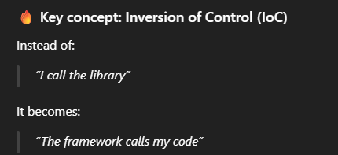
Characteristics of frameworks are
- Opinionated structure
- Lifecycle management
- You plug your code into predefined places.
- Framework handles whole application, not just utilities.
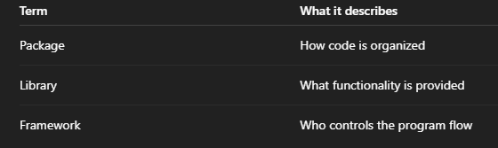
PYTHON LISTS
A list in Python is a mutable, ordered collection of items.
Lists are the most general sequence type and can contain any Python object, including other lists.
They are defined using square brackets [] or with the built-in constructor list () and support a wide range of operations.
Lists are
- Ordered - Lists preserve the order in which items are added; first item added is at index 0 and so on.
- Mutable - You can modify a list after you create it — change items, append, delete, etc.
- Heterogeneous - A list can store items of different types in one container — e.g., integers, strings, other lists.
- Dynamic – can be increased/decreased to any size
SORT() vs SORTED()
Sort() changes the original list and sorted() creates a new list
Use sort()
- You don’t need the original order
- You want better performance
- You’re okay modifying the list
Don’t use sort()
- When you need the original list unchanged
- When chaining operations
- When working with immutable sequences (like tuples)
Use sorted()
- You need the original list unchanged.
- You want to chain operations.
So, we use sort() in case of dataset with millions of records since the original dataset is changed using sort. We are not creating a new object so that saves a lot of memory.
+= vs +
+= changes in original object and in the assignment copy.
+ changes only in original object but not assignment.
Membership vs index confusion while testing
Membership is safe while writing a condition
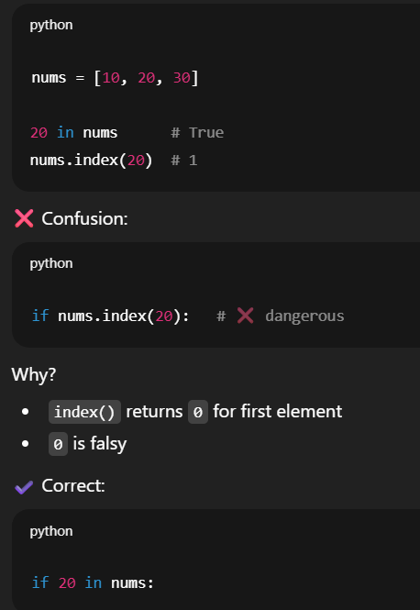
DEFAULT LIST TRAP
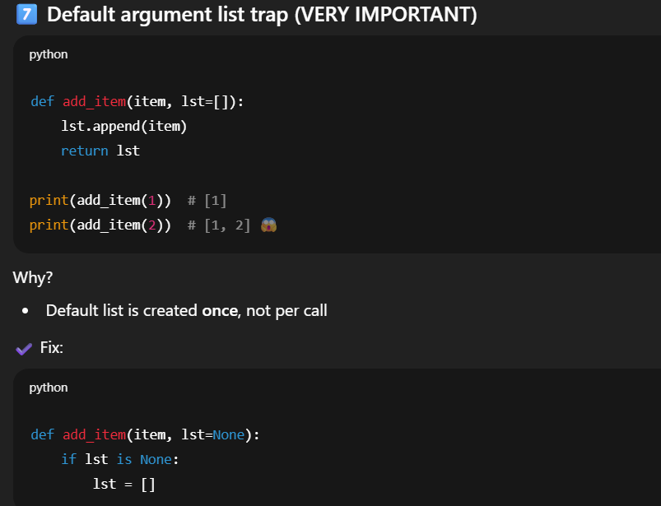
TIME COMPLEXITY IN LIST OPERATIONS
- Access Operations
Index and assignment – O(1) since list store elements in contiguous memory
- Traversal
Looping and printing – O(n)
- Insertion
Append at end – O (1)
Insert at beginning – O(n)
Insert at index – O(n)
- Deletion operations
Pop last - O(1)
Pop at index - O(n)
Remove by value - O(n)
Delete slice - O(n)
Why O(n)?
- Elements must be shifted to fill the gap
- Search Operations
Membership test - O(n)
Index lookup - O(n)
Count - O(n)
- Sorting & Reversing
Sort – O (n log n)
Sorted copy – O (n log n
Reverse – O(n)
Slice & reverse – O(n)
- Copying list
Shallow copy – O(n)
Slice copy – O(n)
Constructor – O(n)
- Concatenation & Repetition
Concatenation – O(n+m)
Extend – O(m)
Repetition – O(nk)
- Min/max/sum – O(n)
PYTHON SETS
“A Python set is an unordered, mutable collection of unique, hashable elements, optimized for fast membership testing and mathematical set operations.” A set can only store hashable (immutable) objects.
“Python sets are hash-table–based collections optimized for uniqueness and fast membership testing, with O(1) average-time operations.”
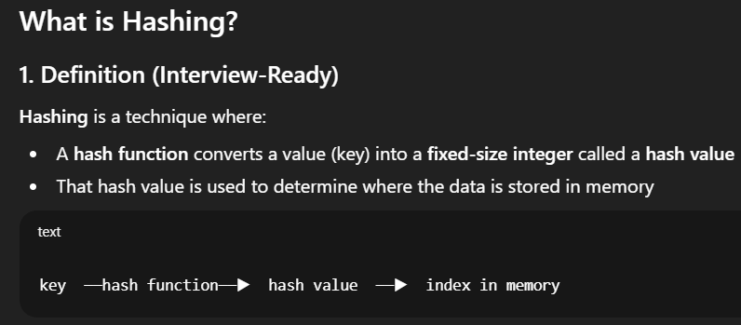
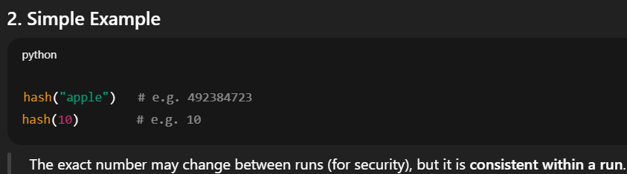
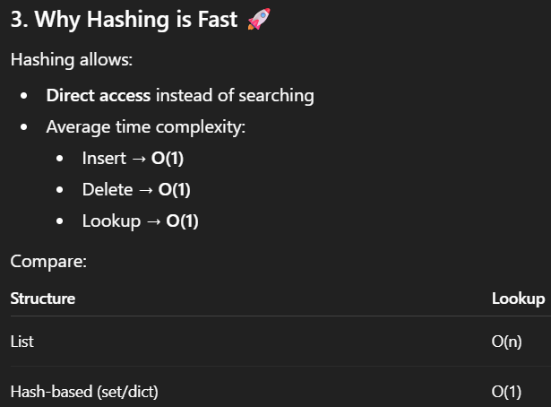
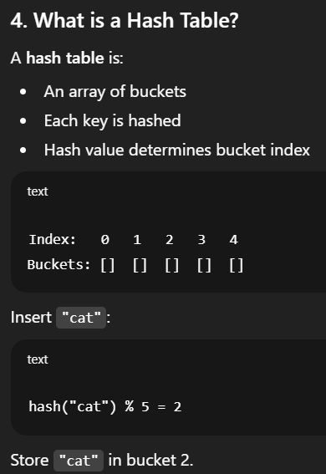
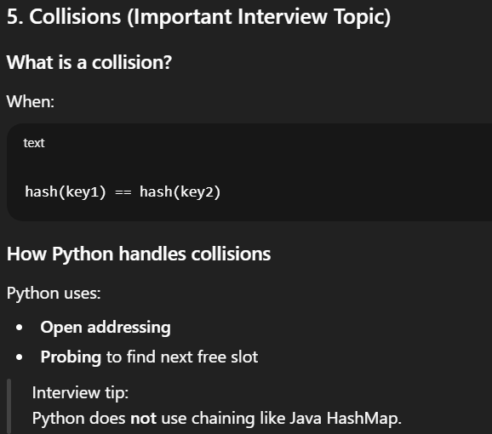
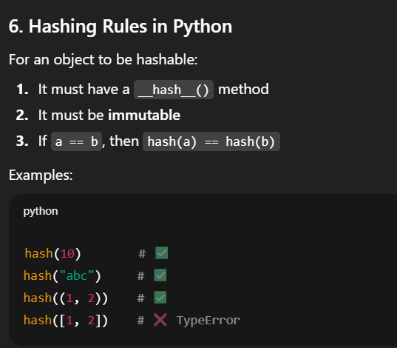
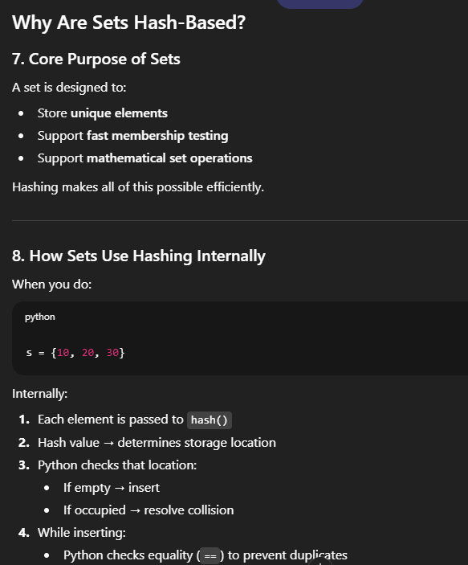
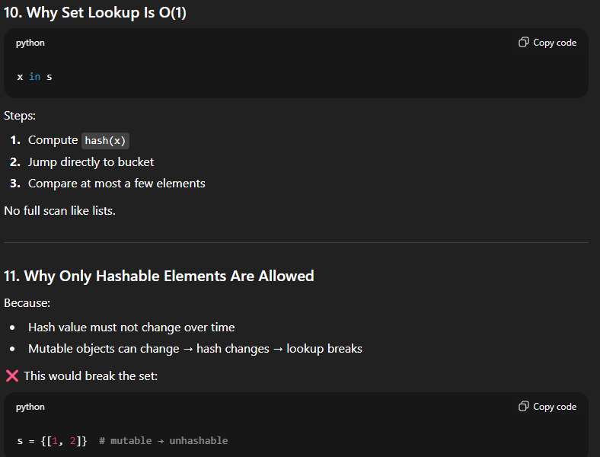

FROZENSET
It’s an immutable set that can be used for keys of a dictionary. We can’t use a normal set since it’s mutable, dictionary needs immutable keys.
Sets are faster than lists in memberships tests as it uses hash table concept.
Time complexity
Add – O(1)
Remove – O(1)
Lookup – O(1)
Union/intersection – O (len s))
Sets are heavily used in ETL pipelines, data cleaning and log analysis.
INTERVIEW QUESTIONS ON SETS
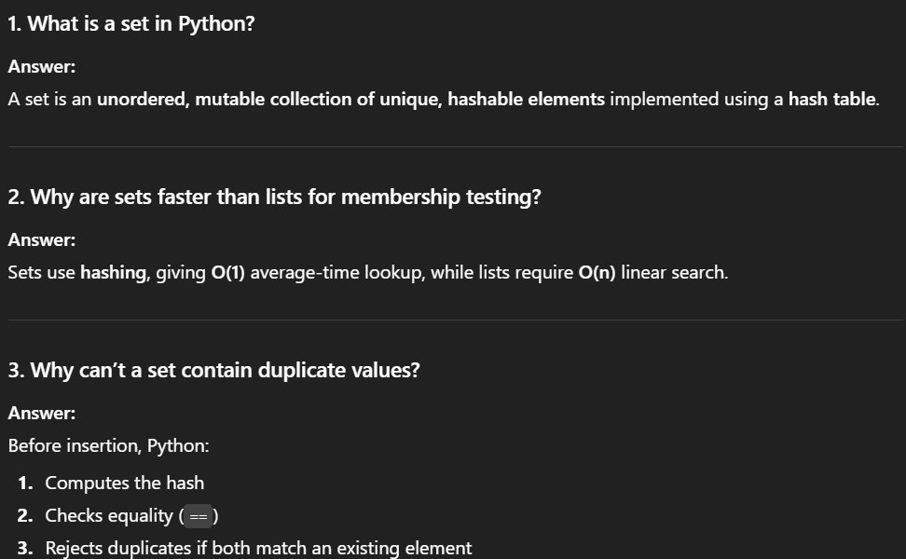
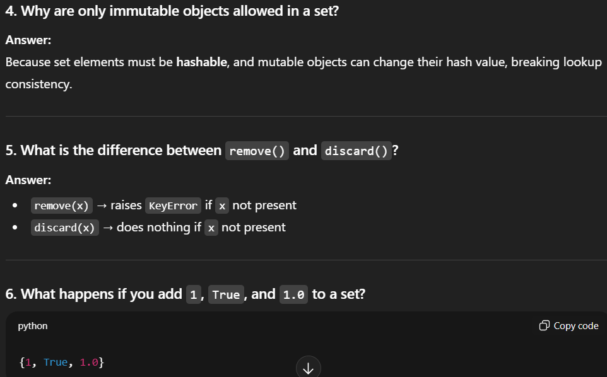
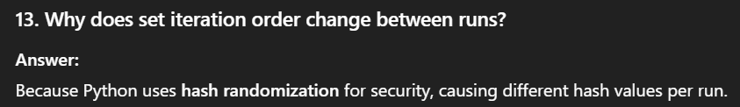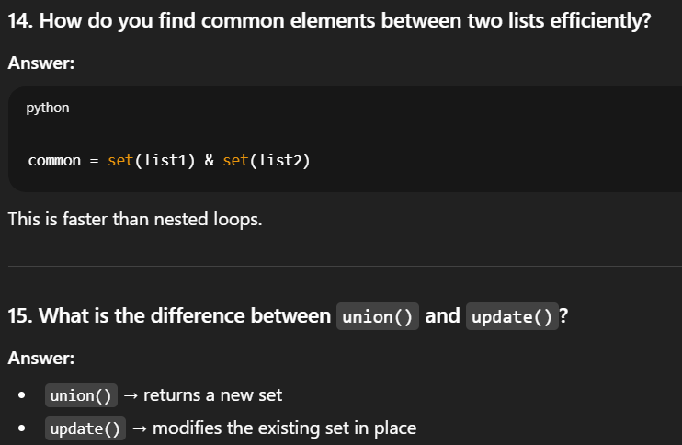
DICTIONARIES IN PYTHON
A dictionary (dict) is a mutable, unordered (insertion-ordered since Python 3.7+) collection of key–value pairs.
Keys → unique & immutable(hashable)
Values → can be any data type
TUPLES IN PYTHON
Tuple is an ordered, immutables and heterogeneous collection
  - Allows duplicates
  - Allows hashing if elements are hashable
Use cases of tuples
- Data integrity
DAYS = ("Mon", "Tue", "Wed")
- Dictionary keys(hashable) only if all elements inside tuple are immutable
location = {(40.7, -74.0): "New York"}
- Tuples consume less memory and faster than lists
- Used in saving function returns
def get_stats():
return 10, 20
a, b = get_stats()

FUNCTIONS
Functions are reusable block of code that
- Performs a specific task
- May take input(parameters)
- May give output(return value)
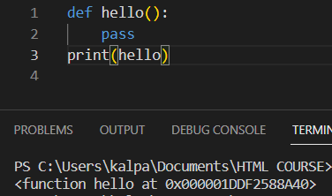
Without () the function doesn’t get executed and just is function if we just type function name.
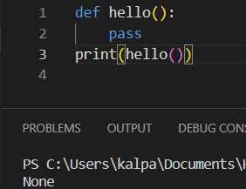
Prints none if function has nothing inside
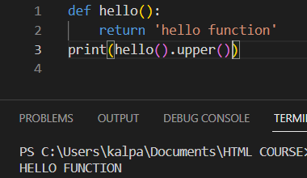
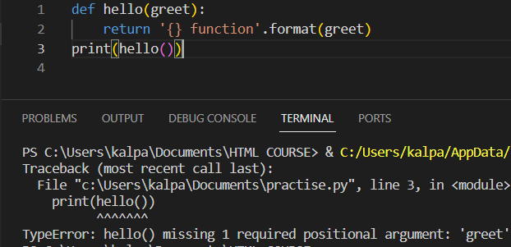
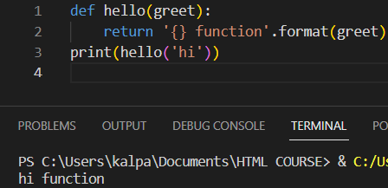
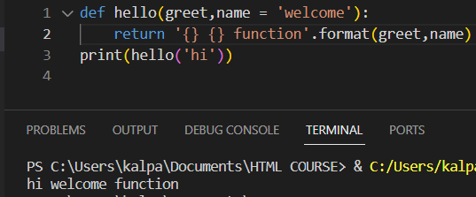
we passed a default variable called YOU so we don’t need to pass them while calling the function
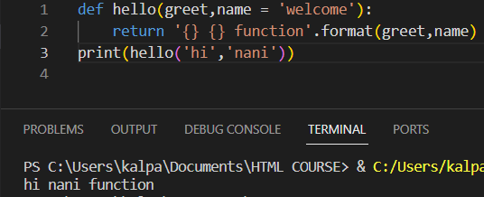
We can change the default variable if we want to change while calling the function. Required positional arguments have to come before keyword arguments.
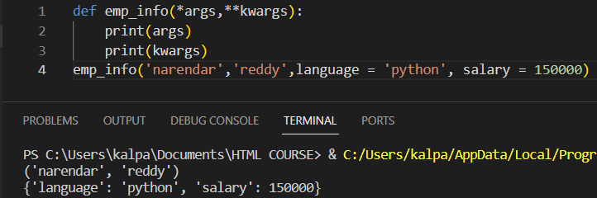
*args are tuple and **kwargs are dictionary
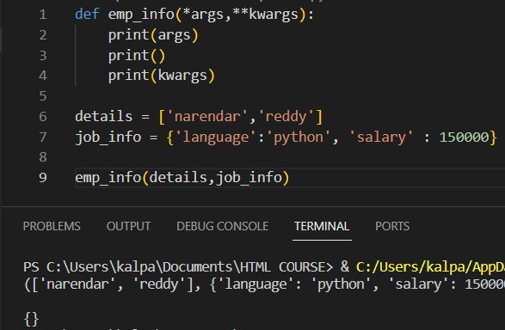
We can observe that both courses and info variables have been packed into tuple (*args considered) and dictionary has become empty. So, to pass them into unpacked, the following need to be done
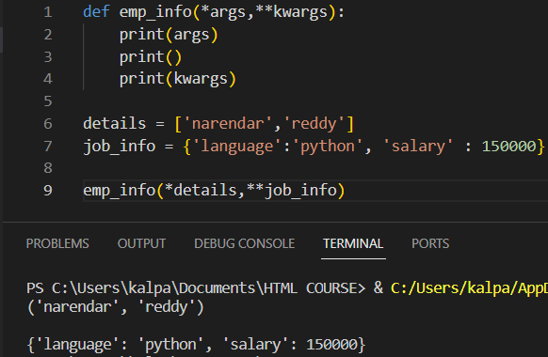
Just compare the results of the both outputs
PYTHON CLOSURES
A closure is a function that is defined in another function that can remember the variable from it’s enclosing function and can access them even after that outer function execution is finished.

PYTHON TYPEDDICT vs DATACLASS vs PYDANTIC
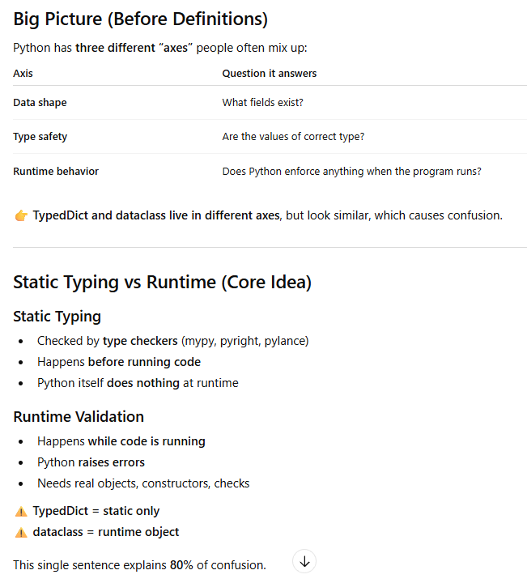
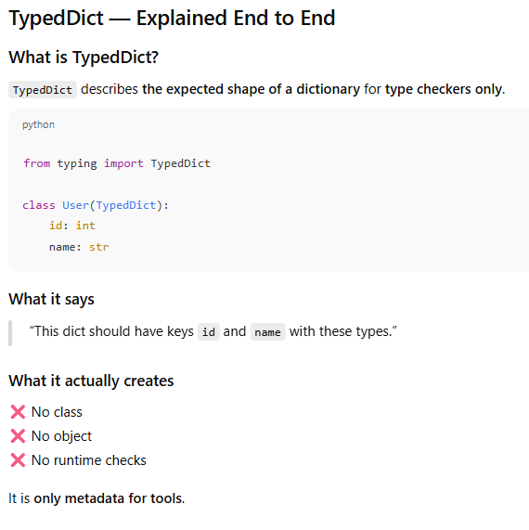
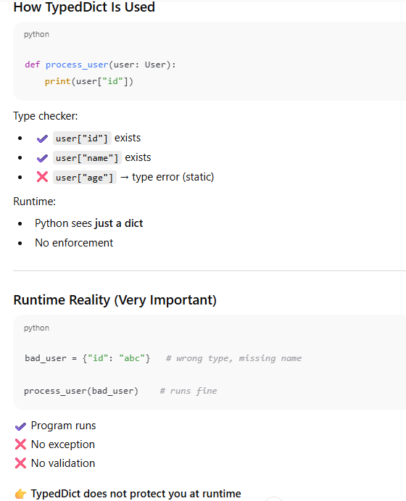
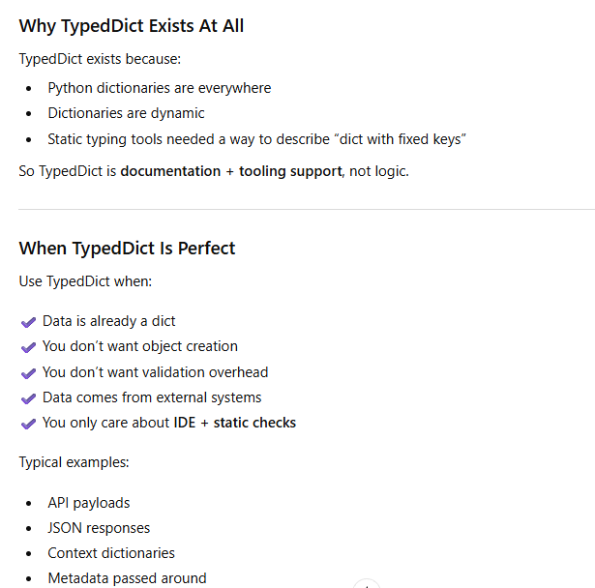
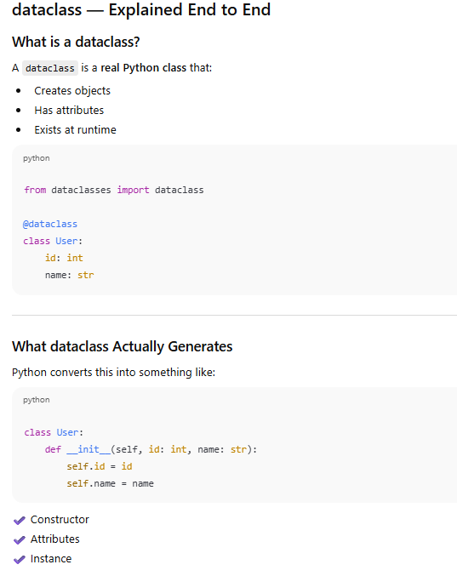
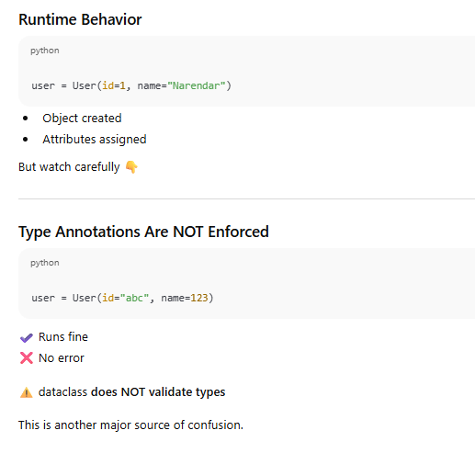
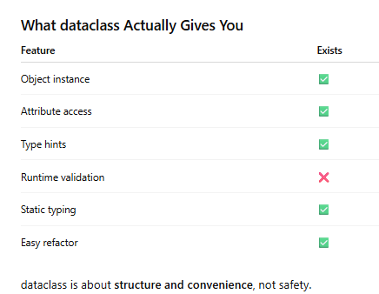
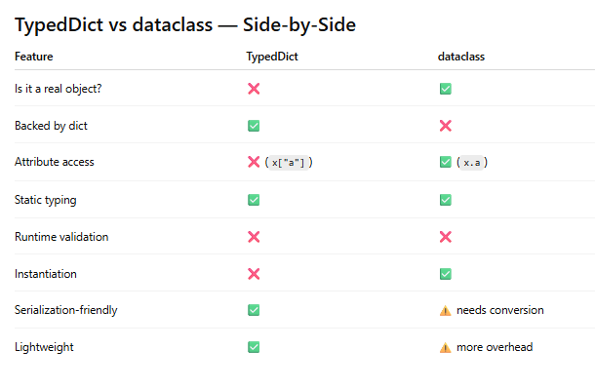
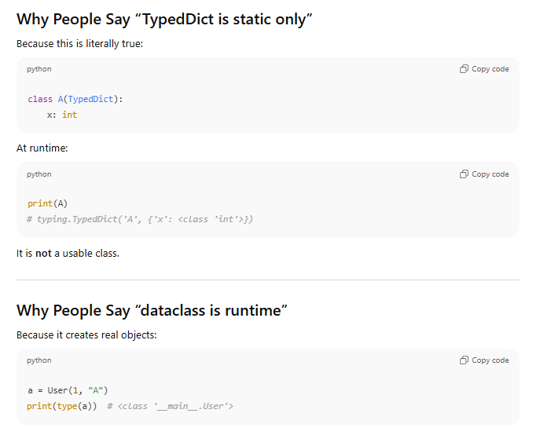
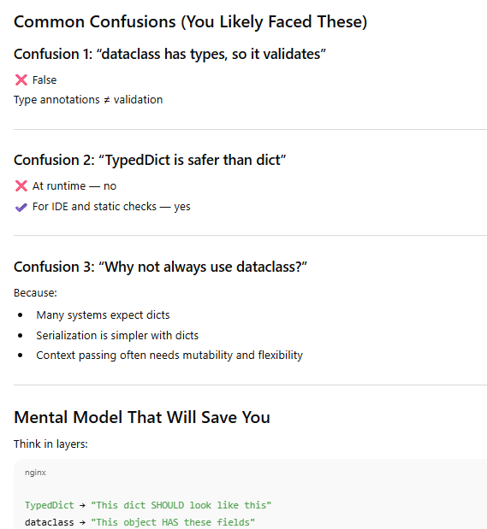
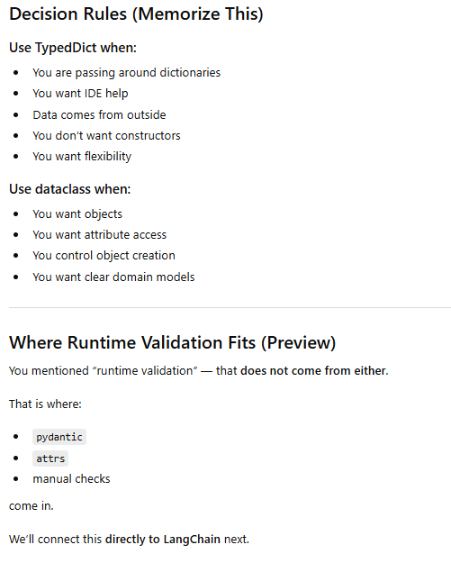
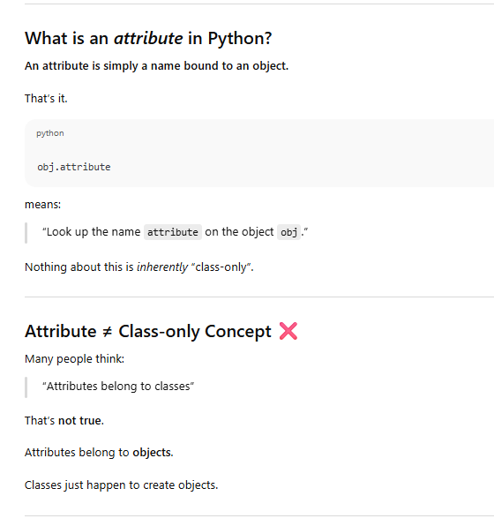
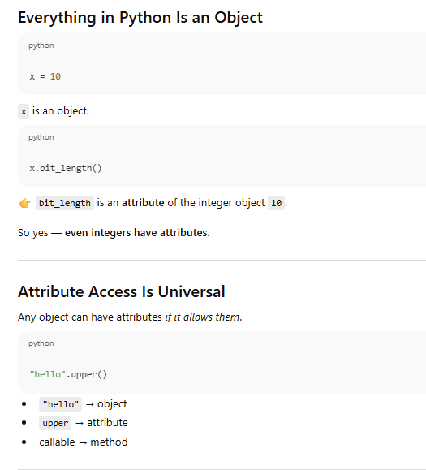
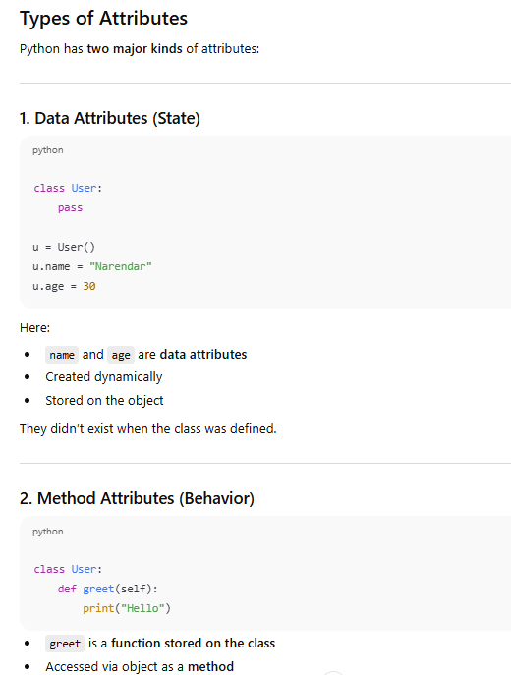
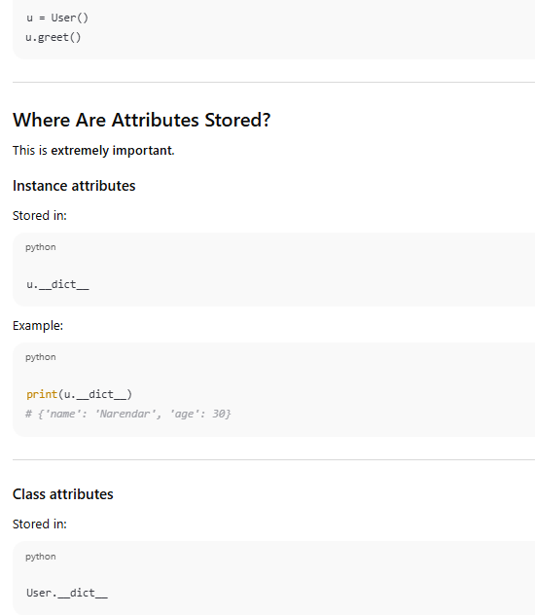
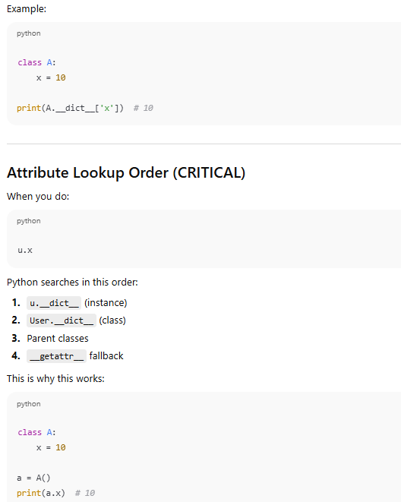
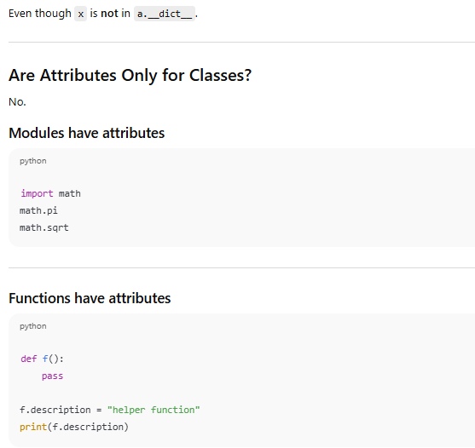
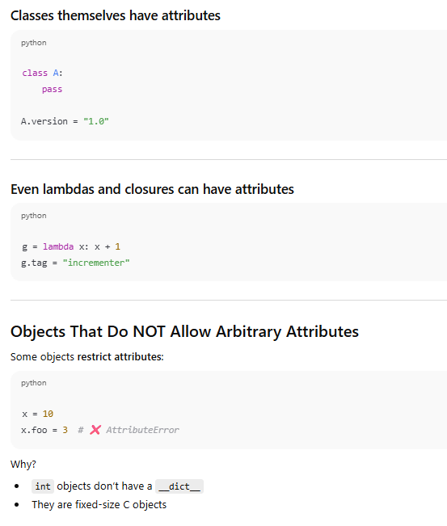
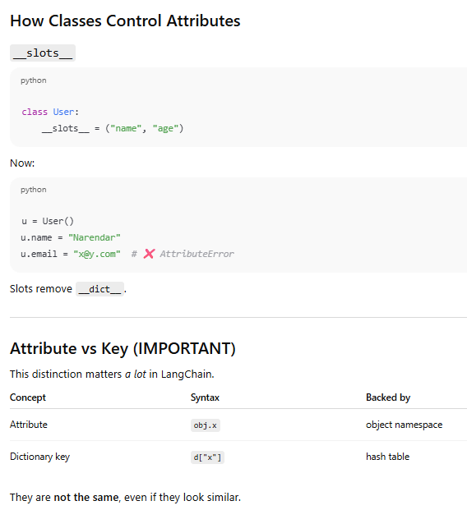
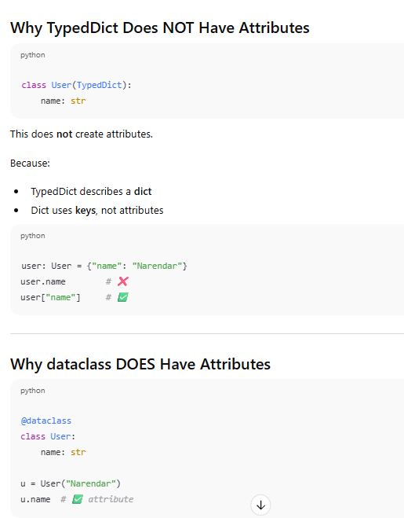
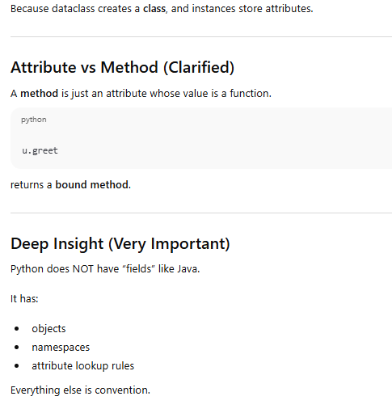
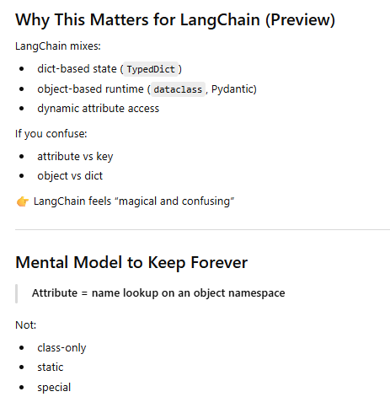
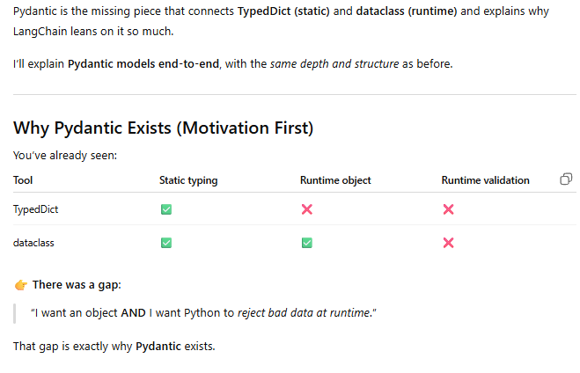
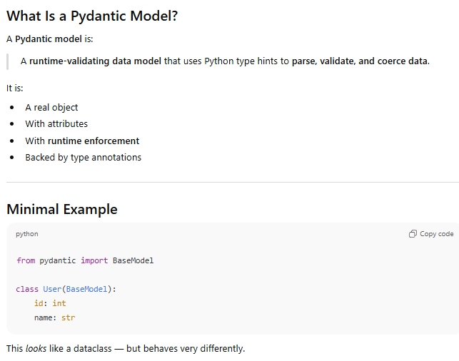
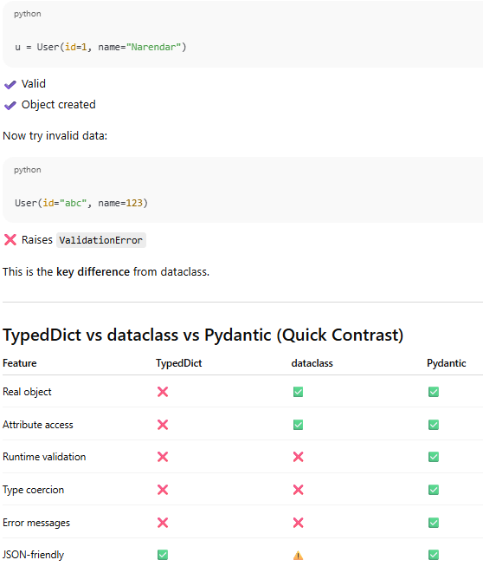
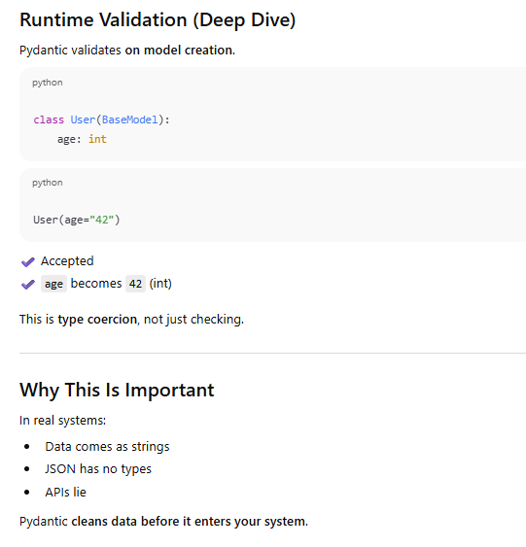
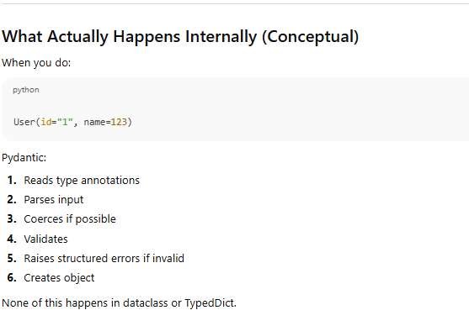
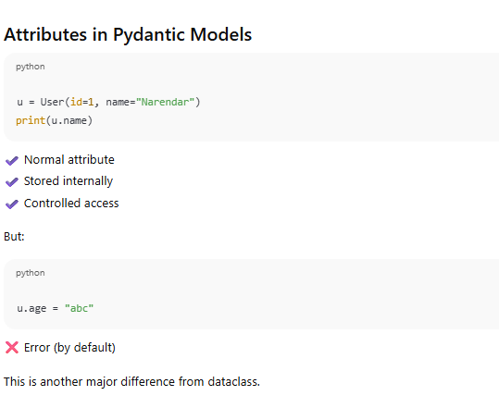
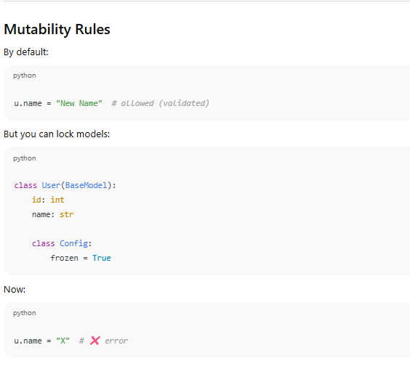
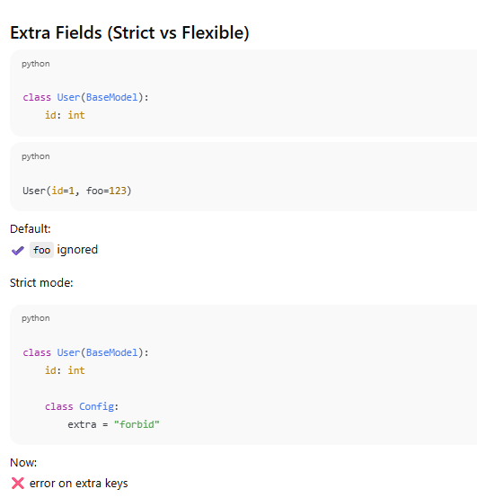
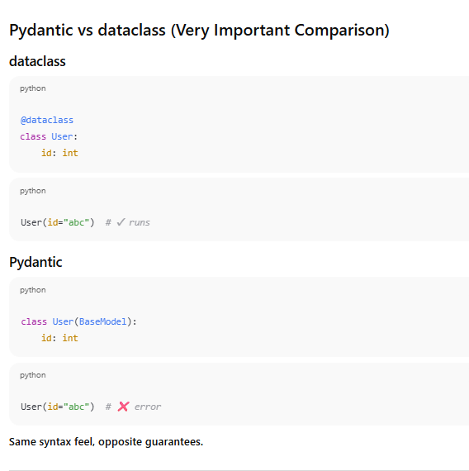
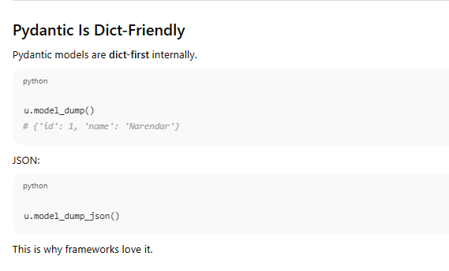
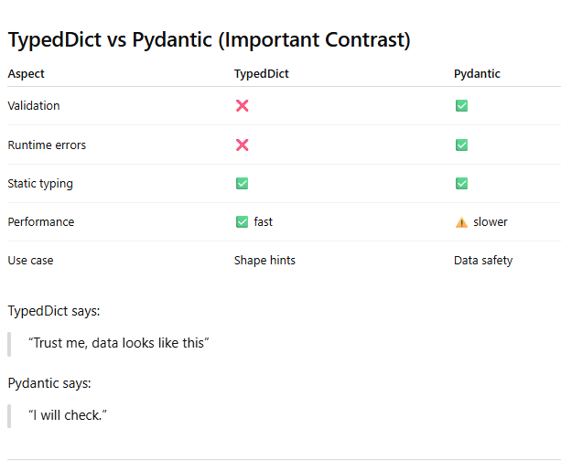
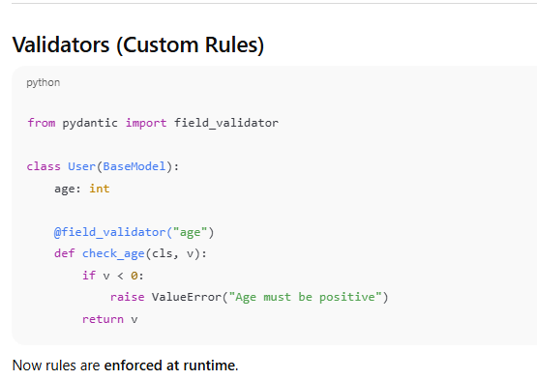
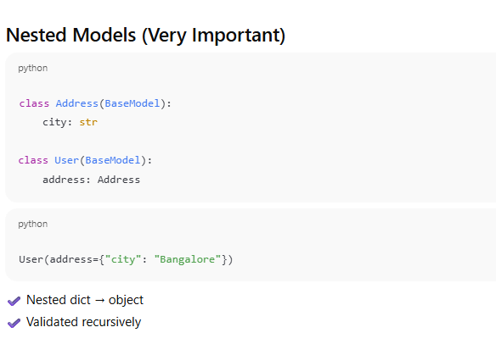
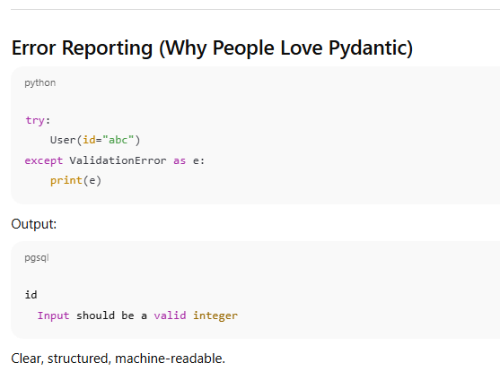
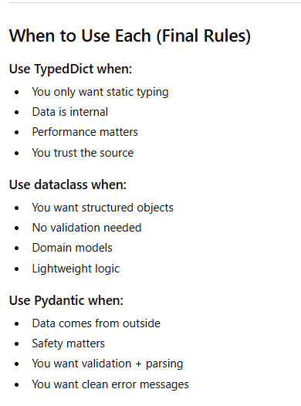
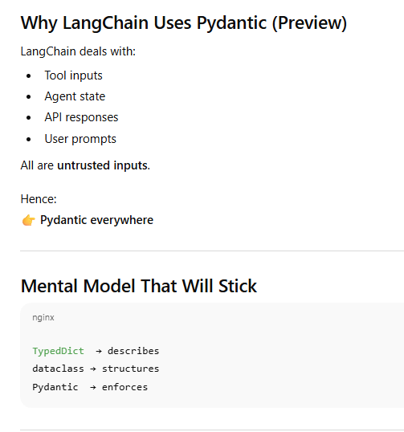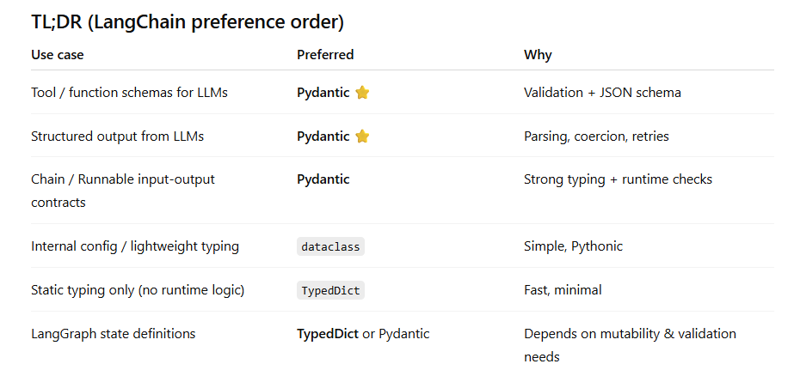
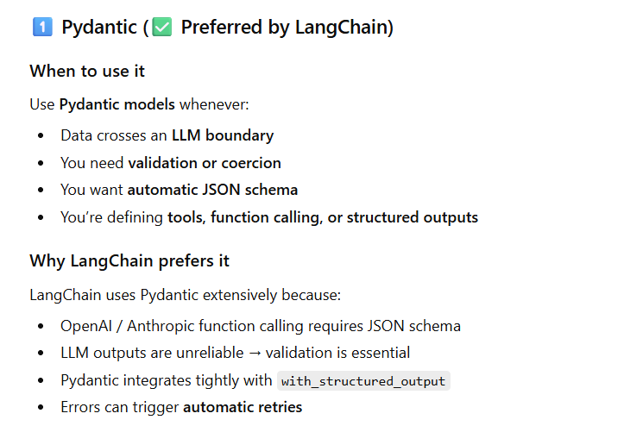
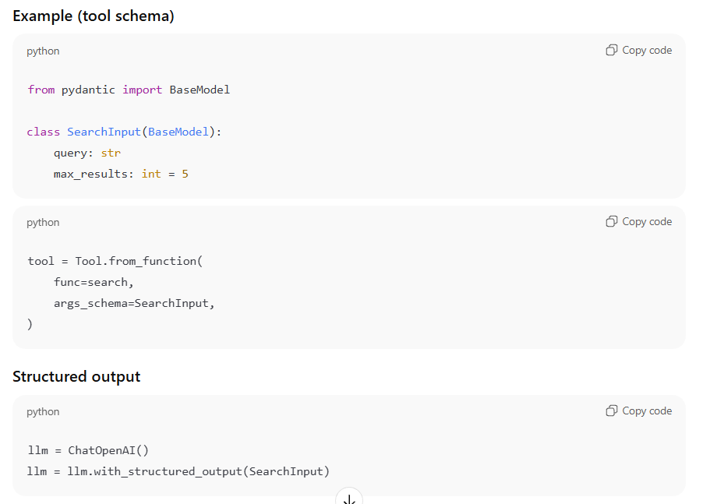
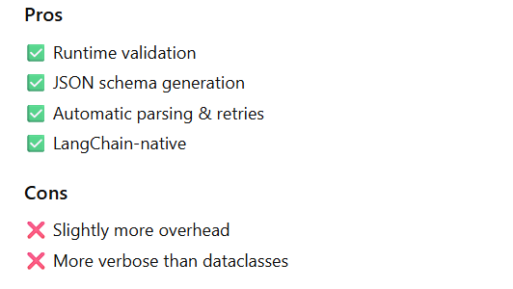
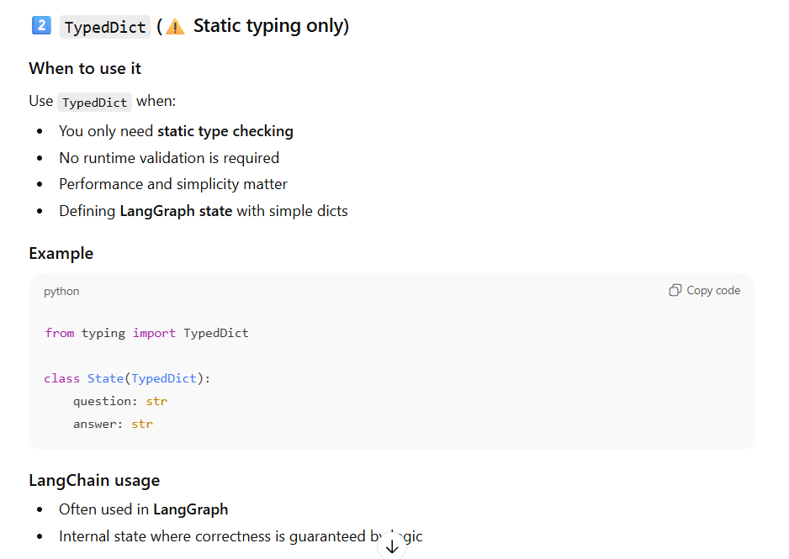
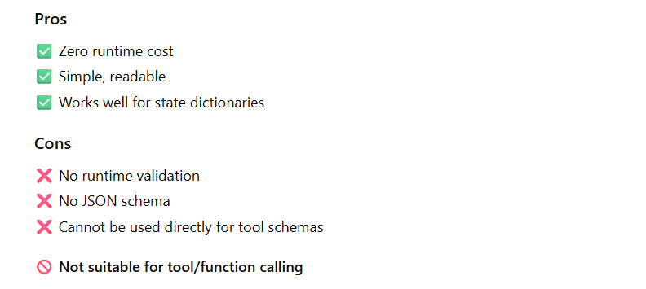
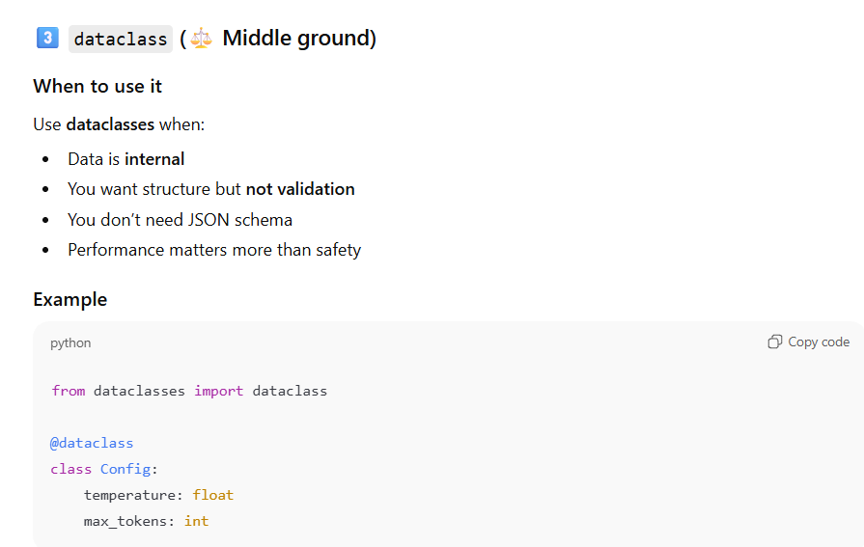
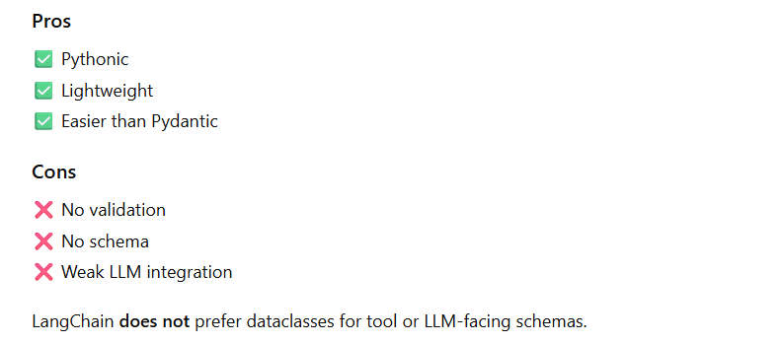
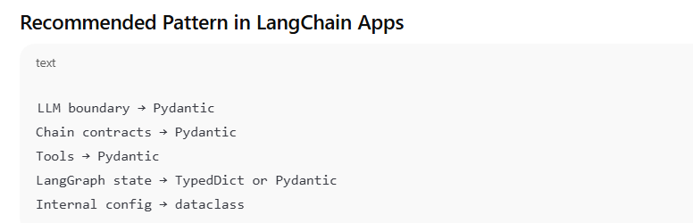
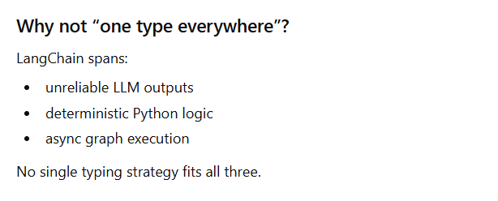
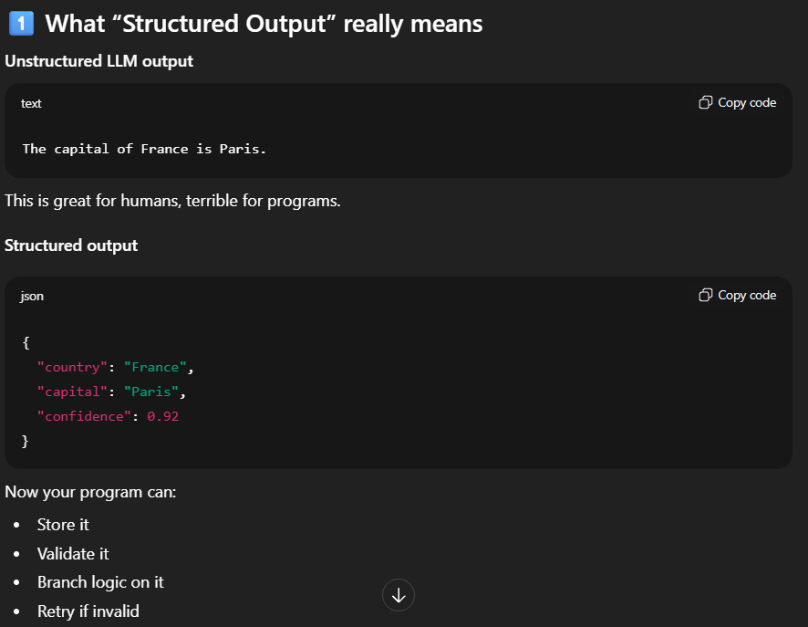
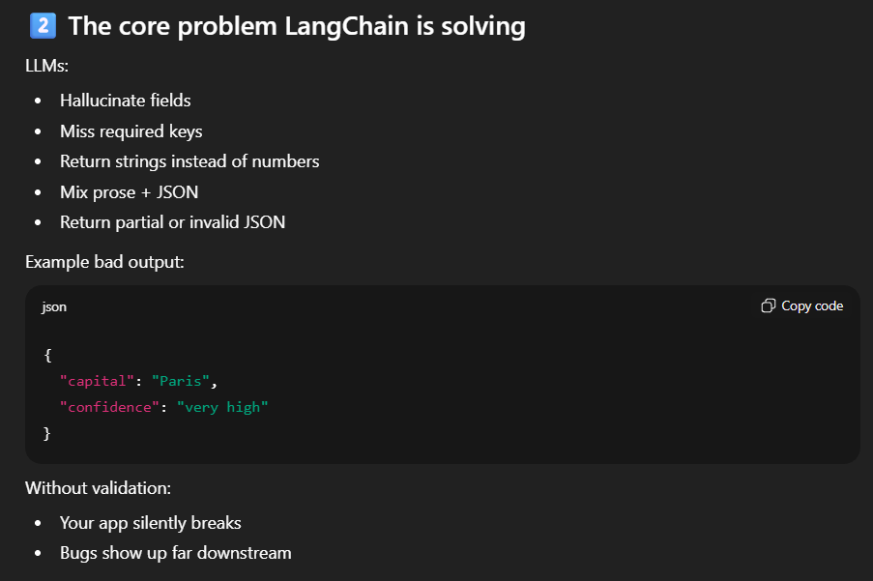
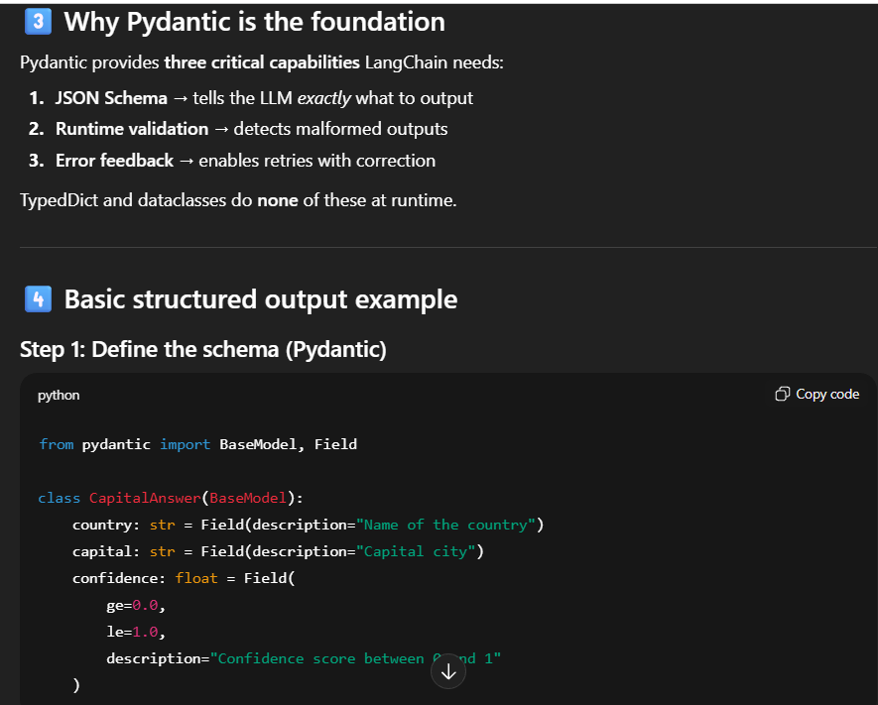
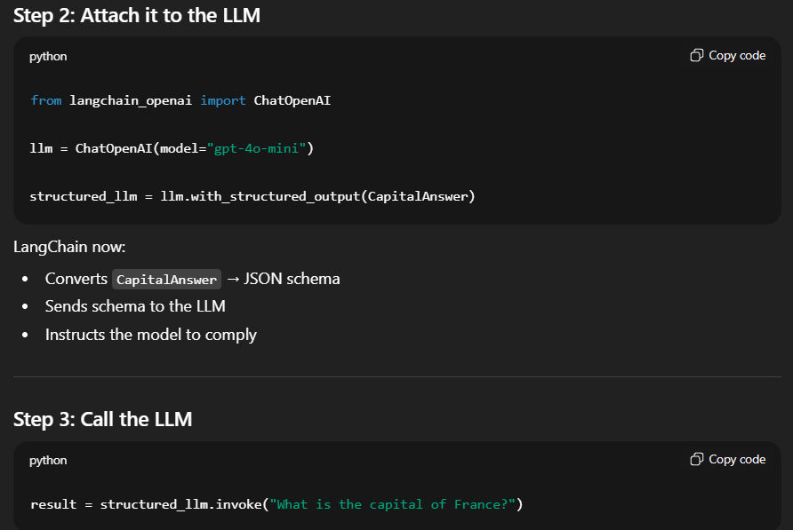
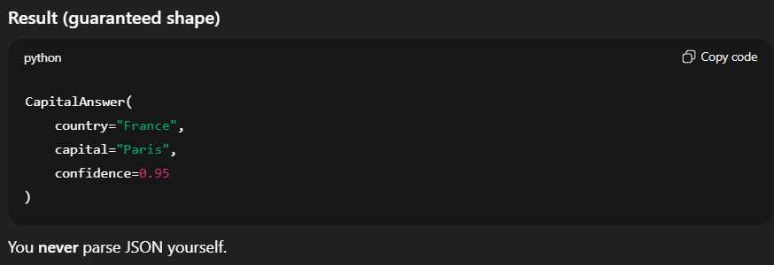
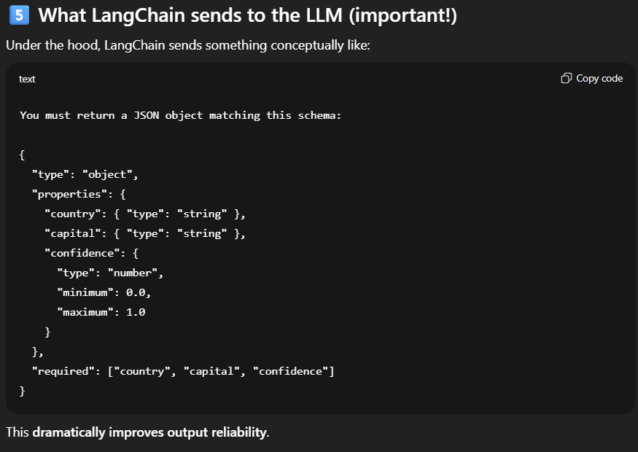
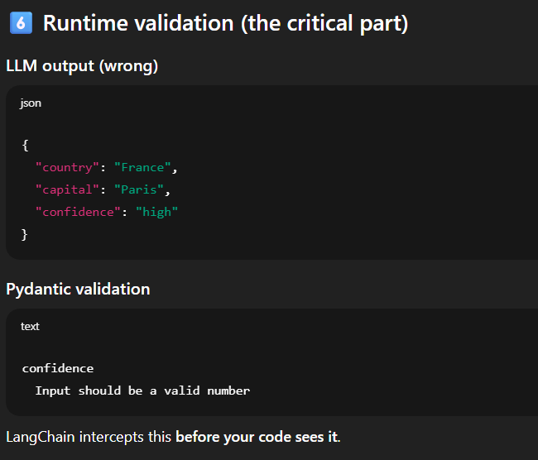
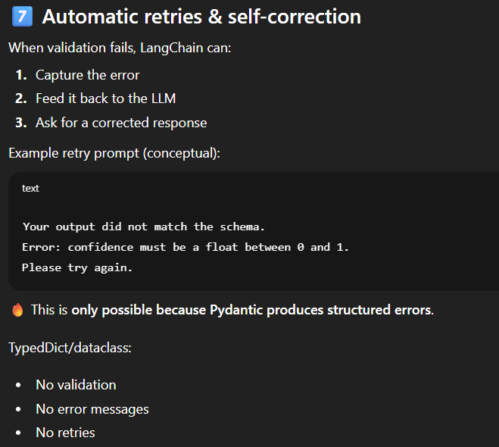
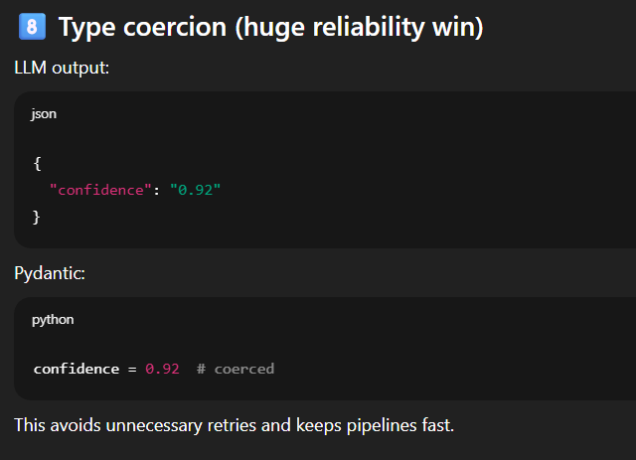
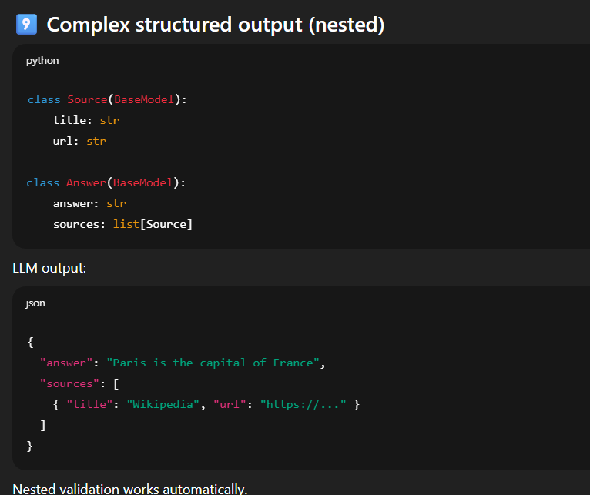
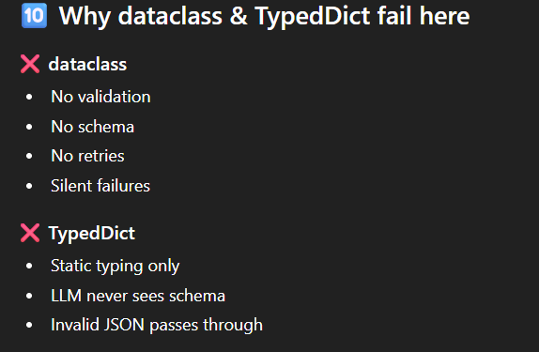
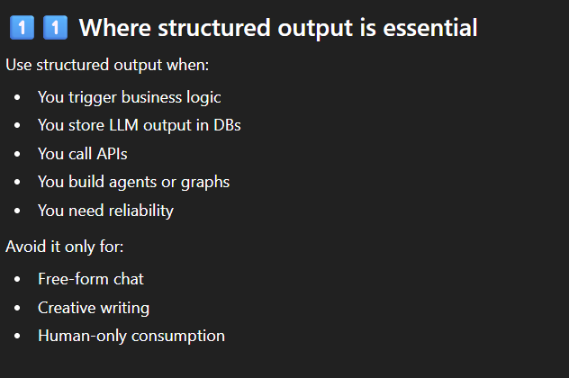
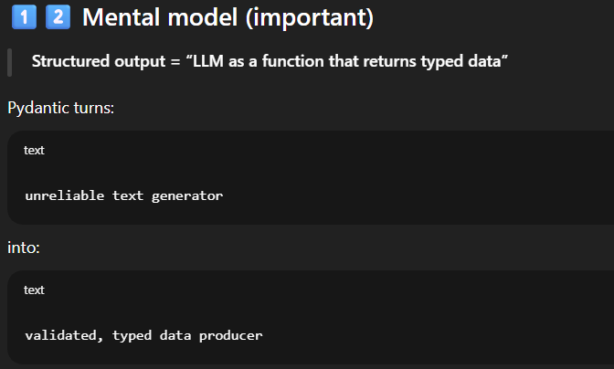
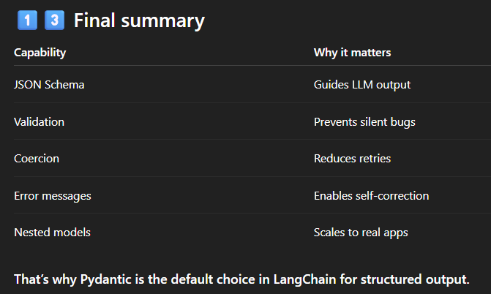
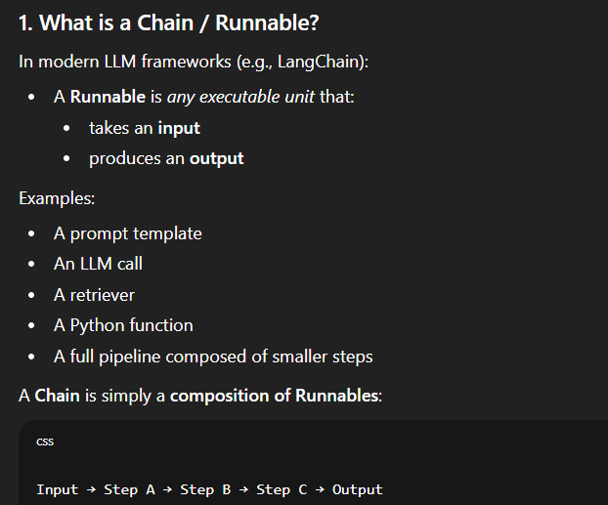
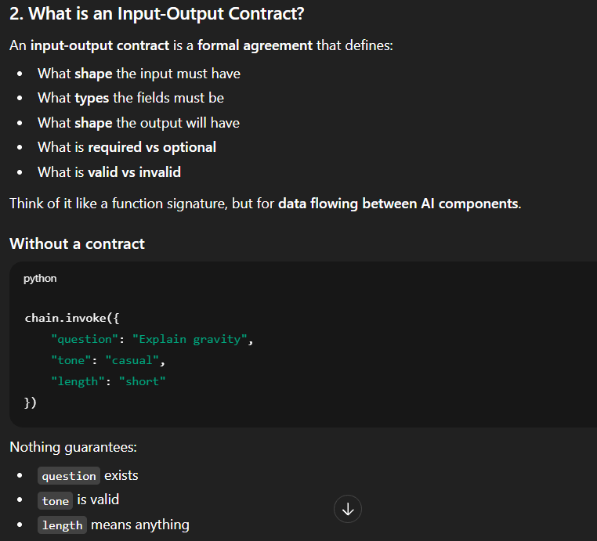
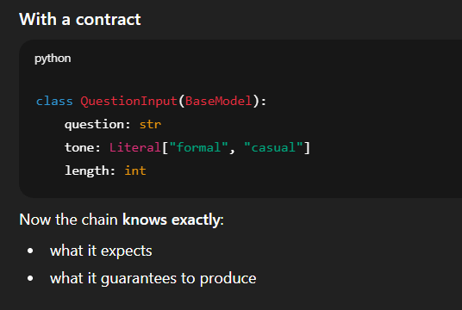
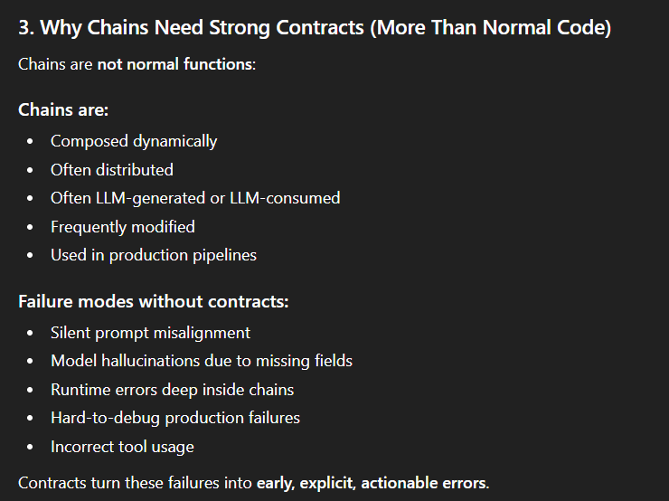
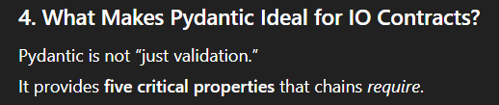
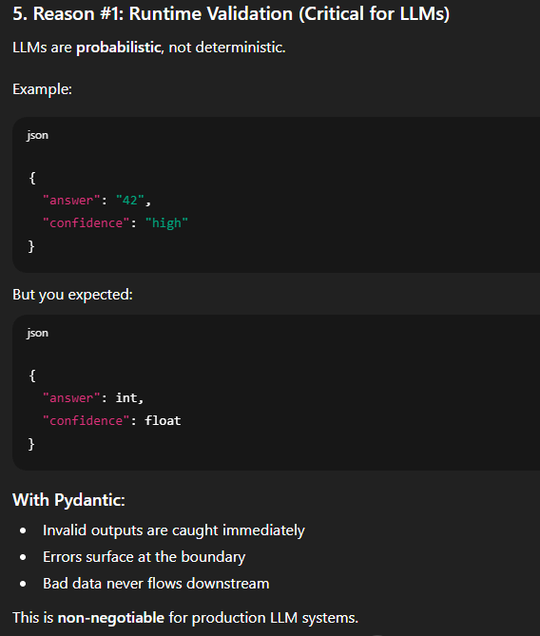
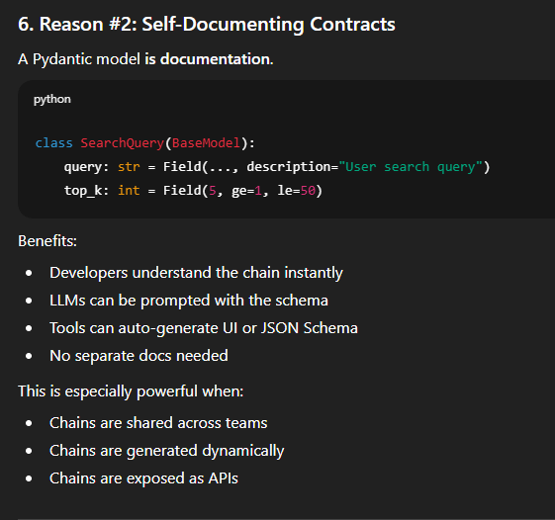
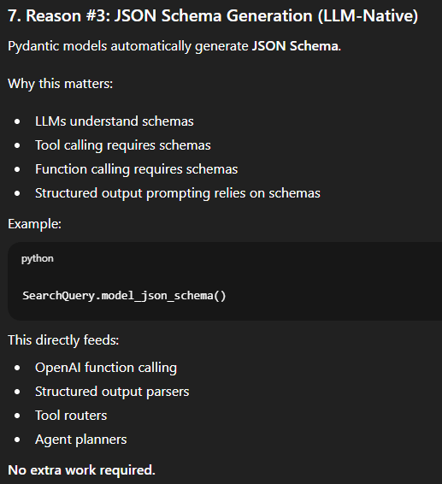
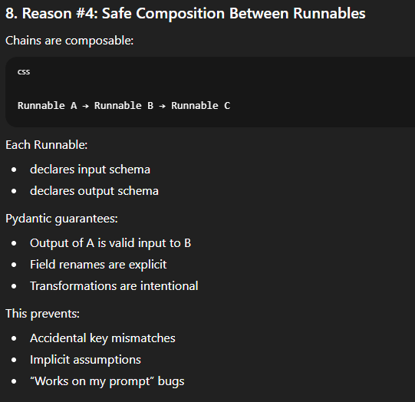
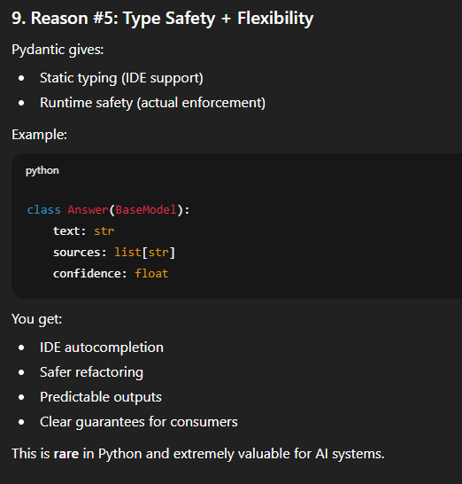
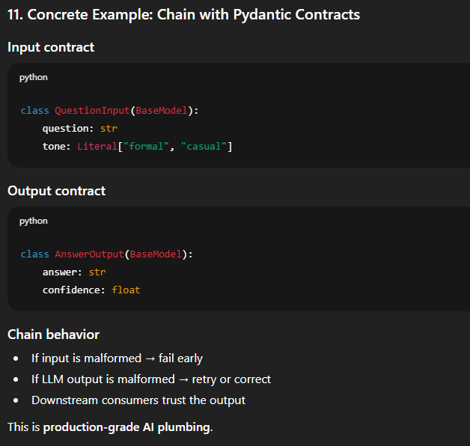
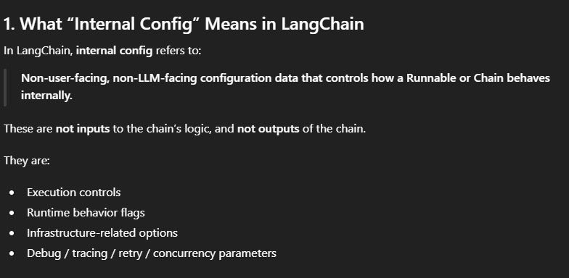
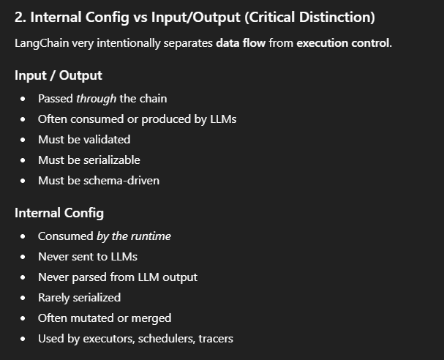
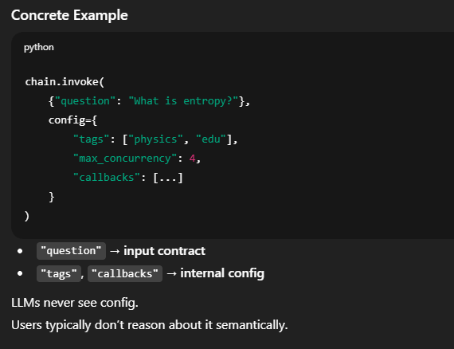
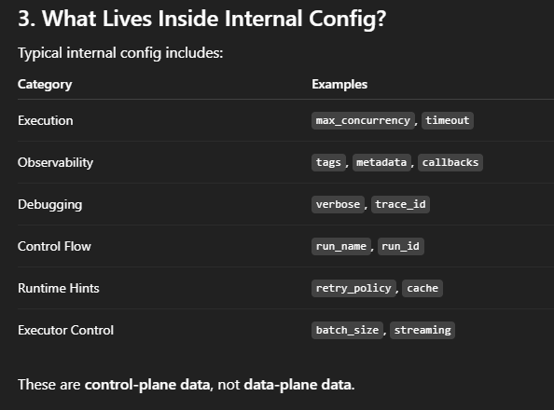

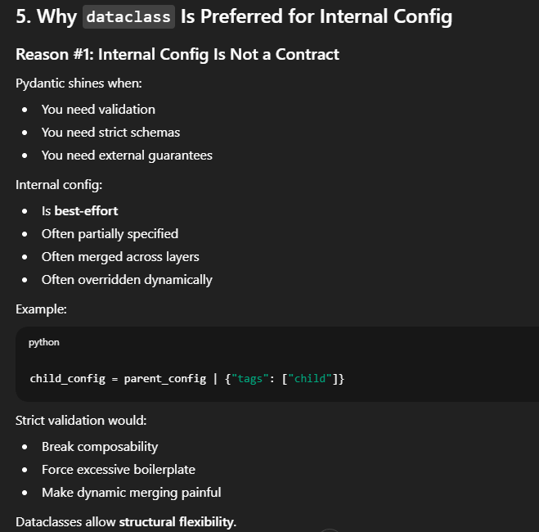
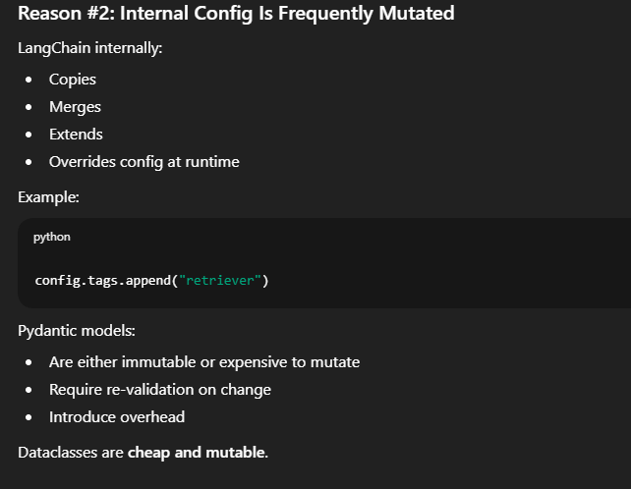
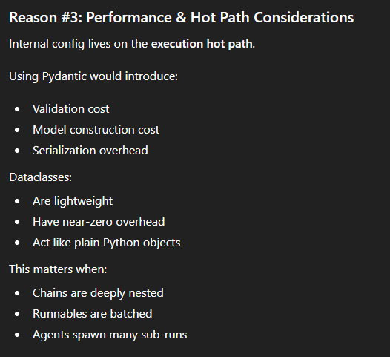
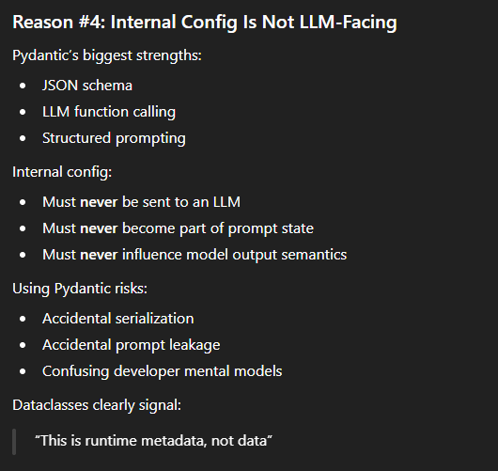
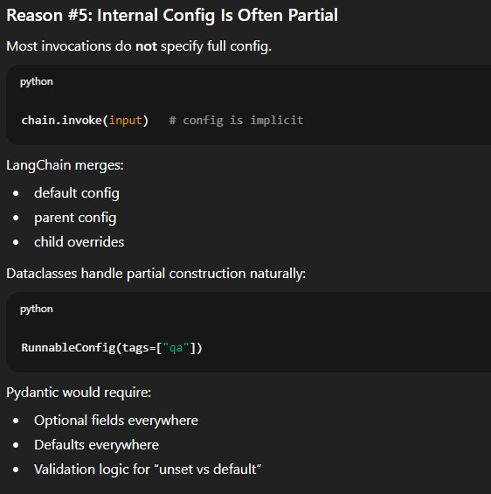
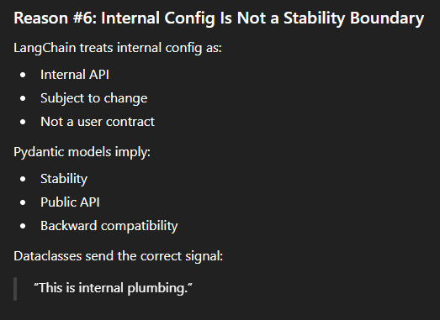
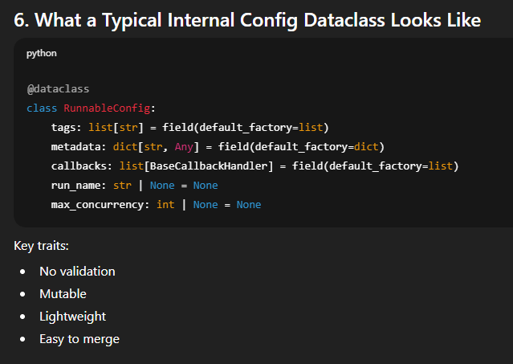
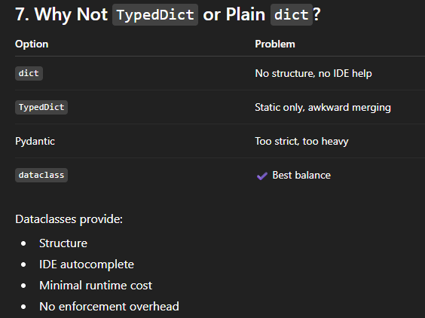
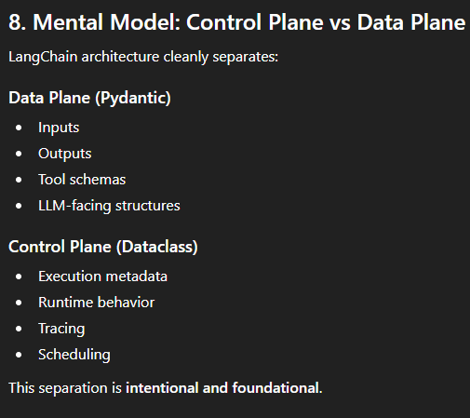

SERIALIZATION IN PYTHON
Serialization is the process of converting an in-memory Python object into a format that can be stored or transmitted and later reconstructed back into the same object.
Serialize → Python object ➜ bytes / string
Deserialize → bytes / string ➜ Python object
Why is Serialization Required?

PYTHON TYPING
The typing module in Python provides type hints—a way to describe what kinds of values variables, function parameters, and return values are expected to have. It does not change runtime behavior by default; it exists to improve readability, correctness, tooling, and maintainability.
ENVIRONMENT VARIABLES IN PYTHON
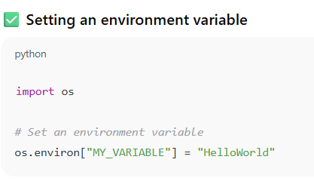
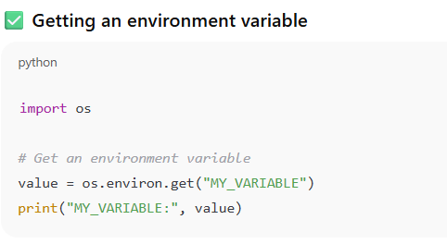
Environment variables set with os.environ will live only until the python process is running and once the script is over, they are gone.
How to deal if we have a .env file?
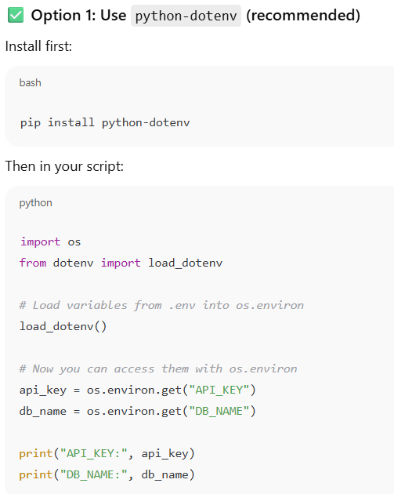
How do we save our environment variables so that the developers can just access but not able to see what they actually are?
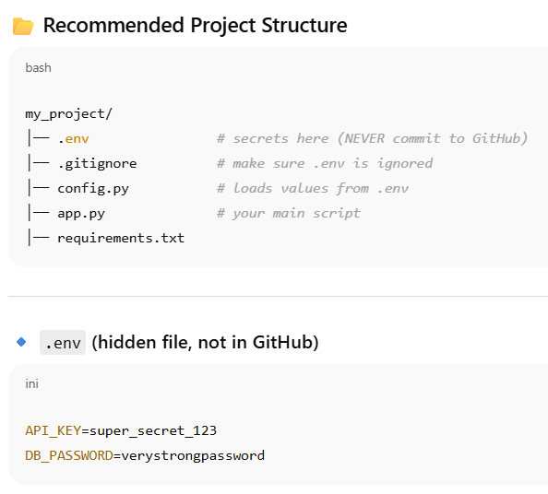
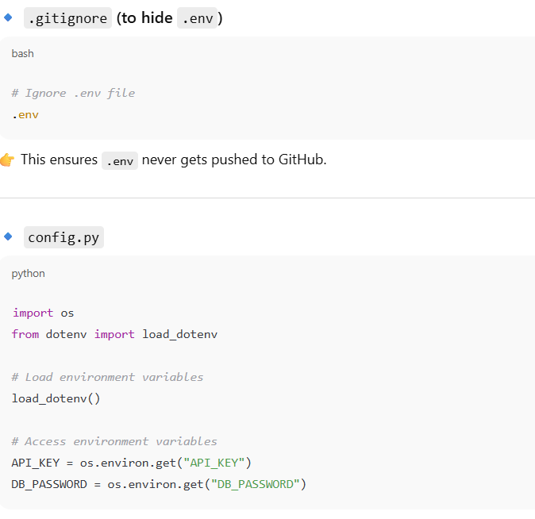
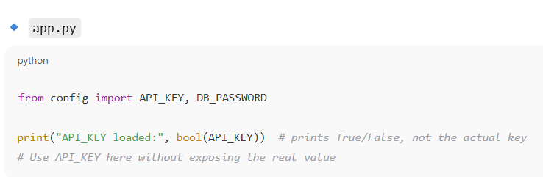

SYNCHRONOUS AND ASYNCHRONOUS PROGRAMMING
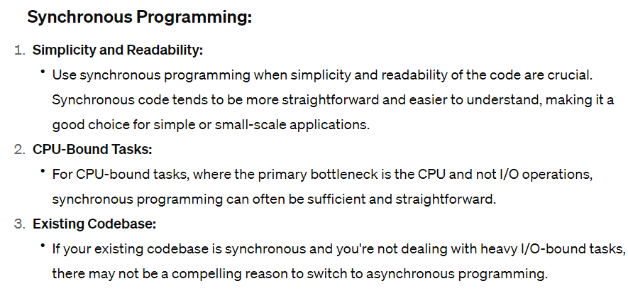
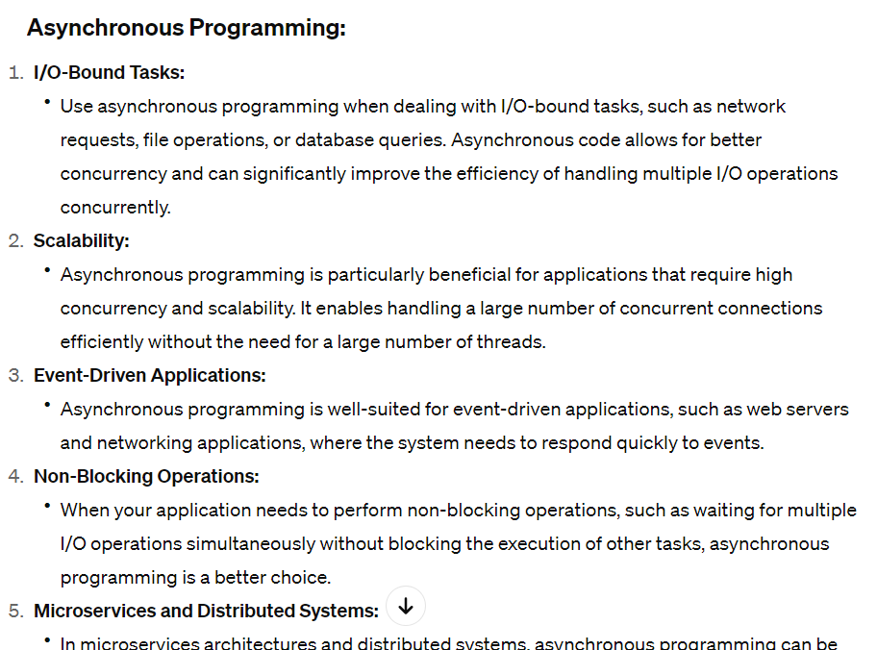

CPU BOUND AND I/O BOUND OPERATIONS IN PYTHON
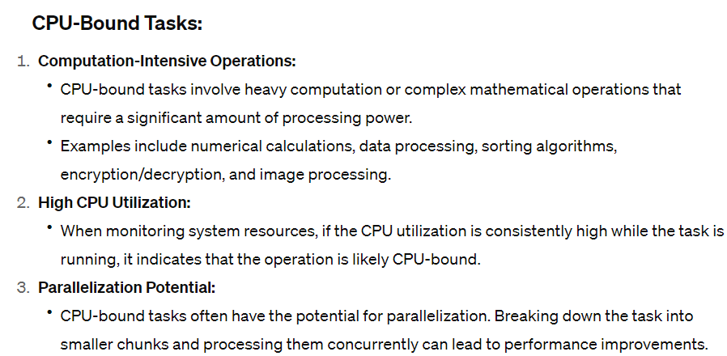
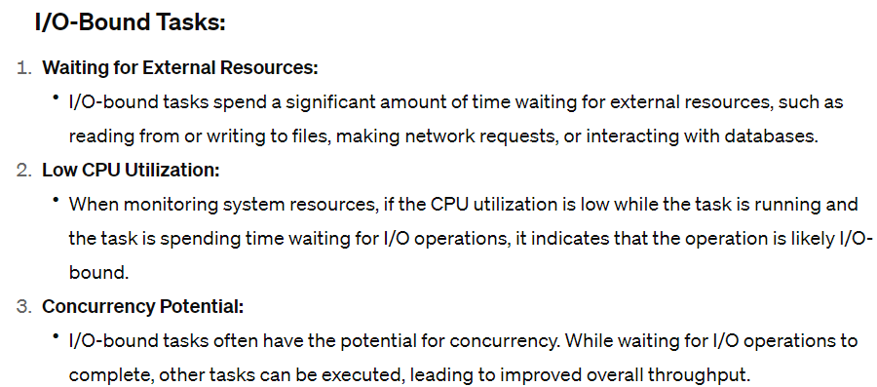

Async module in python
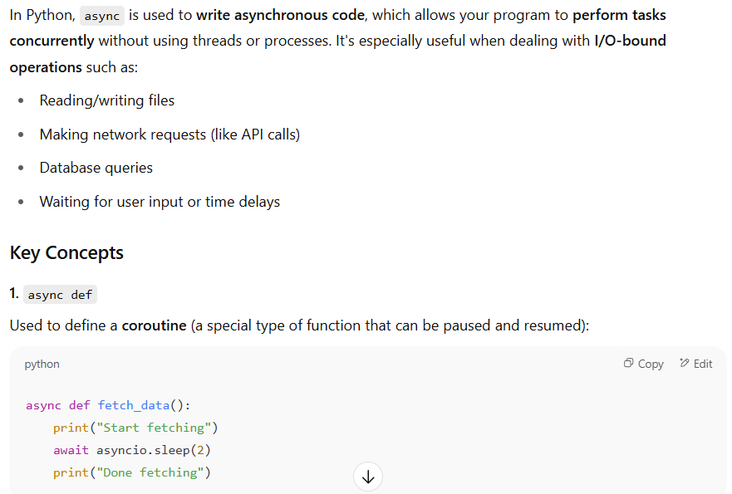
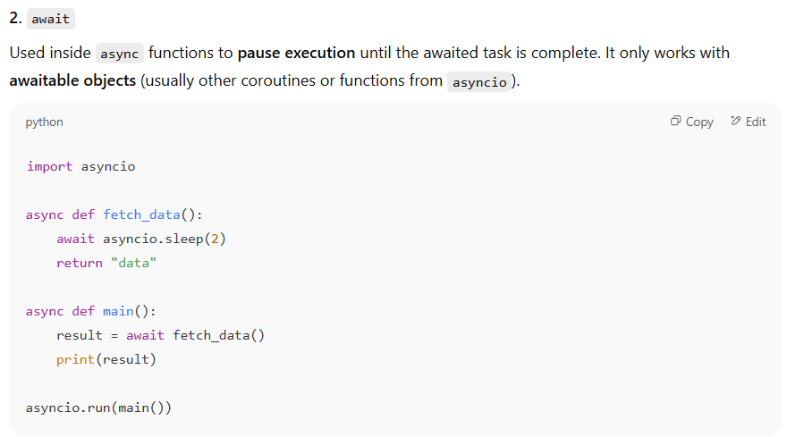
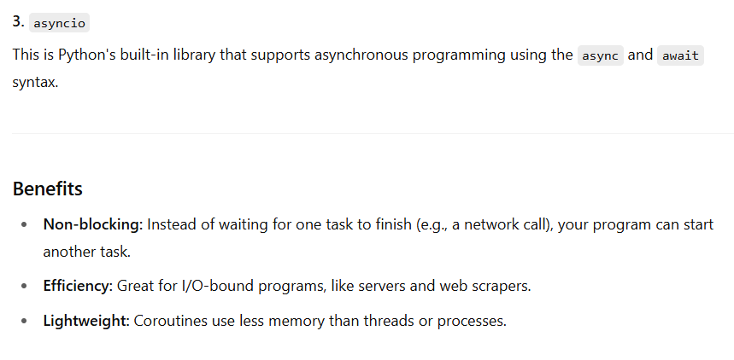
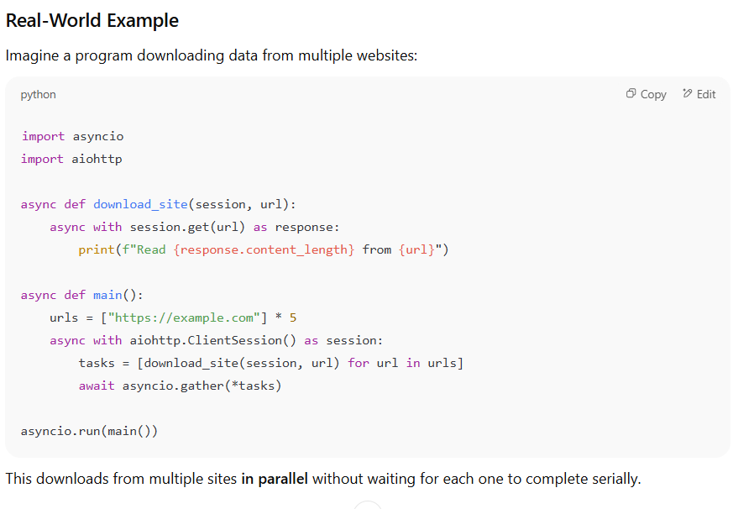
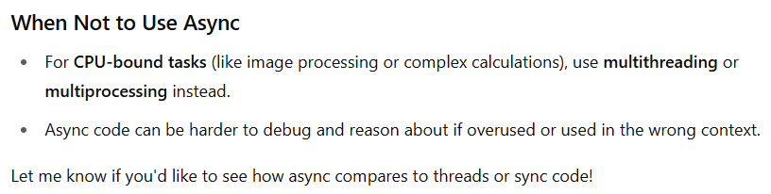
SORTS IN PYTHON
Bubble Sort:
Bubble Sort is a simple sorting algorithm that repeatedly steps through the list, compares adjacent elements, and swaps them if they are in the wrong order. This process is repeated until the list is sorted.
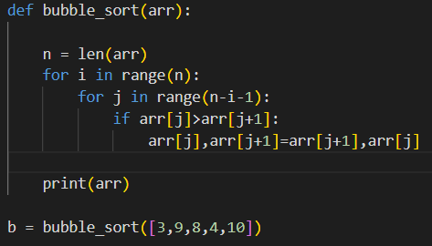
Selection Sort:
Selection Sort is a simple index comparison-based sorting algorithm. It divides the input into a sorted and an unsorted region. It repeatedly selects the smallest (or largest) element from the unsorted region and swaps it with the first element of the unsorted region.
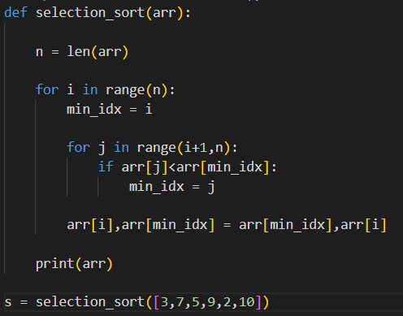
Insertion Sort:
Insertion Sort is a simple sorting algorithm that builds the final sorted array one item at a time. It is much less efficient on large lists than more advanced algorithms such as quicksort, heapsort, or merge sort.
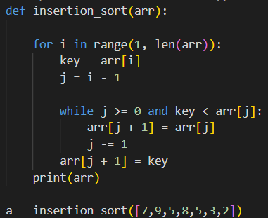
Quick sort:
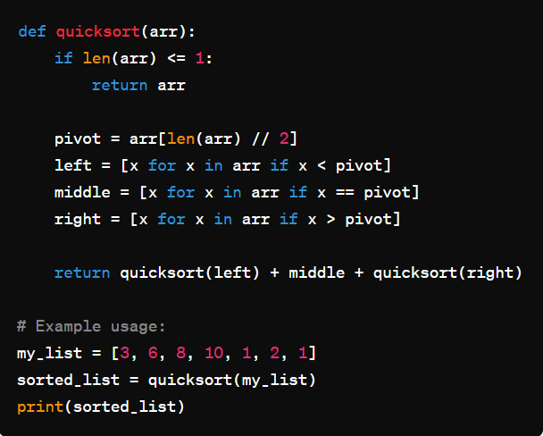
SEARCHES IN PYTHON
Linear Search:
Linear search is a simple search algorithm that checks each element in a list until the desired element is found or the end of the list is reached. It's suitable for unsorted lists.
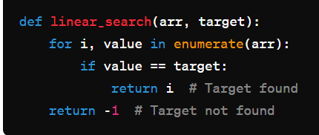
Hash Table / Dictionary Search:
Python dictionaries use hash tables to achieve fast lookups. You can use the in operator or the get() method to check for the existence of a key.
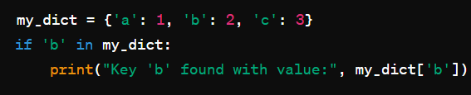
Binary Search
Binary search is an efficient algorithm for finding a specific value in a sorted list. It works by repeatedly dividing the search interval in half. If the value to be searched is equal to the middle element of the interval, then it is found. Otherwise, the algorithm eliminates half of the remaining elements in the search space, and the search continues on the remaining half.
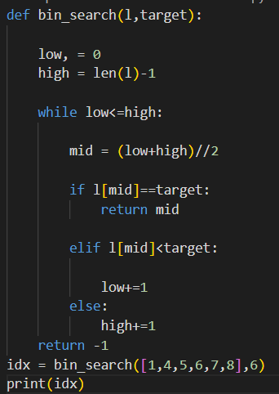

Interpolation Search:
Interpolation search is an algorithm for searching for a given key in an array that has been ordered by numerical values. It calculates the probable position of the target based on the assumption that the keys are uniformly distributed.
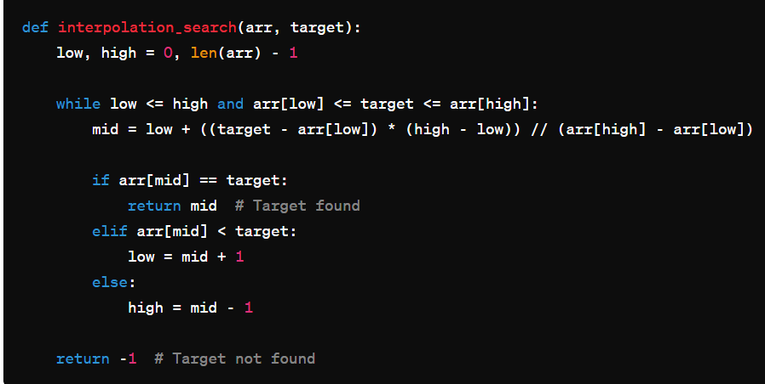
SPACE COMPLEXITY IN PYTHON
Space complexity in Python refers to the amount of memory space required by an algorithm or program during its execution. It is a measure of how efficiently the program utilizes memory as the input size increases. The space complexity of an algorithm is usually expressed in big O notation.
There are two main components to consider when evaluating space complexity:
1) Fixed Space Requirements:
This includes variables that occupy a fixed amount of space, regardless of the input size. For example, constants, single variables, and fixed-size data structures.
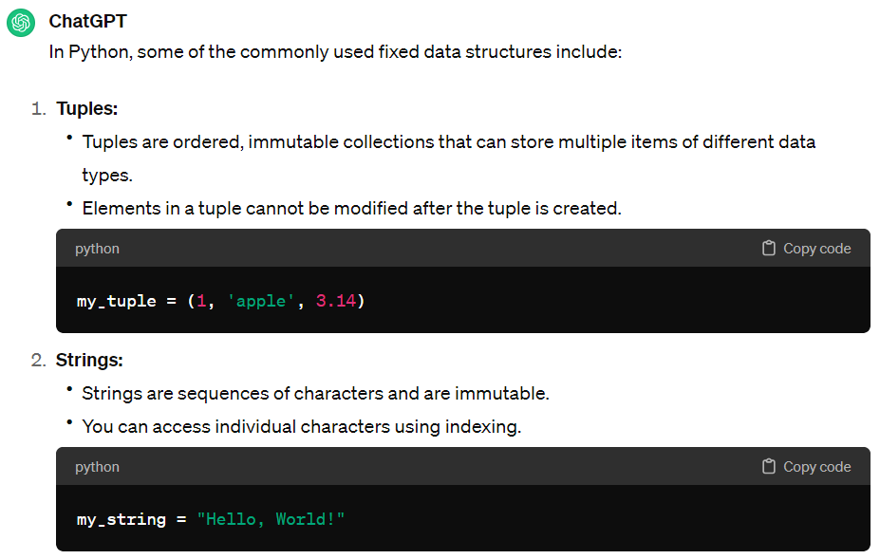
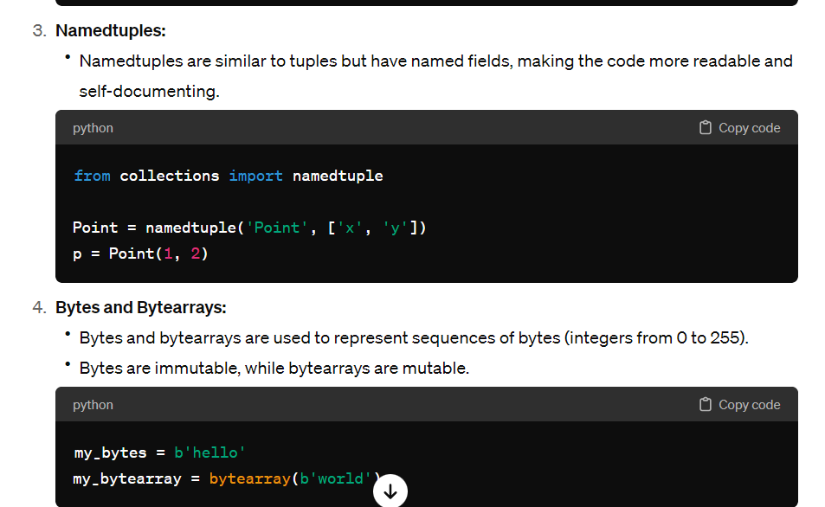
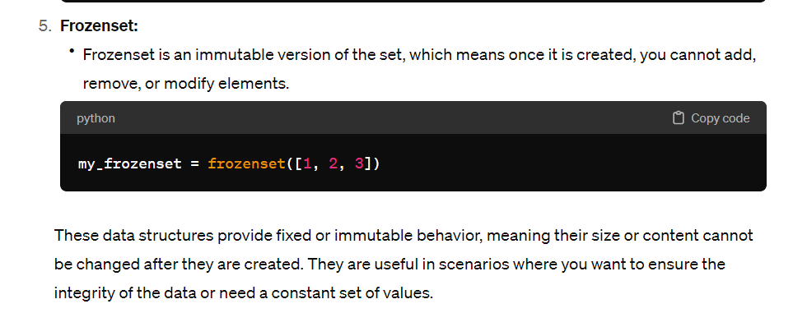
2) Variable Space Requirements:
This includes variables whose space requirements depend on the size of the input. For example, arrays, lists, and other dynamic data structures.
To evaluate space complexity in Python, you can follow these steps:
Identify the Variables:
Identify all the variables and data structures used in the algorithm.
Assign Space Values:
Determine the amount of space each variable or data structure consumes. Fixed-size variables have constant space requirements, while dynamic data structures may have space requirements proportional to the input size.
Sum Up the Space Requirements:
Add up the space requirements of all variables and data structures. Express the total space complexity in big O notation, ignoring constants and lower-order terms.
Here are some common space complexities and their meanings:
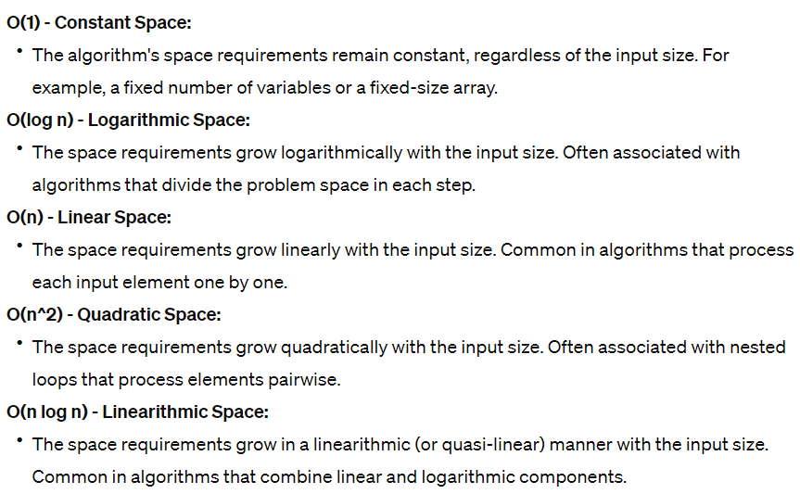
Examples for logarithmic space complexity:
Binary Search:
The space complexity is O (log n), where 'n' is the size of the input array.
Binary Heap:
Binary heaps are data structures that satisfy the heap property and can be implemented using arrays. The height of a binary heap is logarithmic in the number of elements.
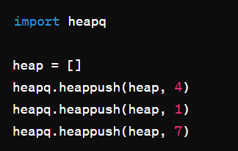
Tree Traversal:
Certain tree traversal algorithms, such as in-order traversal of a balanced binary search tree, occupy logarithmic space.
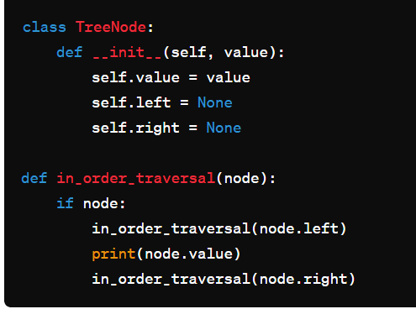
Merge Sort (Temporary Space):
Merge Sort, while not in-place, has a space complexity of O(n log n) due to the additional space needed for merging. The temporary space used for merging grows logarithmically with the size of the input.
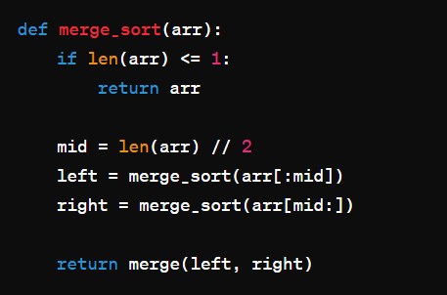
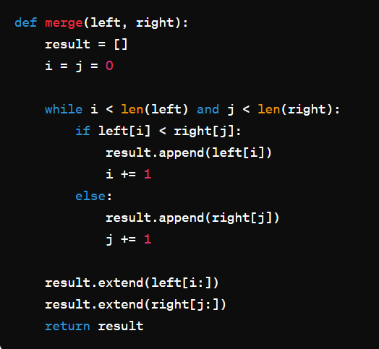
Examples for linear space complexity:
Examples of algorithms or data structures that occupy linear space in Python involve scenarios where the space usage grows linearly with the input size. Here are a few examples:
1) linear search
2) Array or List:
- The space complexity of a standard Python list or array is O(n), where 'n' is the size of the list. Each element in the list occupies space, and the overall space usage scales linearly with the number of elements.
3) Queue (Using Lists):
- Implementing a queue using a Python list has a space complexity of O(n), where 'n' is the number of elements in the queue.
4) String Concatenation:
- Concatenating strings in Python using the + operator creates a new string, and the space complexity is O(n), where 'n' is the total length of the concatenated strings.
5) Linear Time and Space Algorithm:
- Some algorithms may have a linear space complexity due to their nature, even if the time complexity is also linear. For example, counting occurrences of elements in a list.
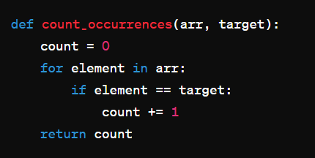
Examples for quadratic space complexity:
Nested Lists:
Creating a nested list or a 2D list where each element is a list results in quadratic space complexity. The space required is proportional to the product of the number of rows and columns.
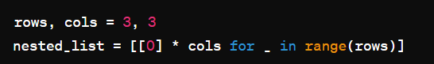
Matrix Representation:
Storing a matrix using a 1D list with indices calculated based on the row and column can lead to quadratic space complexity.
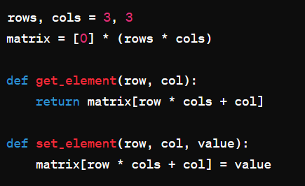
String Concatenation in a Loop:
Repeatedly concatenating strings inside a loop can result in quadratic space complexity due to the creation of new strings at each iteration.
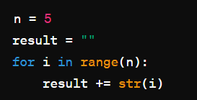
Examples for linearithmic space complexity:
1) merge sort
2) Heap Sort:
Heap Sort is another sorting algorithm that achieves O(n log n) time and space complexity. It builds a max-heap or min-heap data structure.
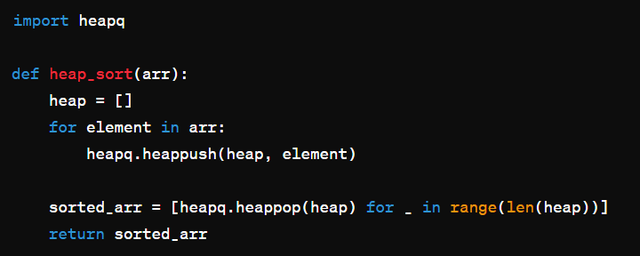
3) QuickSort with Tail Recursion Optimization:
While the classic implementation of QuickSort has O(log n) space complexity, you can optimize it to O(n log n) by using tail recursion optimization. This approach is not the default in Python.
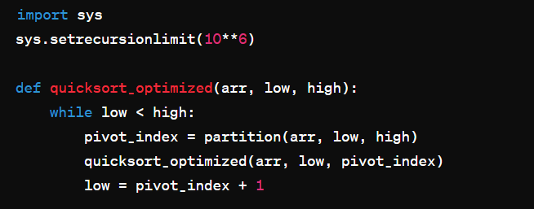
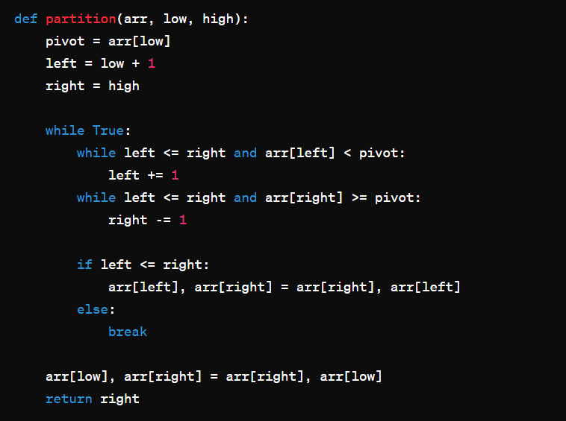
MODULE FOR EVALUATIING MEMORY
In Python, the memory_profiler module is commonly used for evaluating memory usage in a program. This module provides tools for monitoring memory consumption of functions or entire scripts. It is particularly useful for identifying memory leaks or optimizing memory usage.
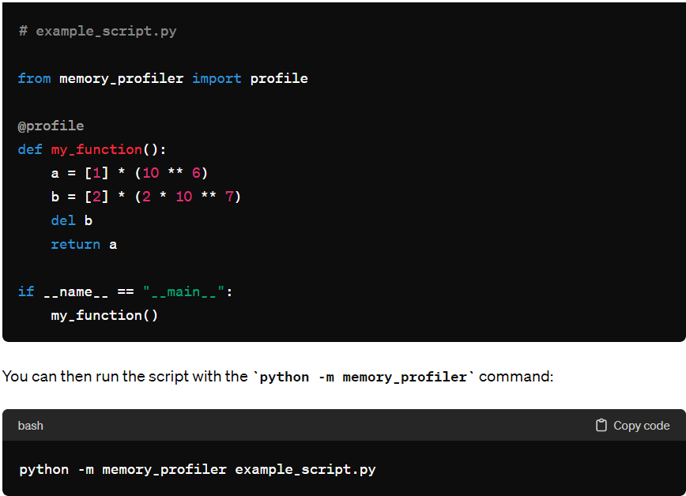

TIME COMPLEXITY IN PYTHON
Time complexity is a measure of the computational efficiency of an algorithm, expressing how the runtime of an algorithm or function grows as the size of the input increases. It is typically expressed using big O notation. Time complexity describes the upper bound on the growth rate of the algorithm's runtime as a function of the input size.
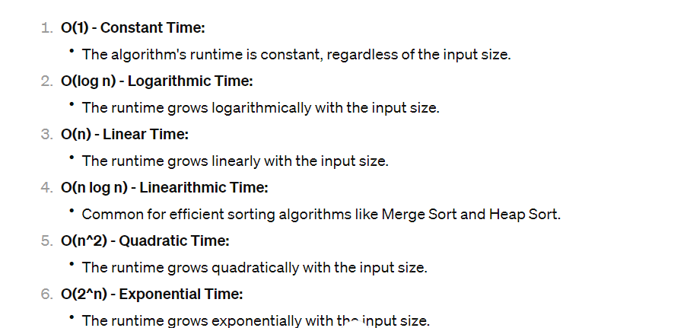
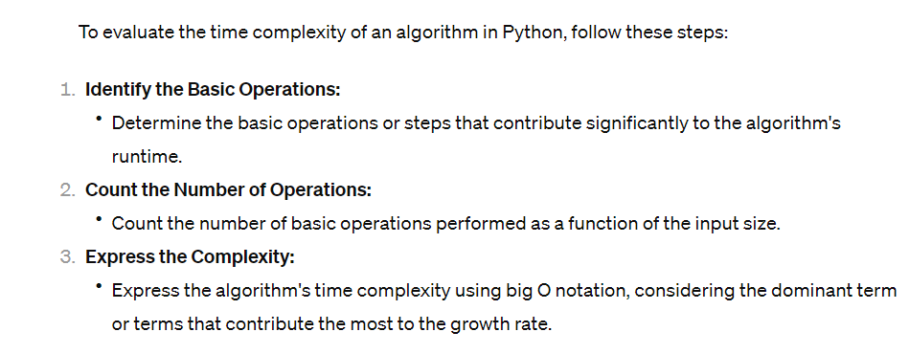
Examples for exponential run time case:
Examples of algorithms or scenarios where the runtime grows exponentially in Python include situations where the number of operations increases significantly with each additional element in the input. Exponential time complexity is often associated with recursive algorithms that make repeated, inefficient calculations. Here are a few examples:
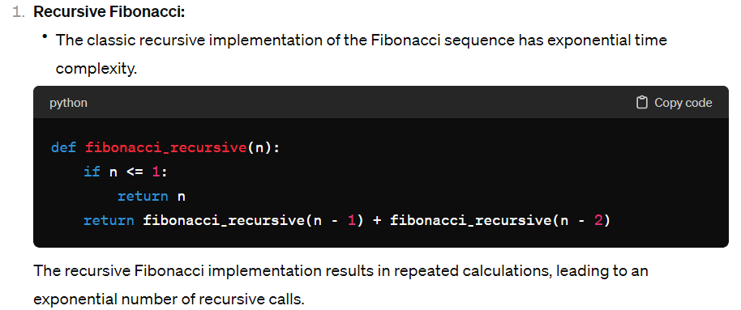
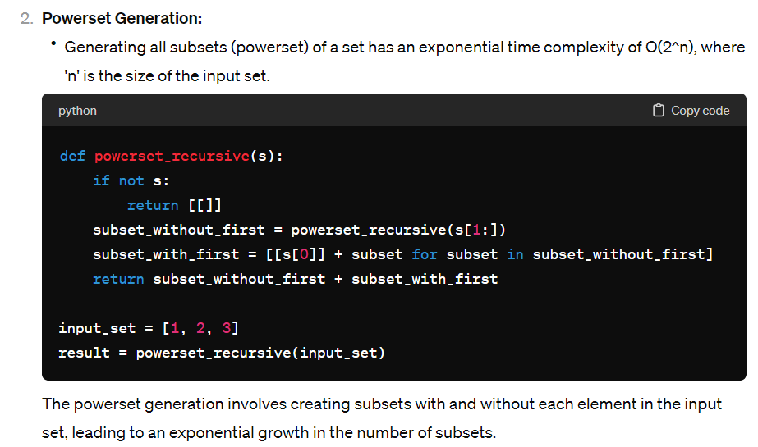
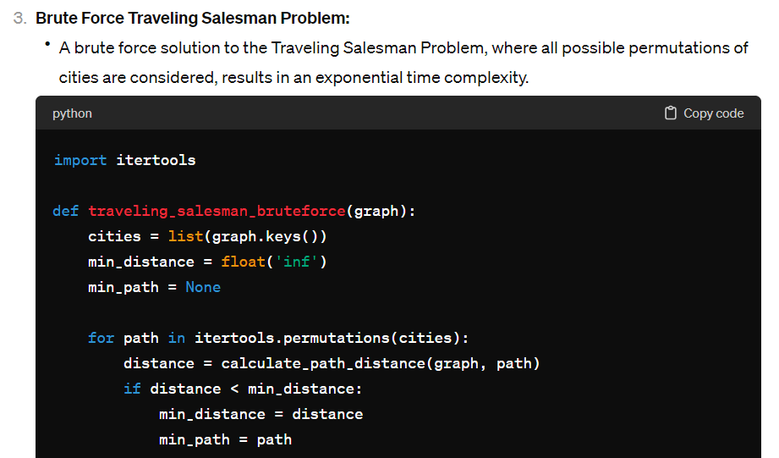
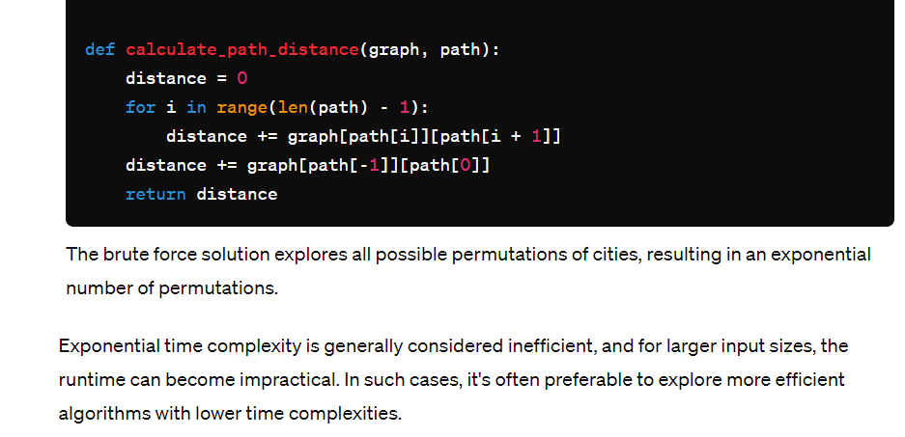
Examples for quadratic run time case:
Quadratic time complexity (O(n^2)) is often associated with algorithms that involve nested iterations or comparisons between each pair of elements in the input. Here are a few examples in Python where quadratic time is consumed for code execution:
1) bubble sort
2) selection sort
3) naïve string matching
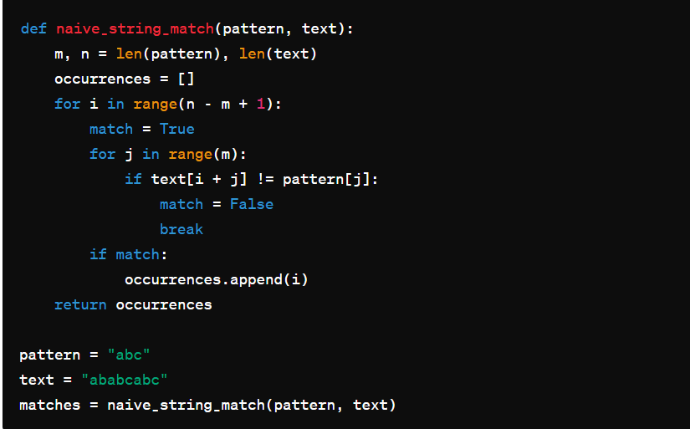
DIFFERENT COMPONENTS IN PYTHON MEMORY MANAGEMENT
Python memory management involves several components that work together to allocate and deallocate memory efficiently. Here are the key components:
Memory Manager:
- The memory manager is responsible for managing the allocation and deallocation of memory for Python objects. It includes a dynamic memory allocator that handles requests for memory allocation during the program's execution.
Memory Pool:
- Manages the allocation of small chunks of memory for objects of the same size. Memory pools help reduce fragmentation and improve the efficiency of memory allocation by organizing memory into pools of fixed-size blocks. Python has separate memory pools for small objects and large objects.
Object Allocator:
- The object allocator is responsible for allocating memory for Python objects. It works in conjunction with the memory pool to efficiently allocate memory chunks of appropriate sizes for different types of objects.
Reference Counting:
- Python uses reference counting as a garbage collection mechanism. Each object has a reference count associated with it, representing the number of references to that object. When the reference count drops to zero, the memory occupied by the object is considered eligible for garbage collection.
Garbage Collector:
- The garbage collector is responsible for reclaiming memory occupied by unreferenced objects. In addition to reference counting, Python has a cyclic garbage collector that can identify and collect objects involved in cyclic references (cases where objects reference each other in a cycle).
Automatic Memory Management:
- Python employs automatic memory management, which includes reference counting and garbage collection. Automatic memory management helps ensure that memory is reclaimed when it is no longer needed, reducing the risk of memory leaks.
Memory Fragmentation Mitigation:
- To mitigate memory fragmentation, Python employs strategies such as compacting memory blocks and using different memory allocators. The memory manager is responsible for handling memory fragmentation issues to maintain efficient memory usage.
Memory Profiling Tools:
- While not part of the core memory management system, tools like memory_profiler and tracemalloc provide a way to profile and analyze memory usage in Python programs. These tools help developers identify memory bottlenecks, leaks, and optimize memory usage.

DIFFERENT MEMORIES IN PYTHON
Stack Memory:
- Python uses a stack to manage function calls and local variables. Each function call adds a new frame to the stack, which is popped when the function returns.
- Local variables and function parameters are typically stored on the stack.
Heap Memory:
- Dynamic memory allocation in Python is handled by the heap. Objects, such as lists, dictionaries, and custom objects, are allocated in the heap memory.
- Memory for objects is allocated and deallocated dynamically during the program's execution.
Code Memory:
- The memory that stores the Python bytecode, which is generated when a Python script is compiled. This memory contains the compiled instructions that are executed by the Python interpreter.
Static Memory:
- This memory is used for static objects, including global variables and constants.
- Global variables persist throughout the program's execution and are stored in static memory.
Memory Pool:
- Python's memory manager uses a pool of memory blocks for small objects. The memory pool helps reduce fragmentation and improves the efficiency of memory allocation for smaller objects.
- The memory pool is managed by the Python memory manager and helps allocate and deallocate memory more efficiently.

ENCAPSULATION IN PYTHON
Encapsulation in Python refers to the concept of restricting access to certain attributes and methods of a class, preventing the direct modification or access outside the class. It helps in creating a well-defined interface for interacting with objects and promotes data hiding.
Private Members:
Private members are denoted by a double underscore (__) prefix before the attribute or method name. They can only be accessed within the class itself, and not from outside the class.
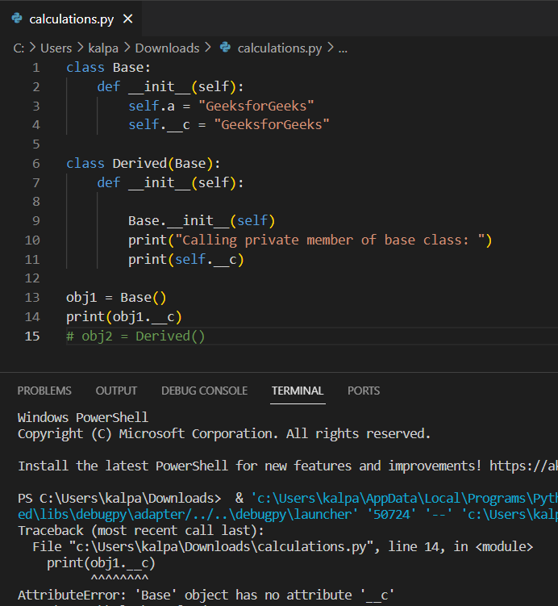
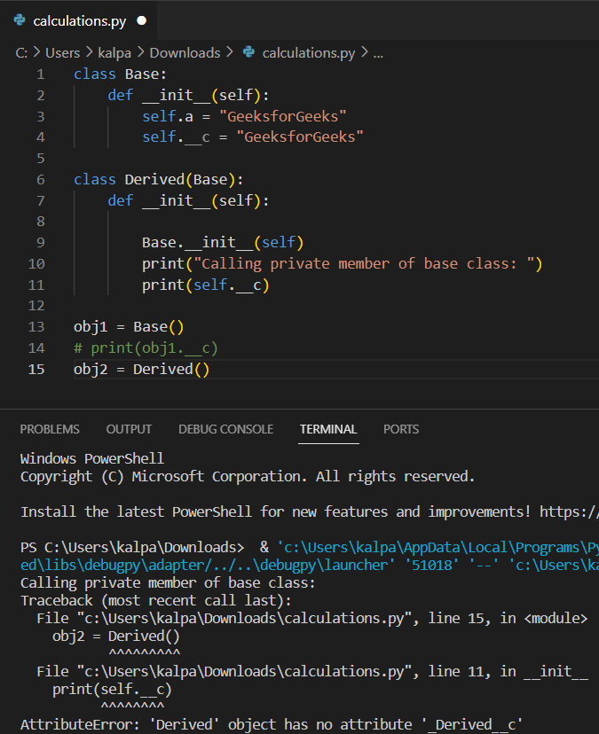
Protected Members:
Protected members are denoted by a single underscore (_) prefix before the attribute or method name. They can be accessed within the class itself and its subclasses (derived classes).
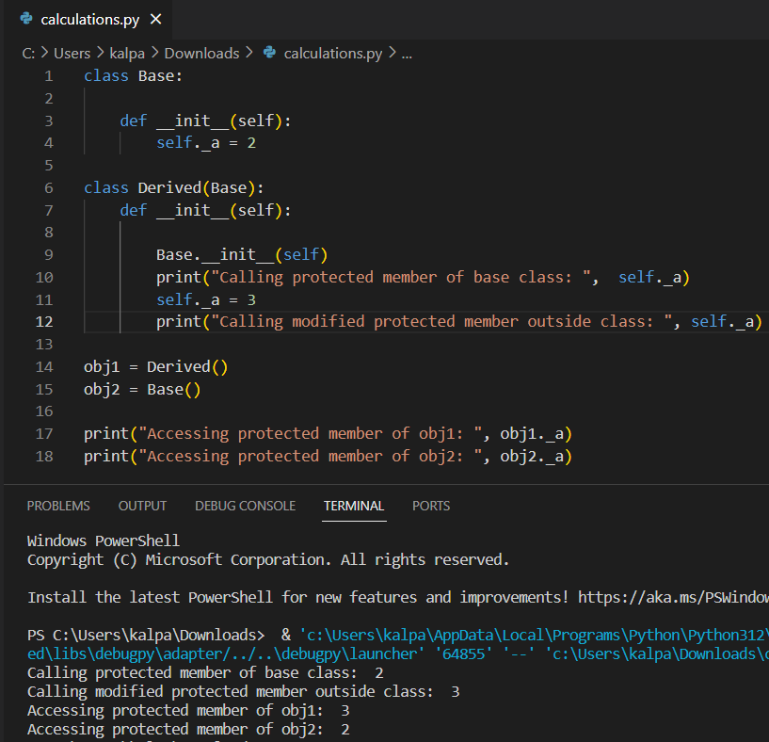
Technically it is still possible to access the protect member but usually no one does this against ethics and though we access and change it in the child class it doesn’t reflect for the parent class while accessing it.
Property Methods:
Property methods allow you to define getter and setter methods for attributes, providing controlled access to them.
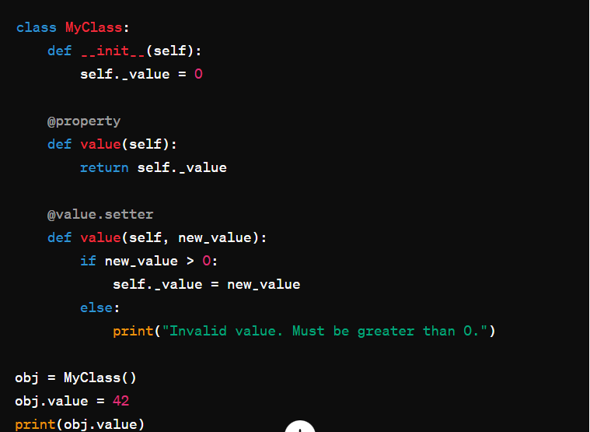

LOGGING MODULE IN PYTHON
Logging levels tell exactly what we want after the execution. It is in 5 levels i.e. debug, info, error, warning and critical.
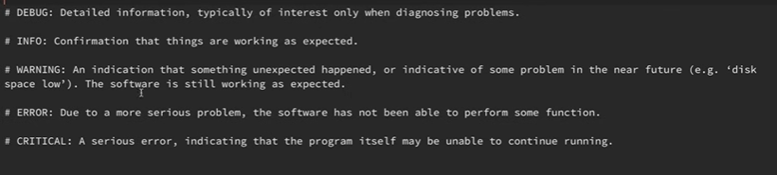
If the default level is set to warning, it will catch everything that is a waring or above
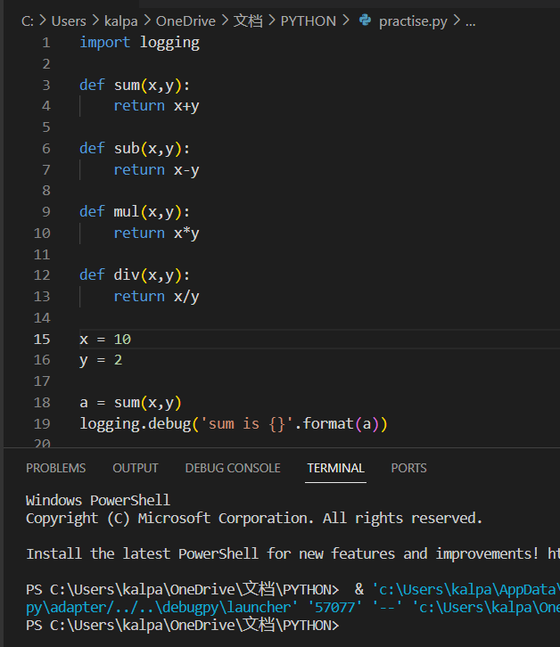
We didn’t get the output with debug
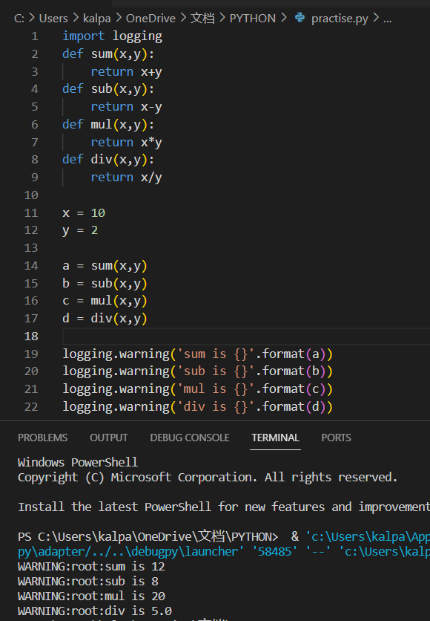
We got the logs in terminal. Right now, we are not using logging correctly because the output is not actually a warning. We really want either DEBUG or INFO as the log lines, so we need to change the log level to DEBUG or INFO. We do this by using basicConfig class.
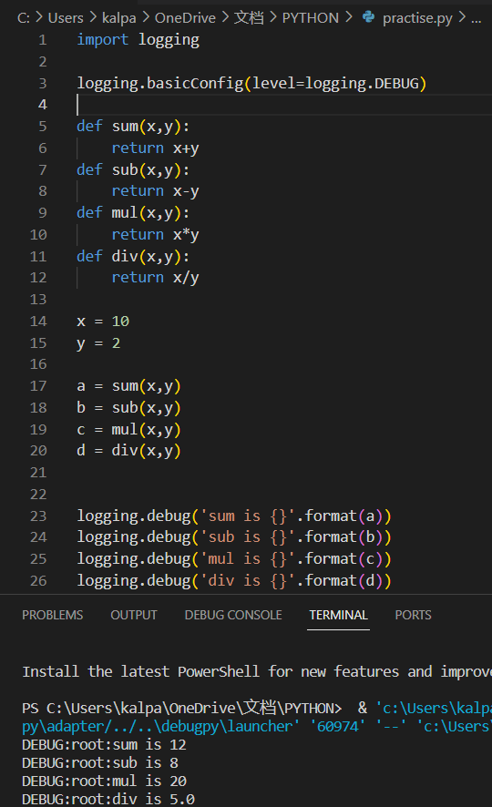
Here the DEBUG is an integer in background (DEBUG = 10, and last CRITICAL = 50)
Log files are the great way to capture the output because it allows us to see log files over a period of time in one place so instead of creating logs in the console let us create the logs in a log file.
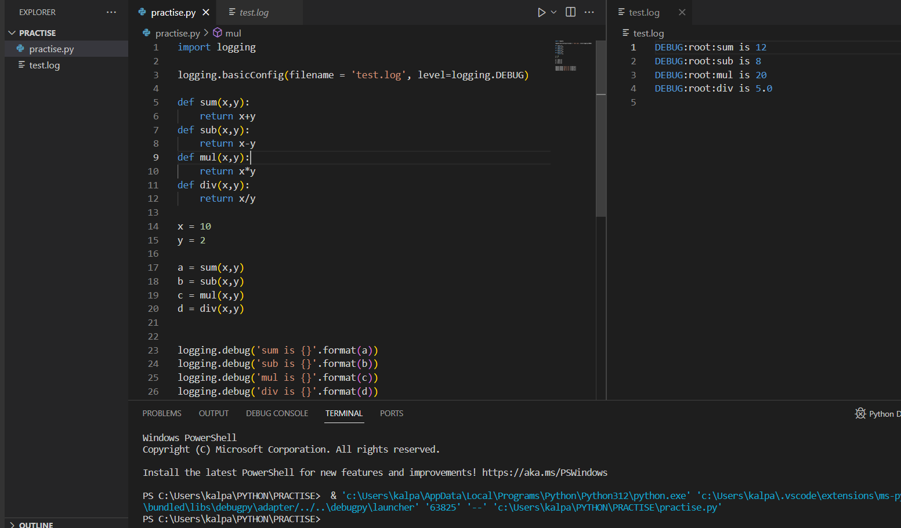
Now we have created a log file and this time. If we see we don’t find logs in terminal but they will be present in log file.
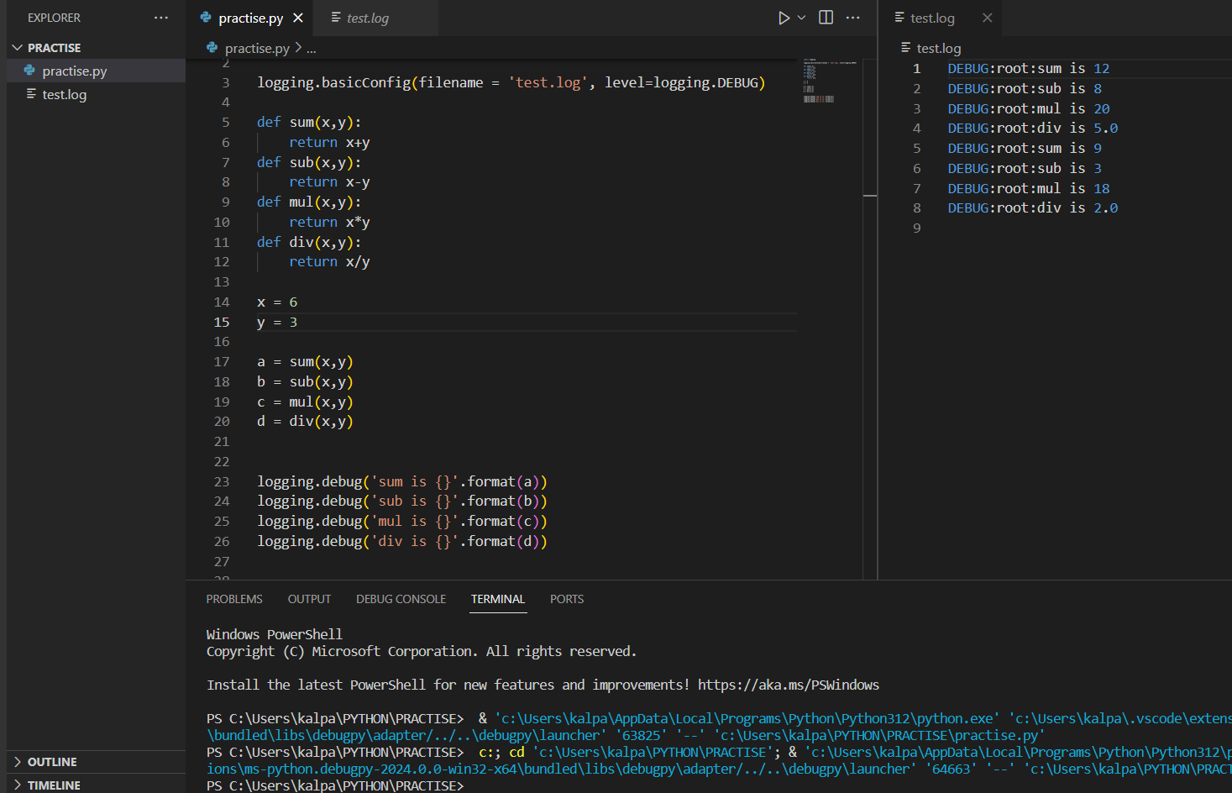
We have changed values in code and run. If we observe now, we can see the previous run logs along with this that makes us difficult to understand which are the current logs. So, to avoid this confusion, we can use log record attributes.
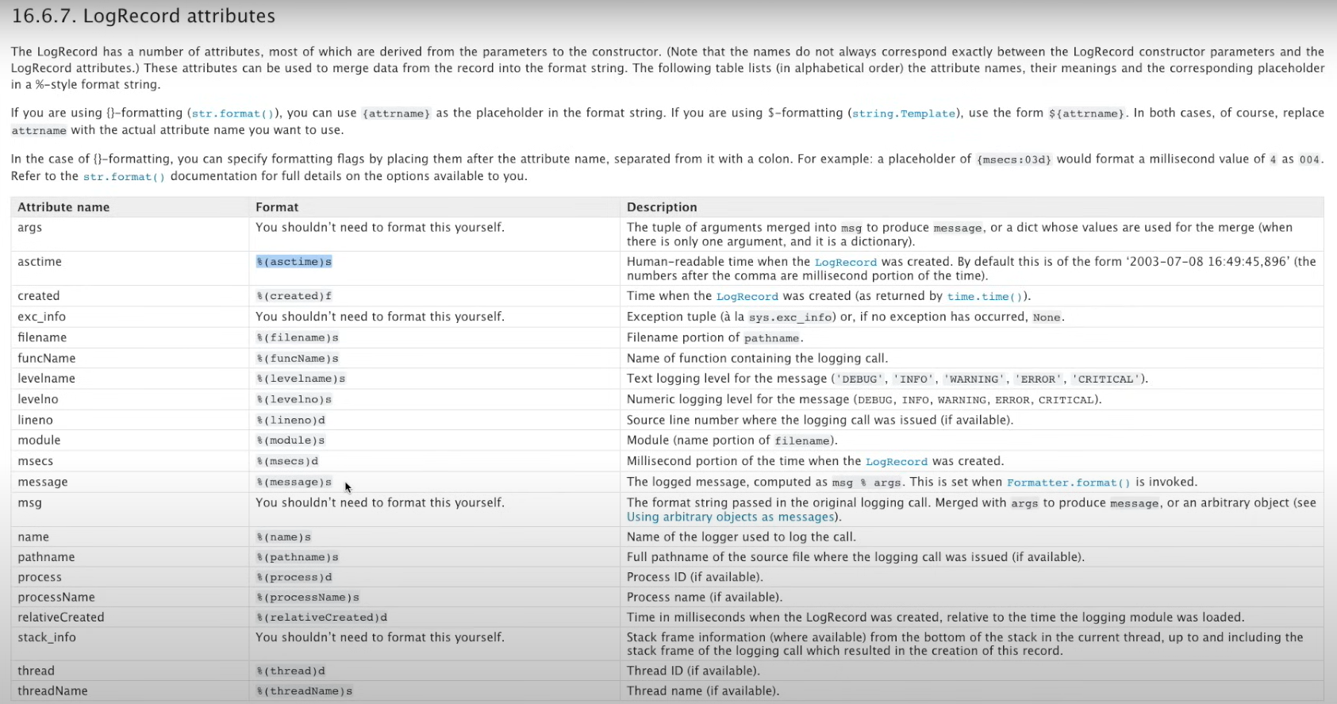
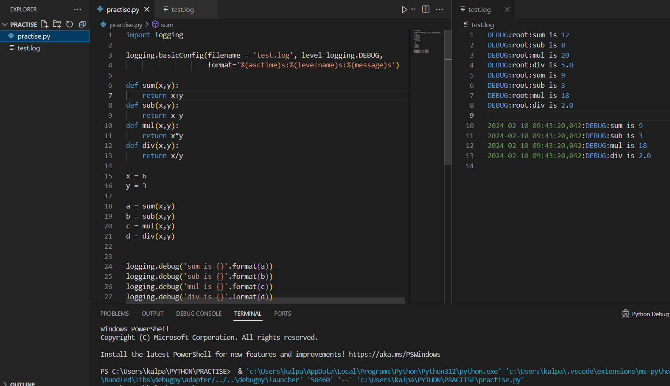
Let us use another file called employee.py and create log file with INFO level
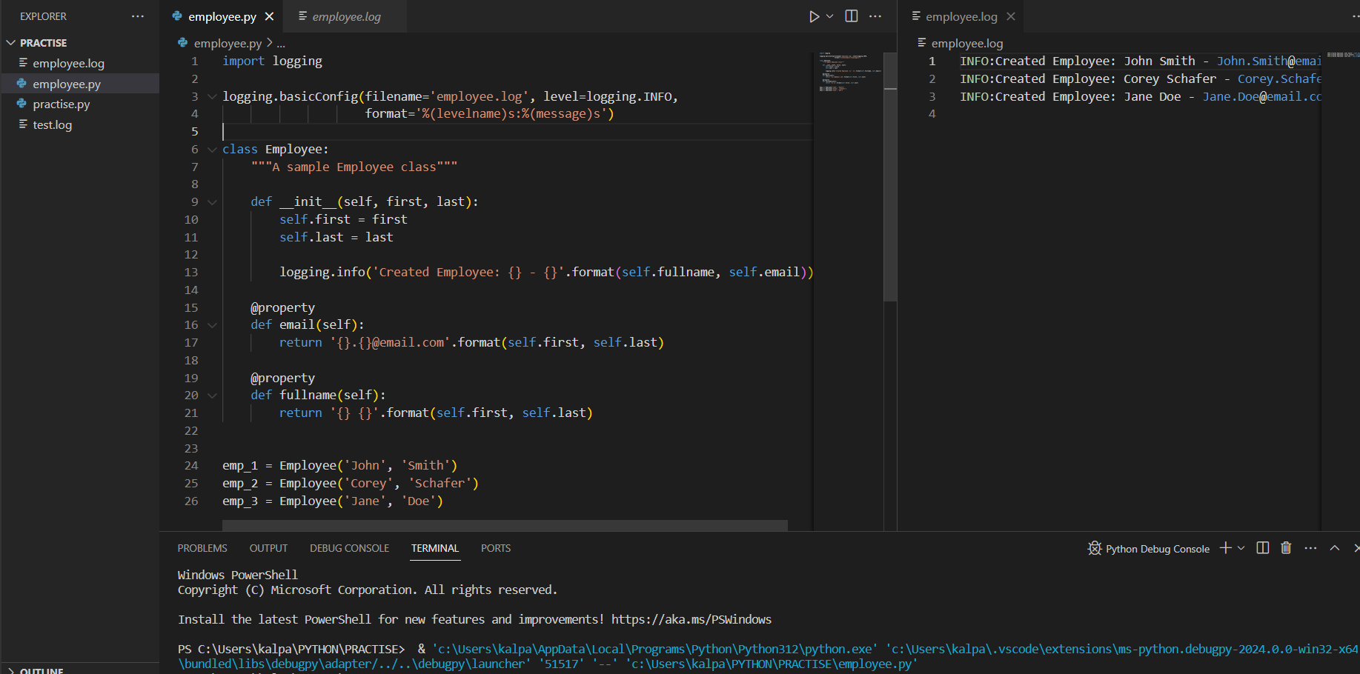
The above logging is good for running a simple file but once we have imports in files it will cause trouble because those modules also try to use same logger. Now, let us look into solving such kind of problems
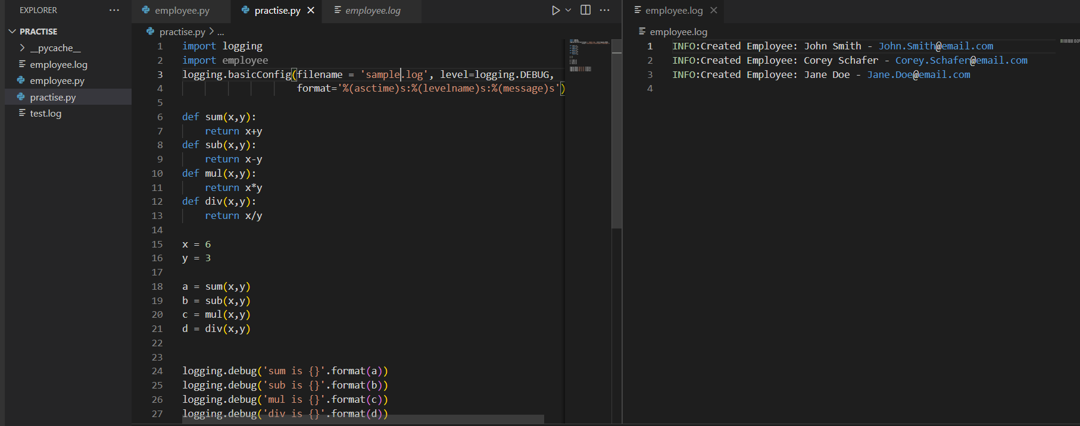
We have imported employee.py in our practice.py but when we run, it has created employee.log file but no sample.log file. This is because, since we set ‘INFO’ level in employee module and importing the employee module before we get to logging set statement in our practice file. The logger we set in employee will get executed as the root logger is set for employee module so we got employee.log file, so the logger set in practice.py can’t override it. Since the root logger is set to INFO in employee, it won’t catch the DEBUG logger set for practice.py. Now, if we change the log to INFO in the practice, we can see them also in employee.log file.
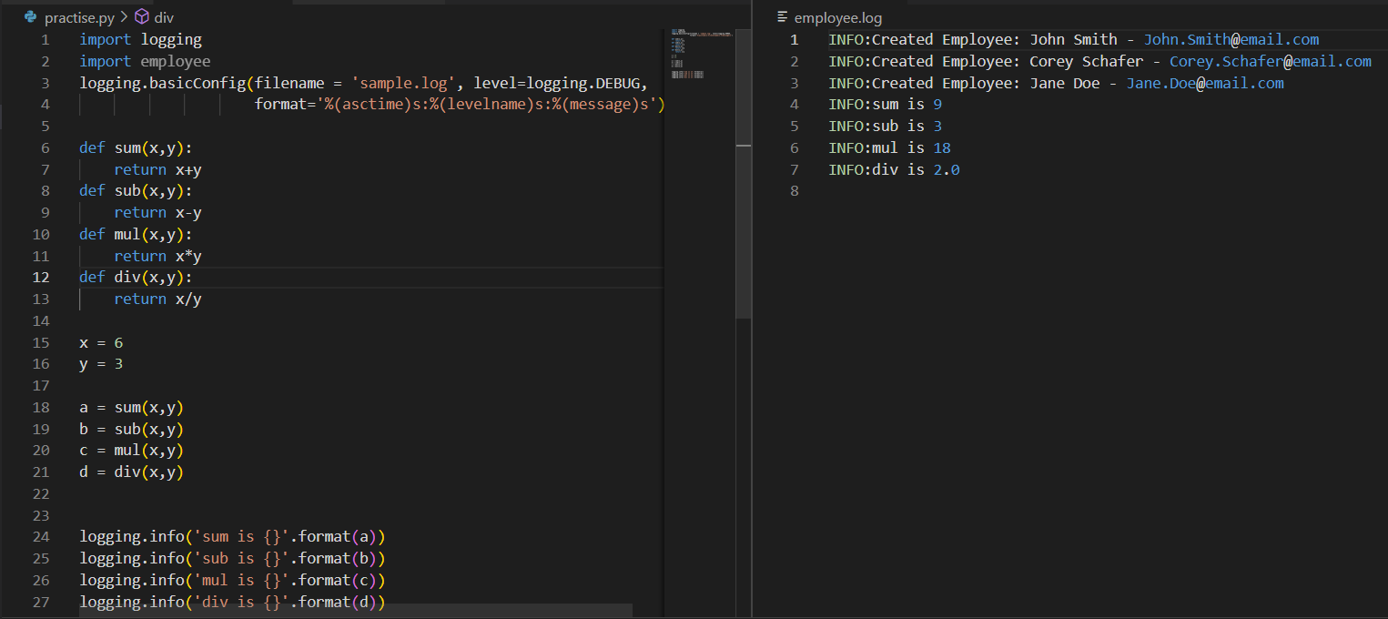
Still, this is a kind of mess so let us create loggers for both of them individually. So, let us create own logger for employee.py file
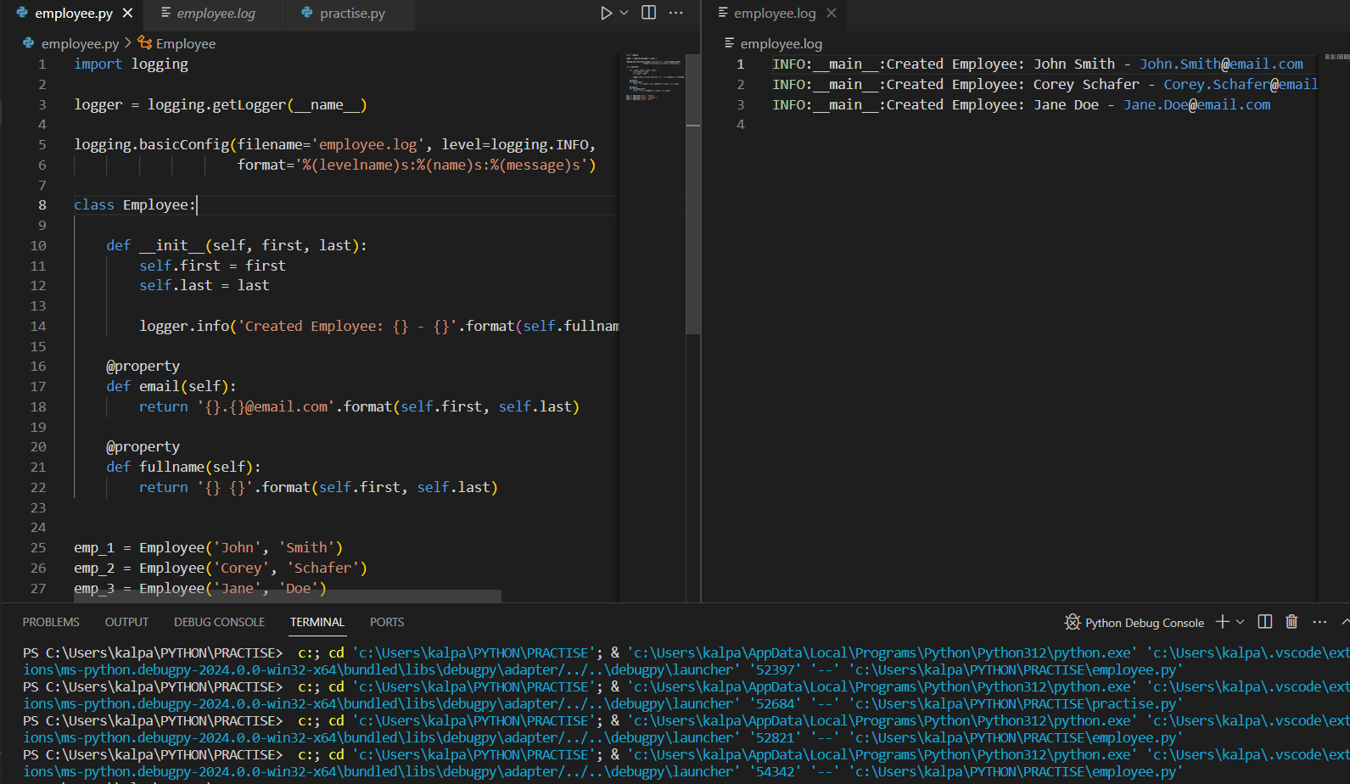
Now we ran employee.py file. See the logs. We got the __main__ in logs.
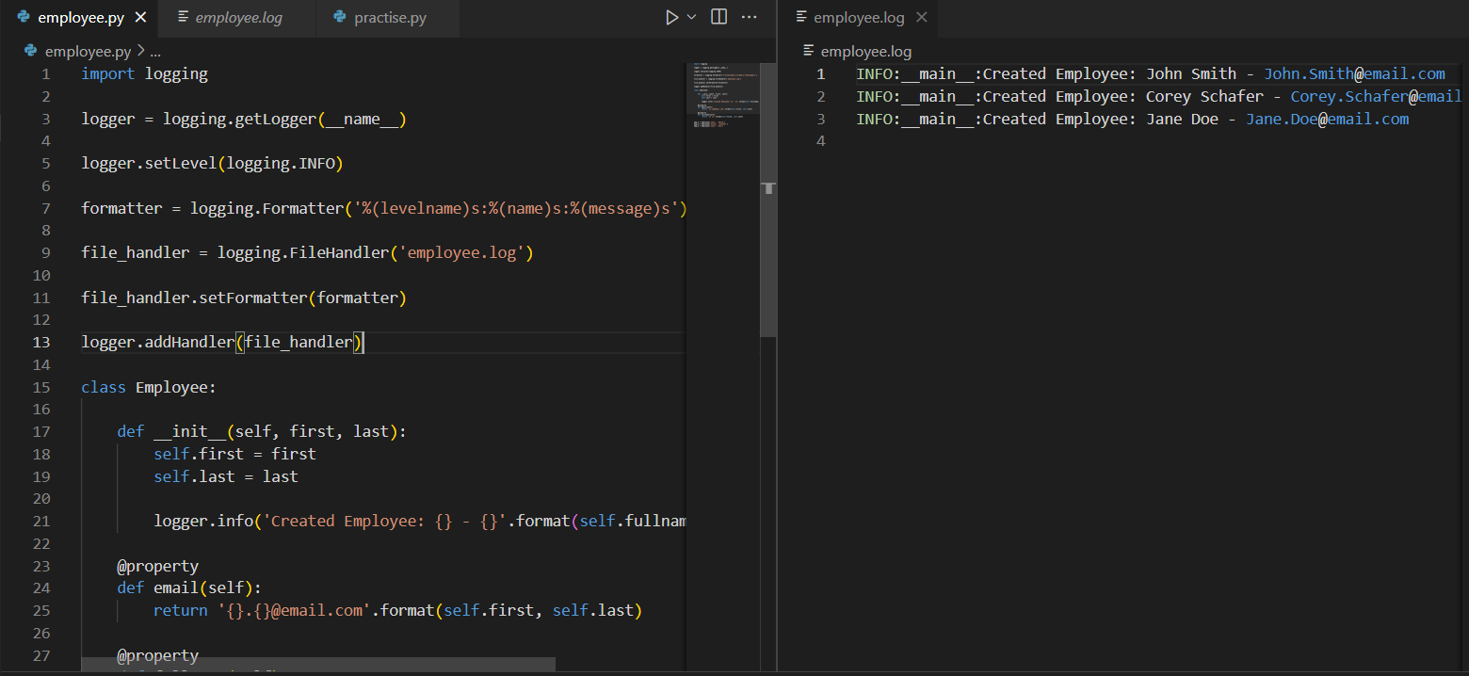
We have set a complete individual logger for employee module and see the output, now let us go back to practice.py and check now with the further modification as we already set individual logger for employee.py
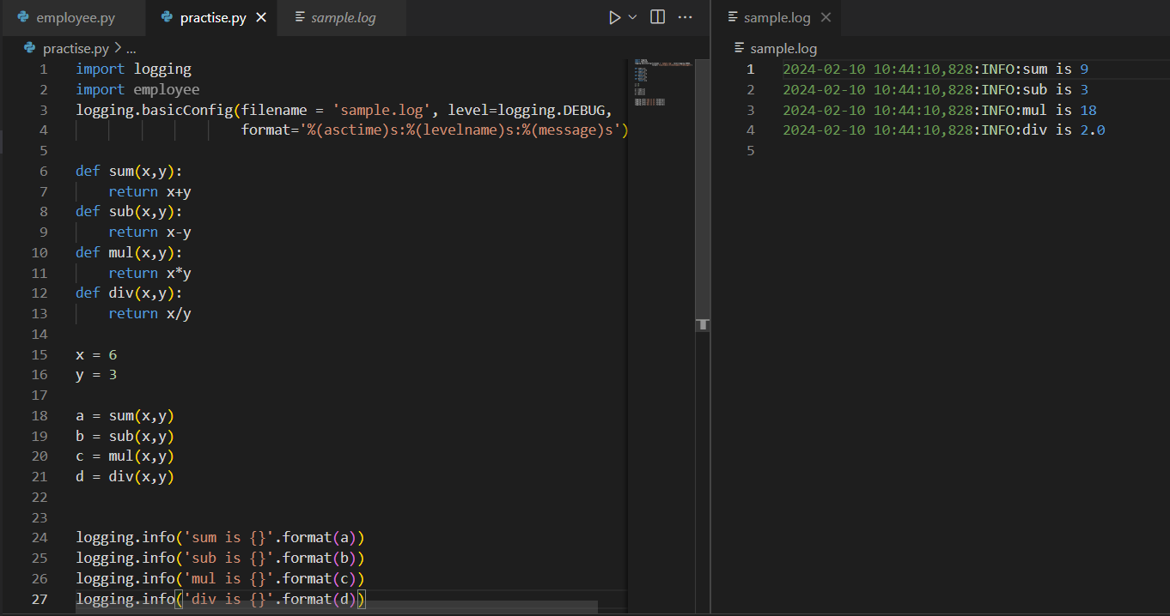
Now if we run our practice file, we get sample.log file now
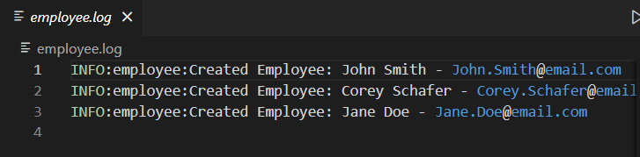
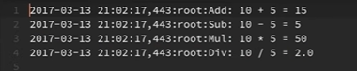
See the difference in both log files, The root logger is yet present in sample logs. So, create own logger for practice file also.
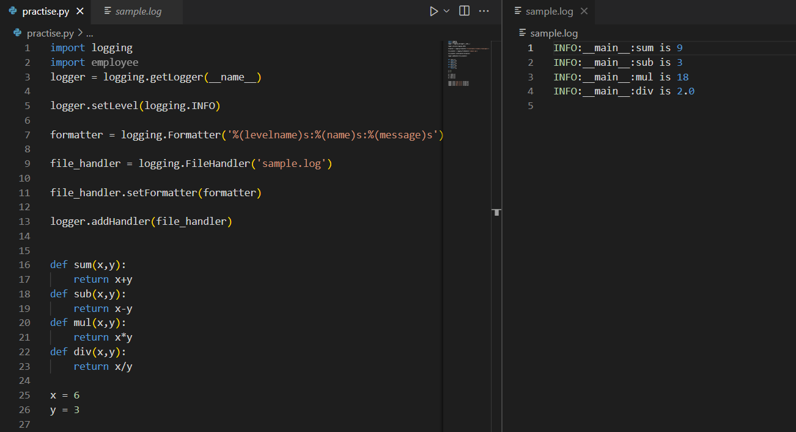
Now, let us say we want to get only if errors are present in logs though we set log level to DEBUG. We can do this by setting the level that we require to file handler.
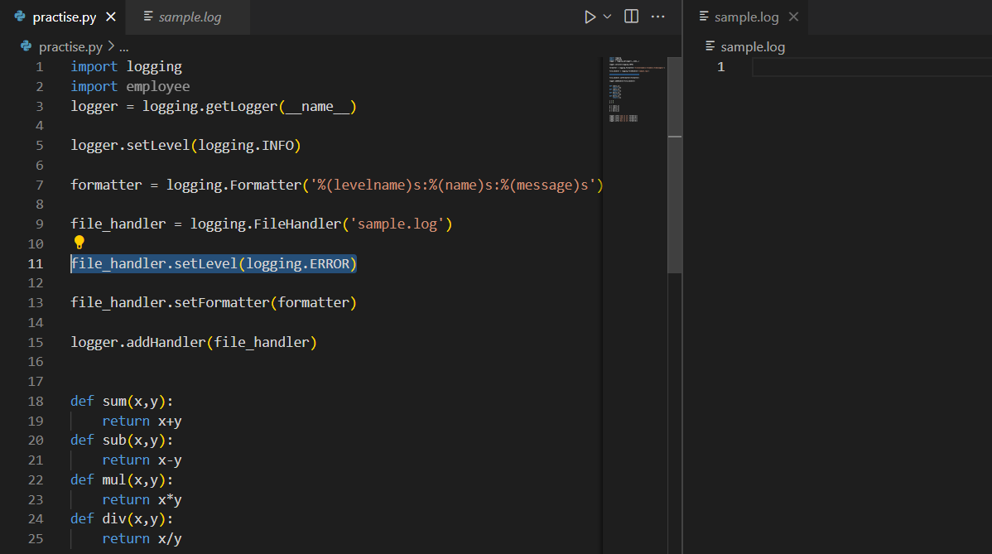
Since we set ERROR for file handler, the file will be empty as there is no error in execution.
Let us do a small modification to our code so we get some error and get it created in the logs
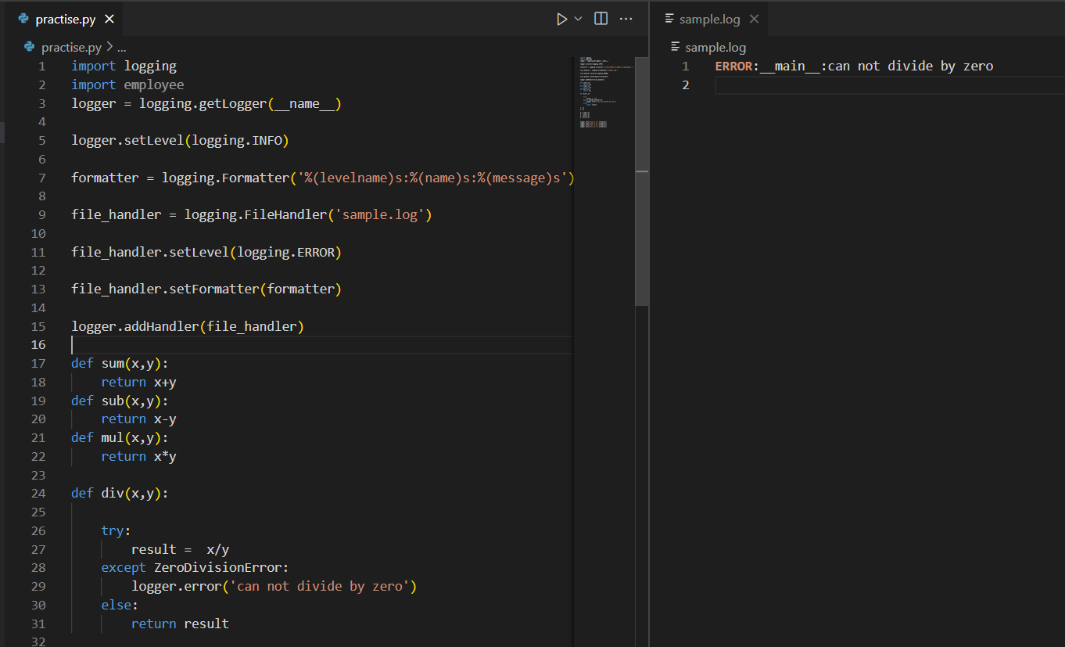
Let us include a traceback which can tell us what exactly happened. Logging allows it by using exception.
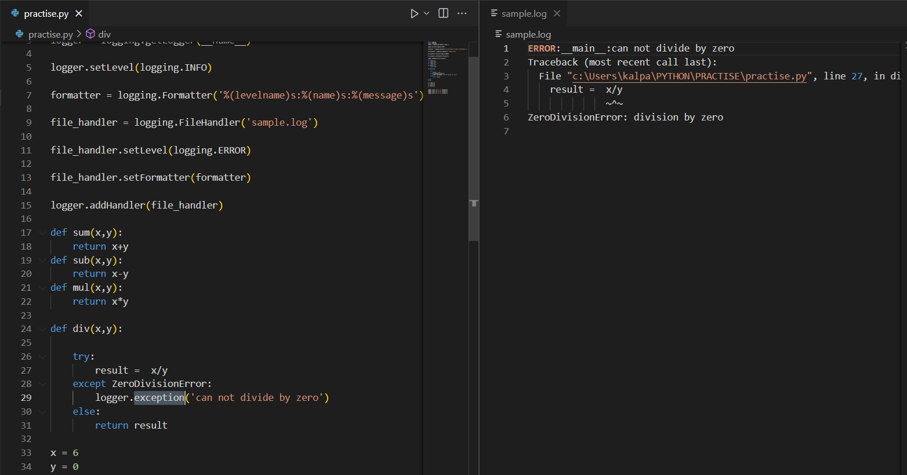
Now, in case we want to see logs in the console instead of creating log files, we can do it by using stream handler
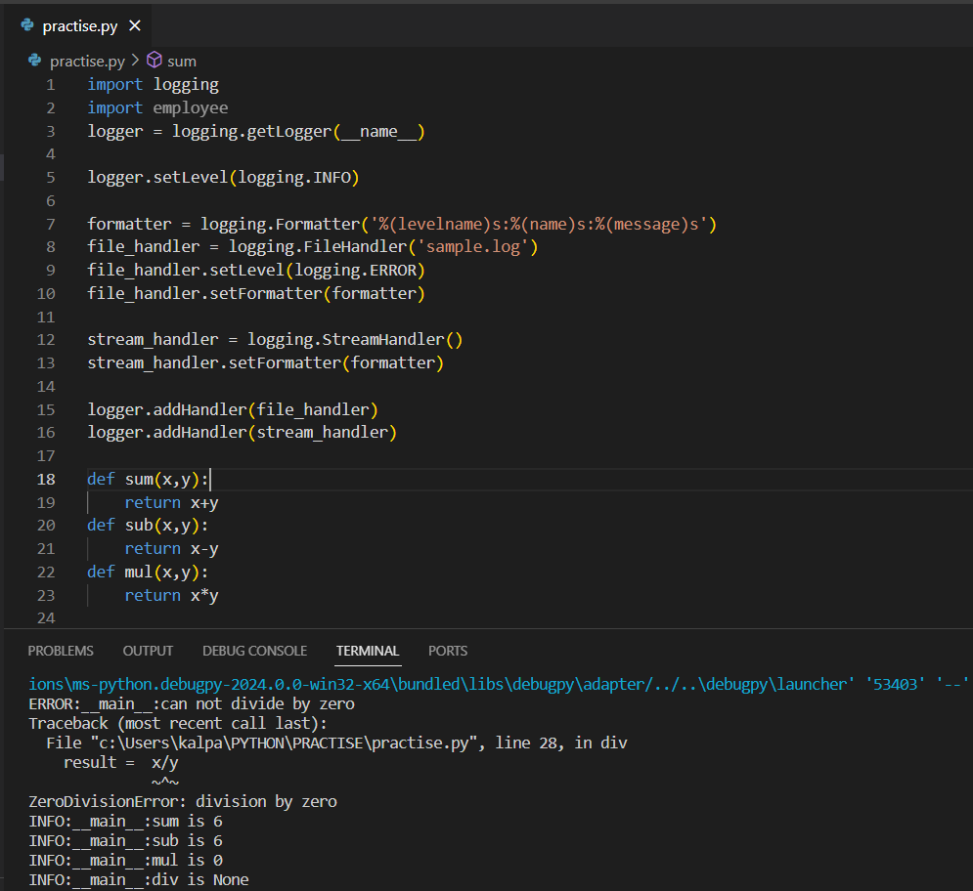
Here, in line no 12, we have not set log level as we already set log level in line 5.
POLYMORPHISM IN PYTHON
Polymorphism in Python refers to the ability of different objects to be treated as instances of a common interface. It allows objects of different classes to be used interchangeably based on a shared interface or a common set of methods. Python supports two types of polymorphism: compile-time polymorphism (method overloading) and runtime polymorphism (method overriding).
PASS BY VALUE VS REFERENCE
In python, both pass by value and reference are different. Pass by value is used with immutables like numeric datatypes, strings, tuples etc. i.e. only the value is passed but not reference(memory) so any changes will reflect only at that instance and while accessing the variable after the instance will give original value in output and in pass by reference, we pass the original object so changes are reflected in original object.
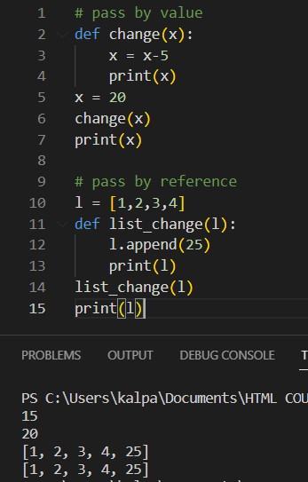
Method overloading
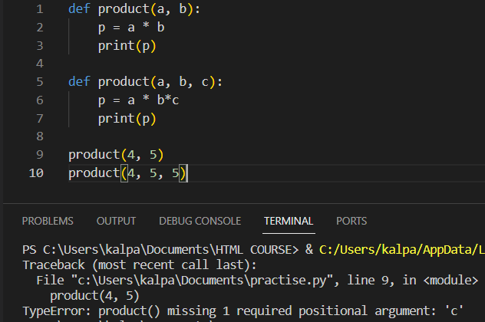
Here we got some error because the two arguments function is overridden by the three arguments function so whenever we try to execute it, it shows error in terminal saying that missing argument.
So, deal with either we can mention the datatypes passed to function and write logic as per need but this is not the efficient one and so multiple dispatch module is used to solve the issue simply
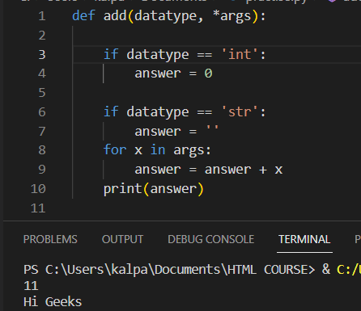

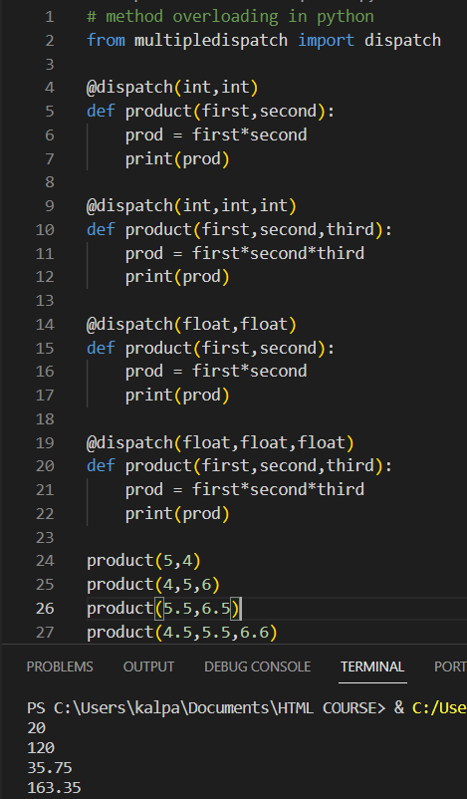

PYTHON REGEX MODULE
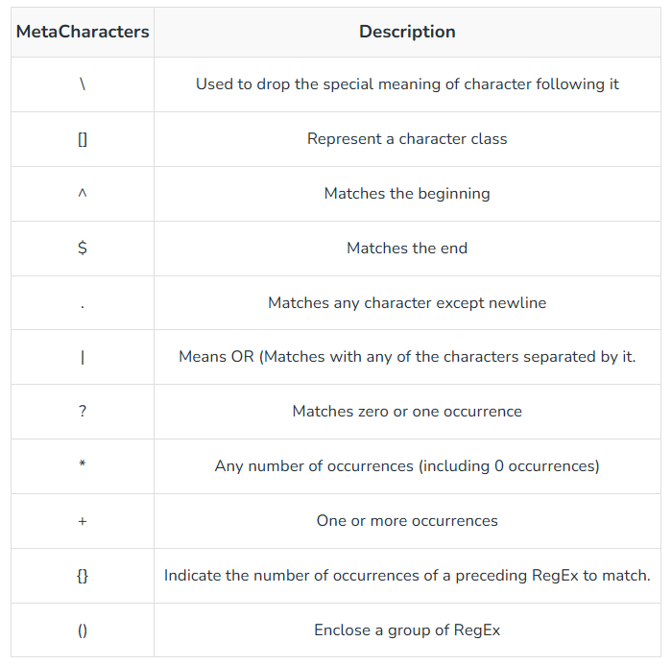
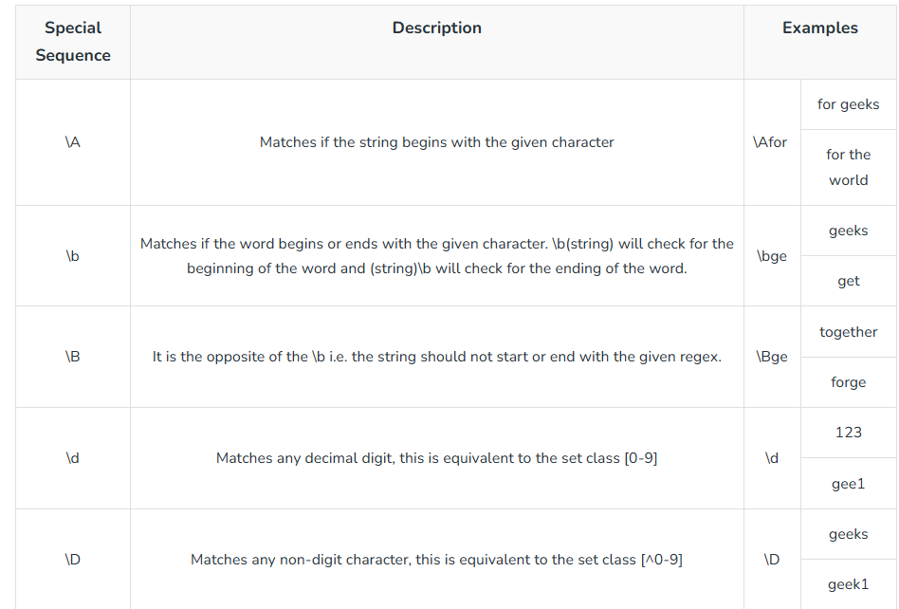
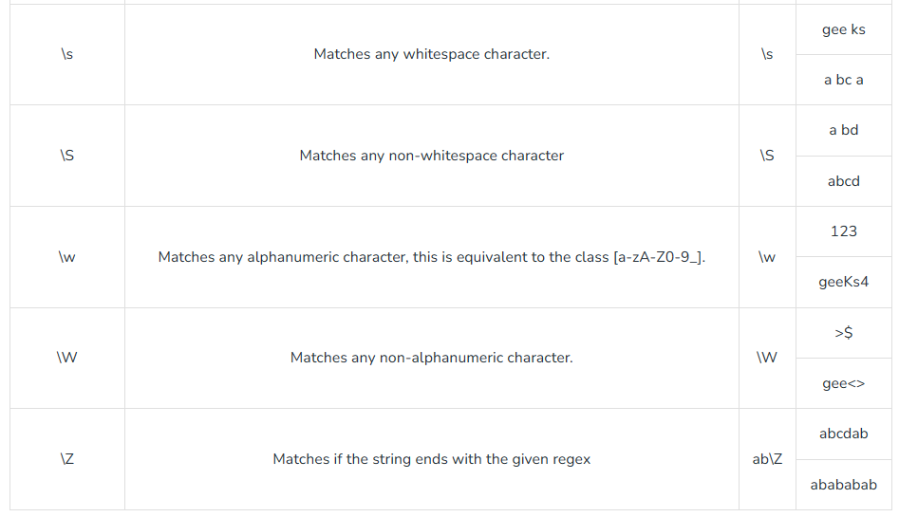
Let us start working with regex module. Here, we are planning to find the matches with a search pattern
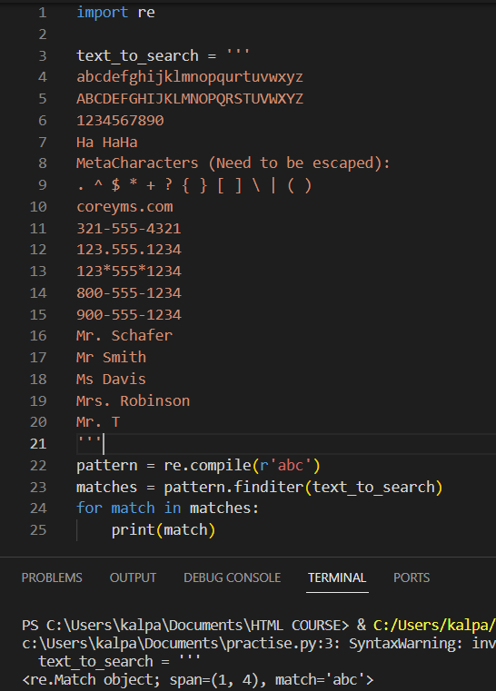
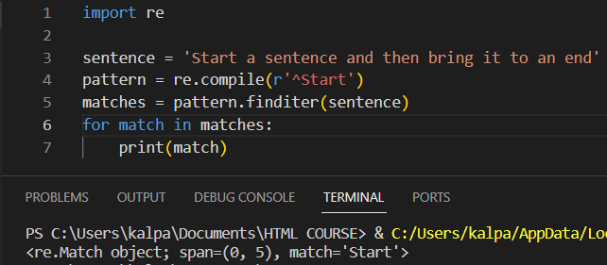
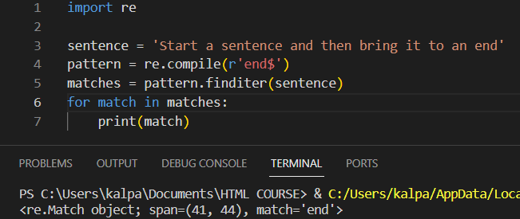
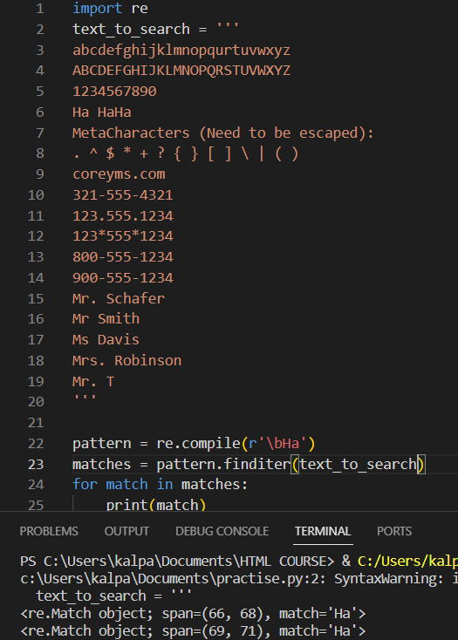
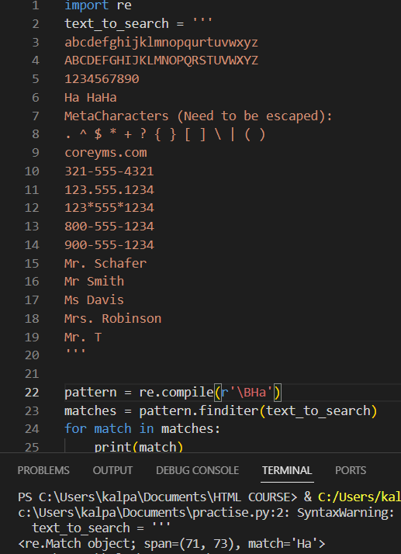
Now let us try to match phone numbers start with 8 or 9 from the data file and let us print the matches.
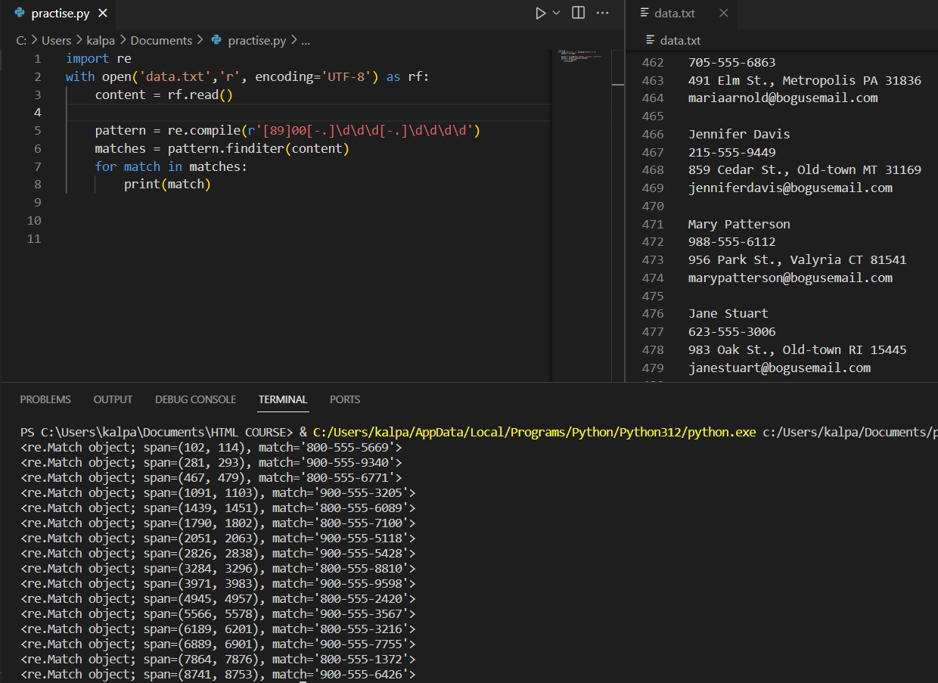
Here, please observe the way to mention the quantifiers.
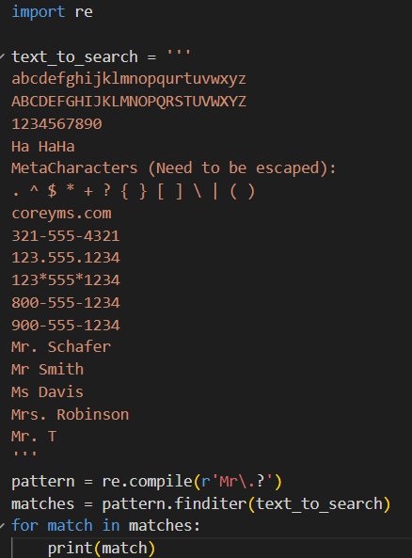
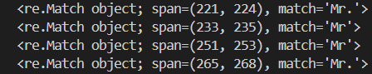
We wanted to match the names start with Mr with or without a period beside them so we used the ? mark for quantifier.

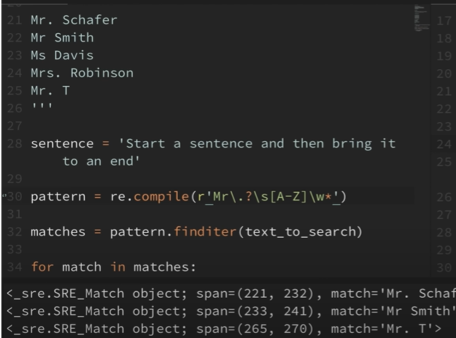
In the above we tried to get names starting with Mr
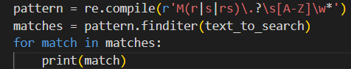
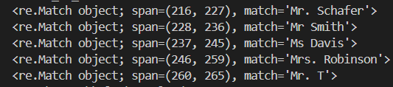
Let us try work out on searching the emails using regex module.
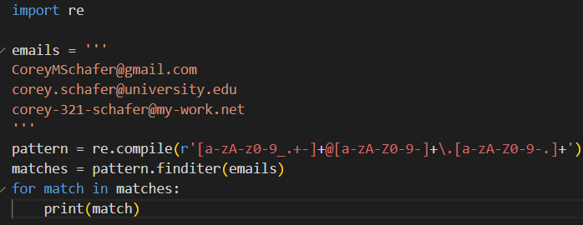
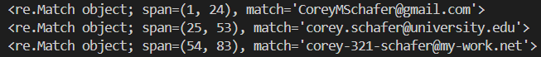

WORKING WITH JSON MODULE IN PYTHON
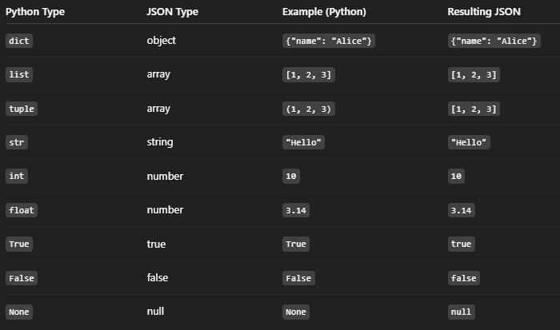
for example:
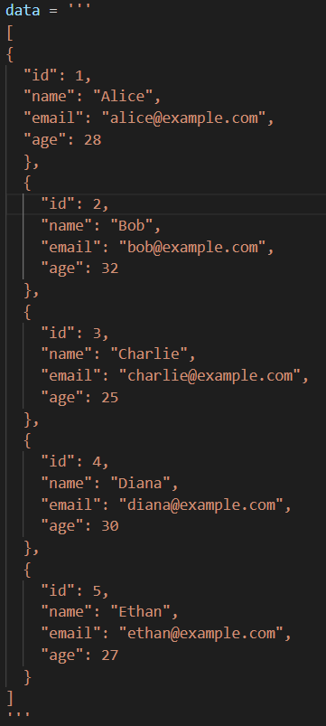
The data is basically a python string that has json array(this array has json objects) so while converting it to json, firstly it’s converted into a python list consisting of dictionaries since json object is converted into python dict as per conversion rule.
We use LOADS method to convert json string object into python dictionary and LOAD to convert json file object into python dictionary or object
We use DUMPS to convert python object to json string and since it is a string output, we can pass indent. We use DUMP for converting python object to json file.
Let us convert a json object to a python dictionary.
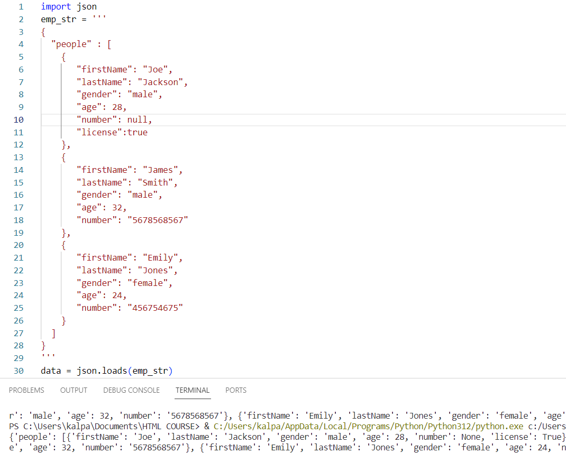
Now the emp_str is a python dictionary.
Since the people in the dictionary is a list, we can loop through and get whatever we want.
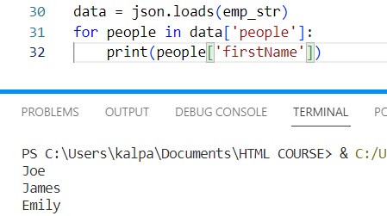
Now let us delete some data from this python dictionary and convert it back to json string
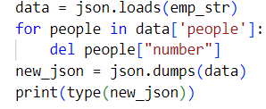
we removed the phone numbers of people and using DUMPS we converted it back to json object. Since the above is a string, we can pass indent, further we can pass sort_keys so the keys come in alphabetic order.
Now let’s work with loading json file into python dictionary and work with them. We have a states.json file here. We opened it and converted it to python dictionary using LOAD after opening the json file. States were having list of objects so they will become dictionaries, we can access the keys
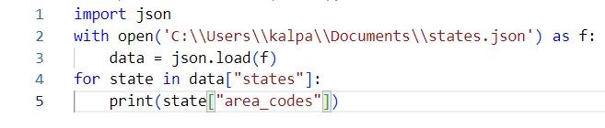
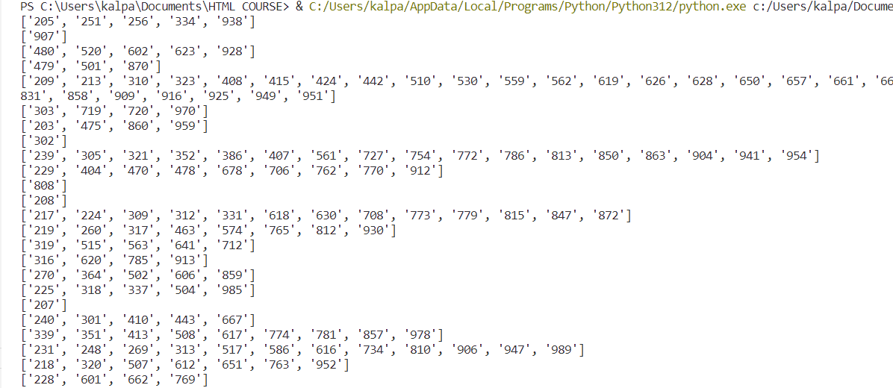
Now let us delete some keys like area code and write it back to a new json file.
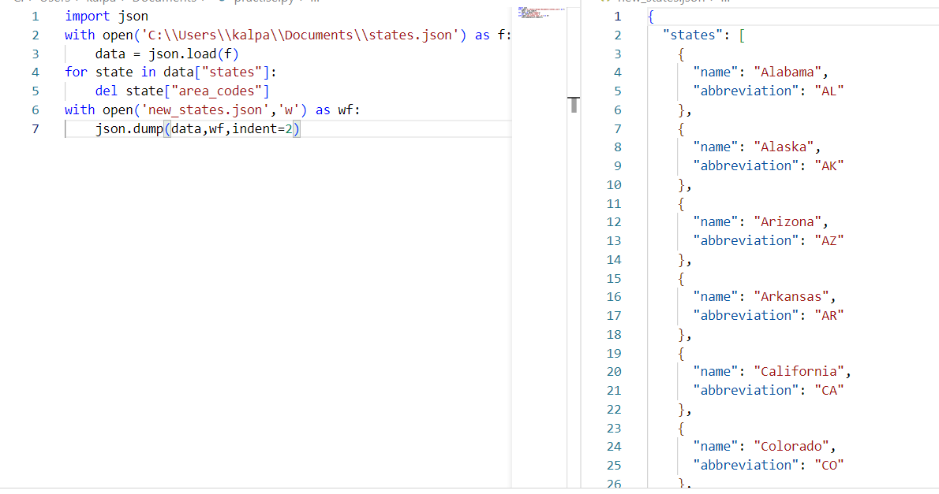
Here we can see that the area codes have been deleted in the new json file.
PYTHON ITERATORS AND GENERATORS
If something is iterable, in general we say we should be able to loop over it. But to say strictly, it should have a __iter__() in it’s directory and if something is an iterator it should have a __next__ in it’s directory
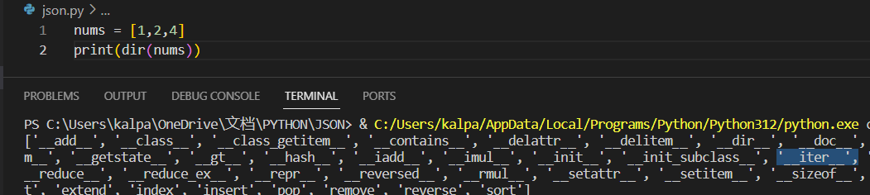
So, whenever we loop over it, the for loop calls the iter() method and creates an object called iterator that remembers it’s state. The iterator gets its next value with __next__ method. A list doesn’t have a next method in it’s dir() so it doesn’t remember the state, this way we can decide whether something is an iterator or iterable.
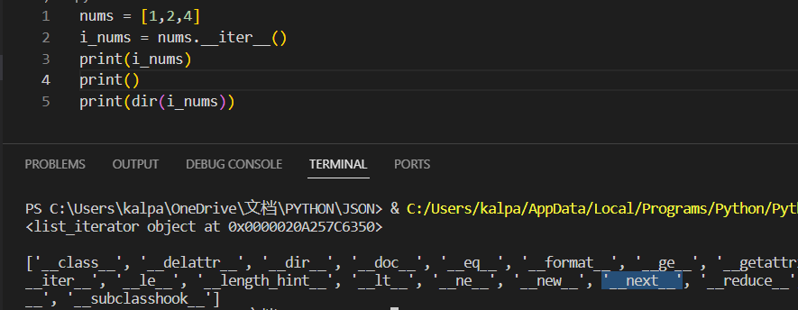
The above is the way the for loop does in the background. Instead of running the __iter__(), we can say iter(nums) which does the same job.
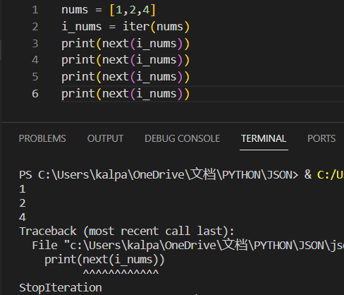
next function to the iterator gives the next values of the iterator. Here we got an error as there is nothing after 3 values.
Example iterator:
let us create an iterator class. To make a class to be iterable, we need to create a __iter__ in it and create a __next__ in it to return something and access the output by calling the class.
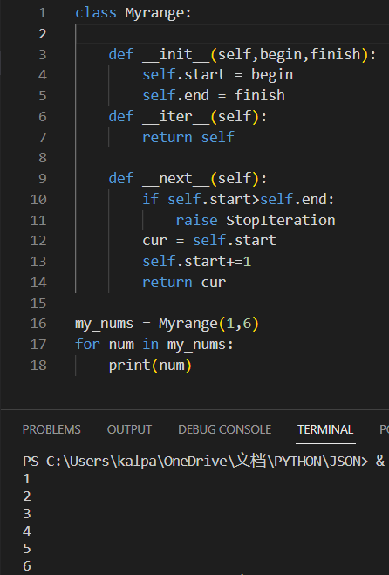
We can go for a for loop in nums or next(nums) to get the next values.
Generator also does the same thing but instead of returning a result, it yields a value. Generators are also iterators, we don’t need to create iter and next methods for it, it will do the job automatically.
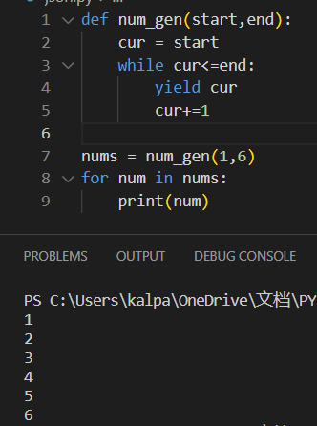
Iterator is a useful concept in case of memory efficiency since it returns only one next value.
Let us use the concept of iterator for getting the words one by one in a sentence using both iterator and a generator concept
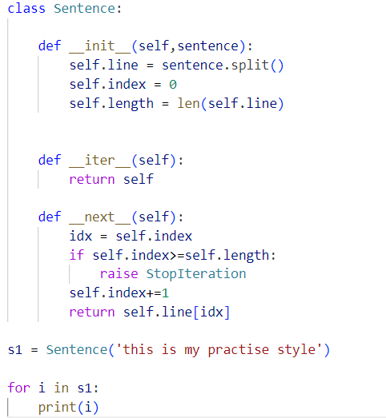
The same code for generator will be as followed and that is so simple
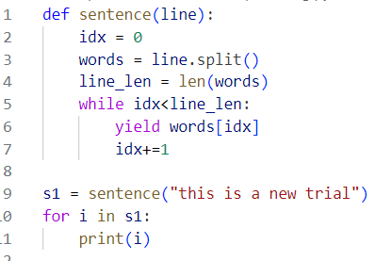
Another very simple way of using generator concept is as followed.
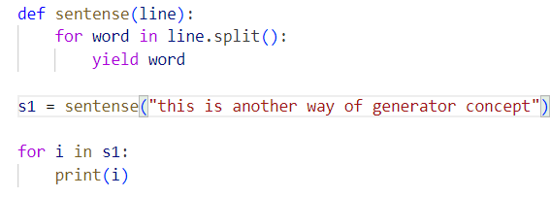
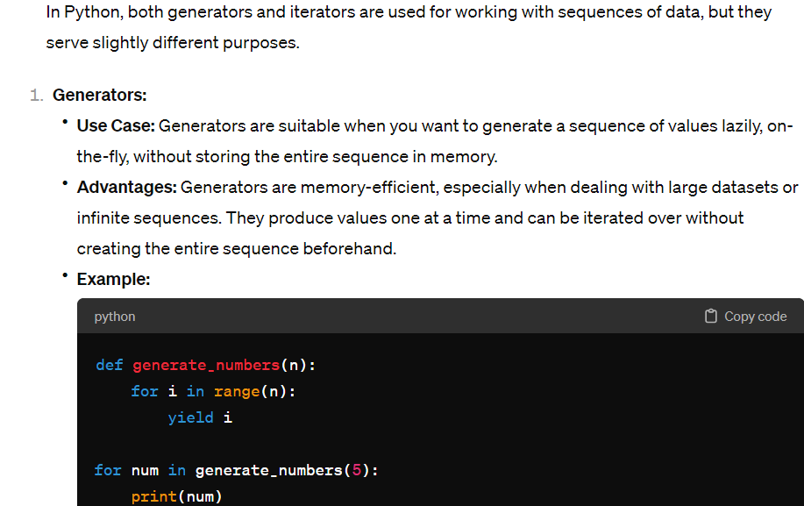
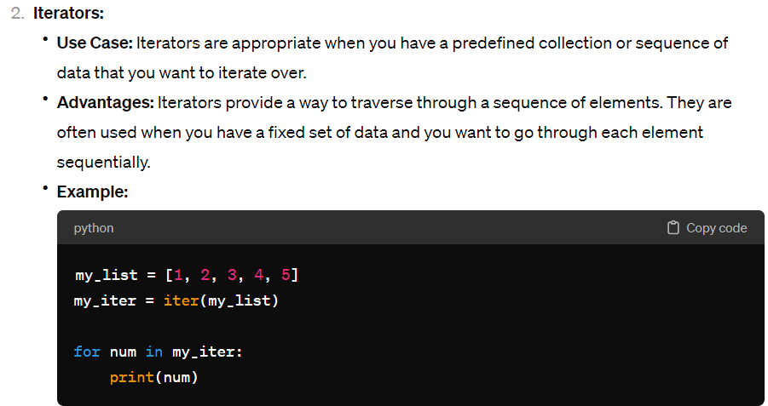
Both iterators and generators are memory-efficient as they produce values lazily. With regards to dealing with infinite dataset we can even write a manual iterator which does same like a generator but generator is syntax friendly(less code).
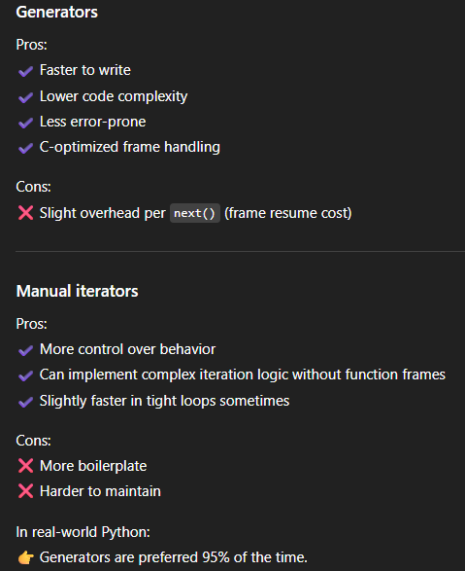
Let us take processing a huge file data as a simple use case and apply all and let us know the differences among usage of them.
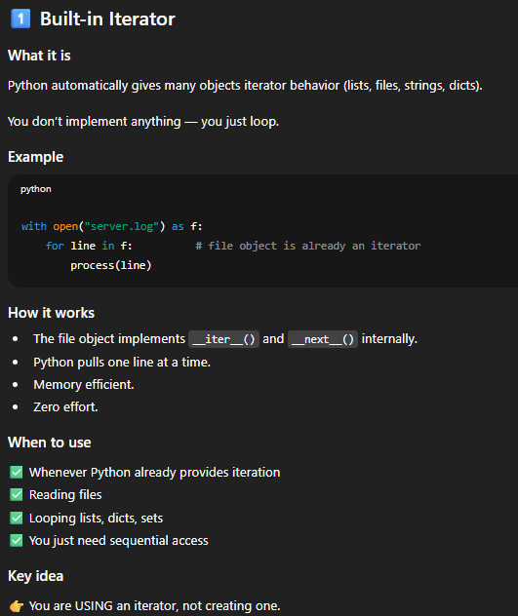
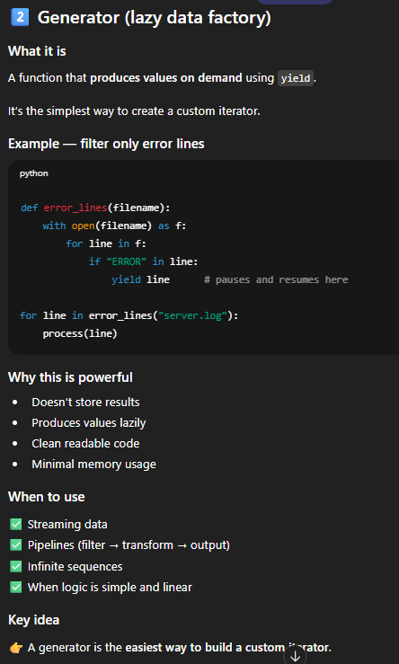
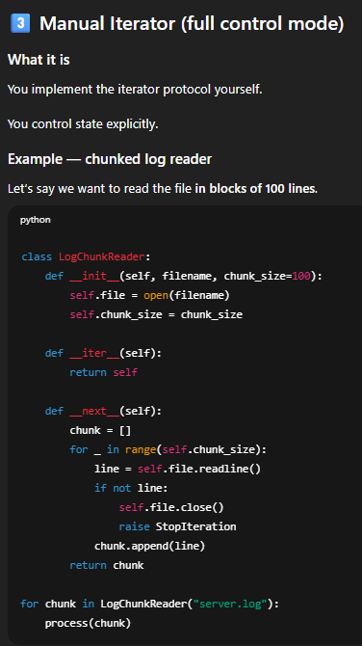
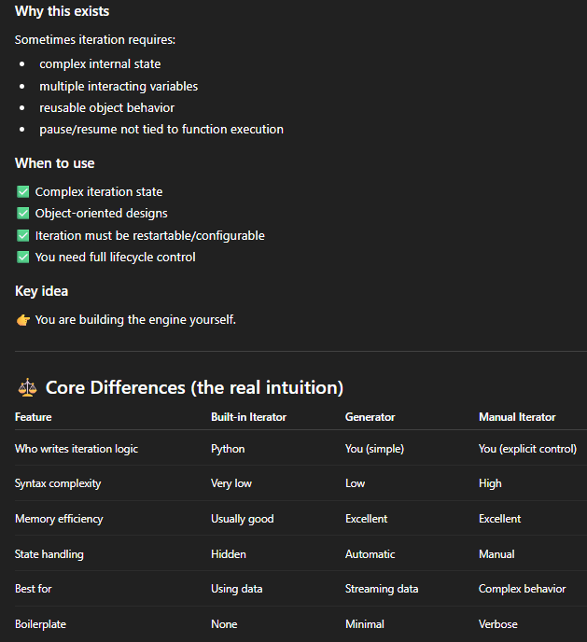
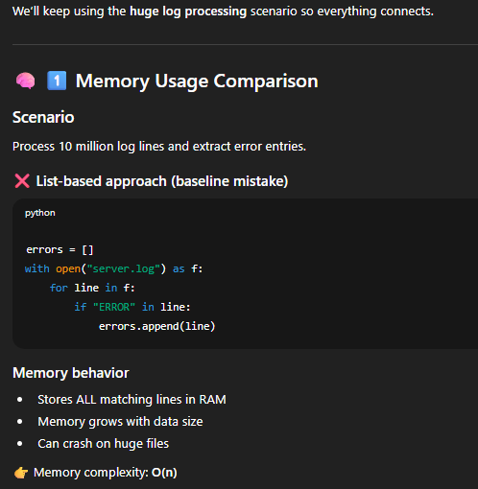
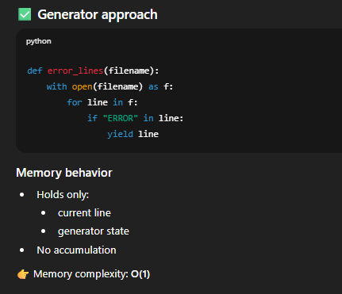
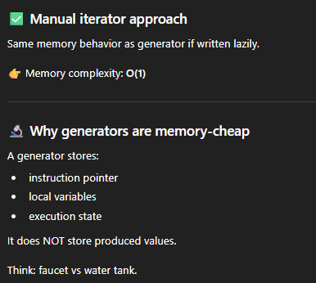
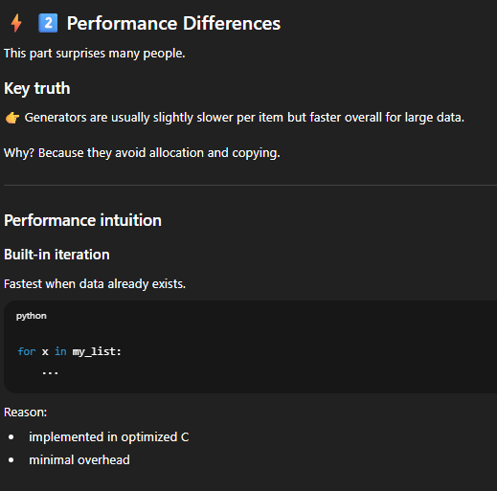
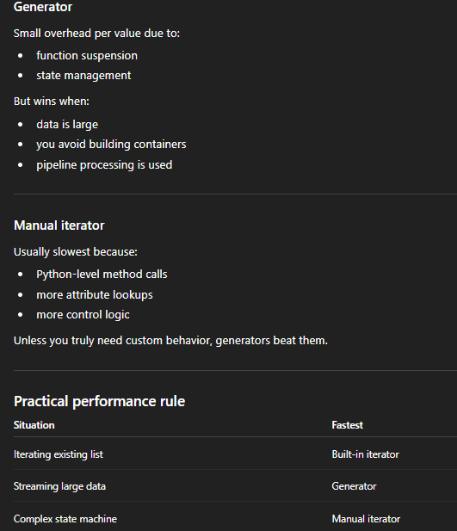
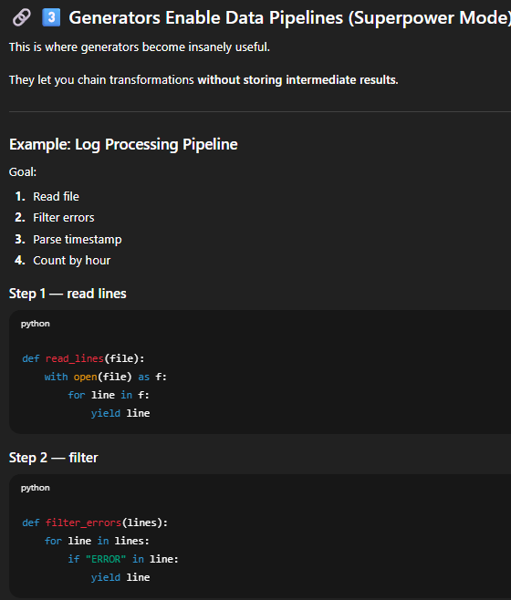
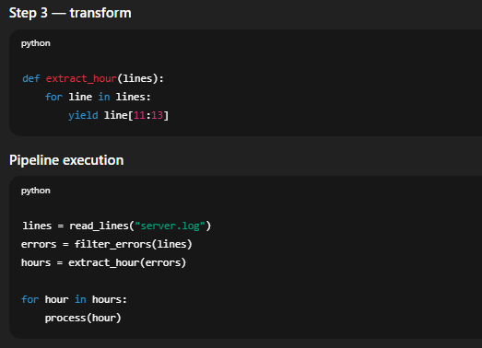
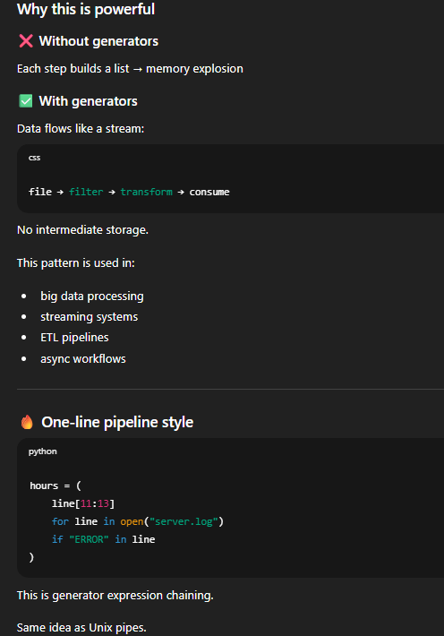
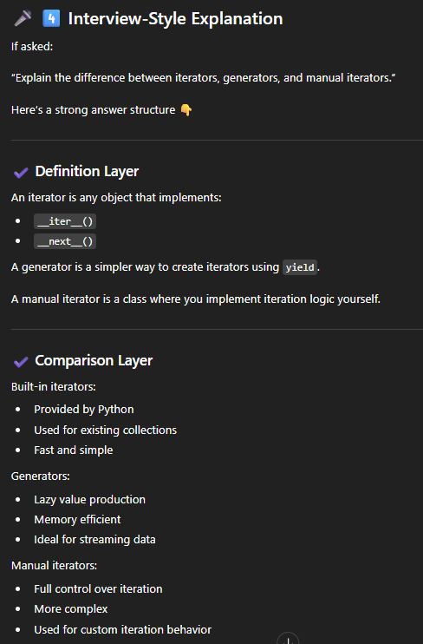
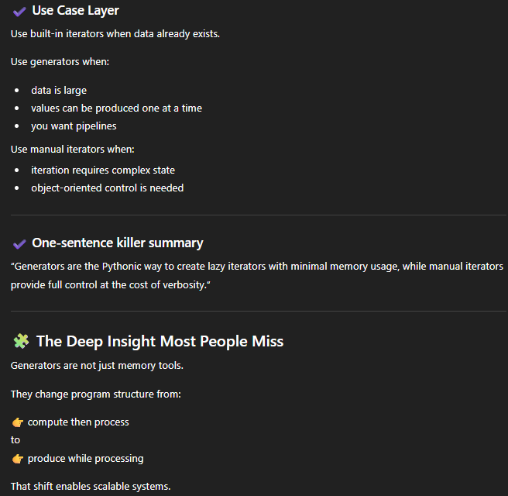
RETURN vs YIELD IN PYTHON FUNCTIONS
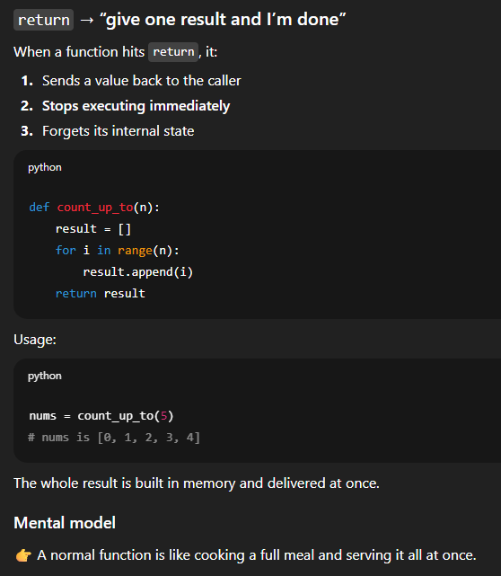
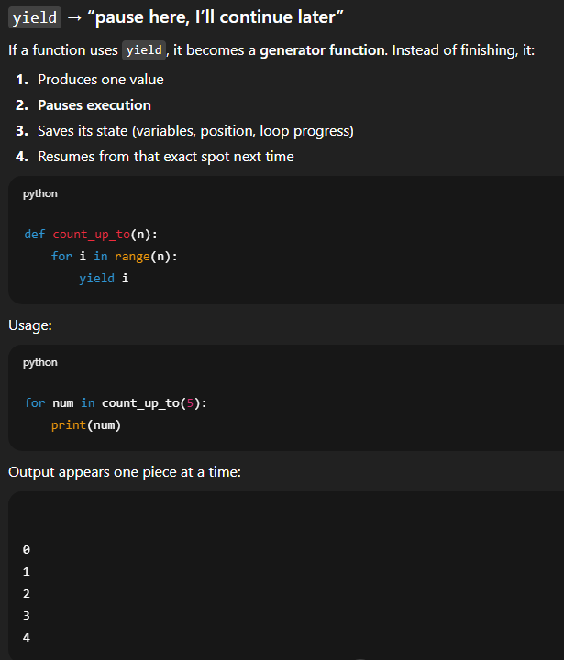
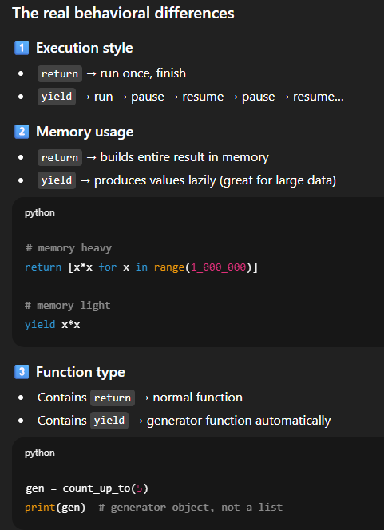
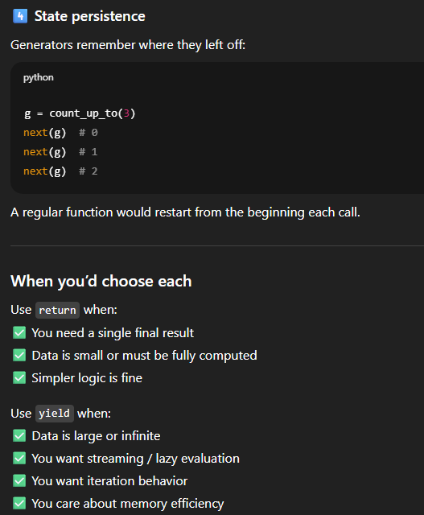
Using Both Yield And Return In A Single Function:
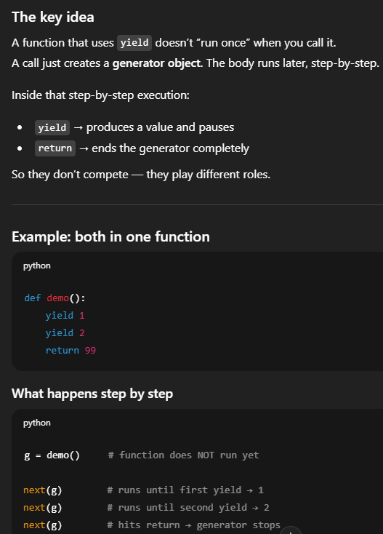
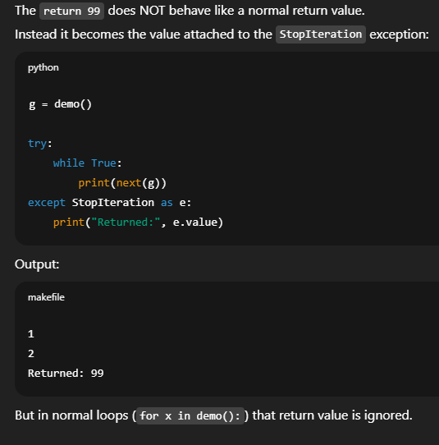
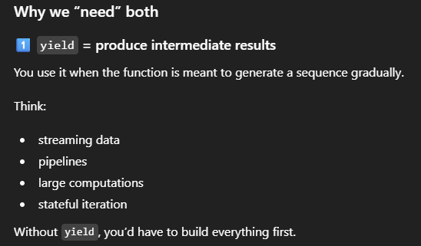
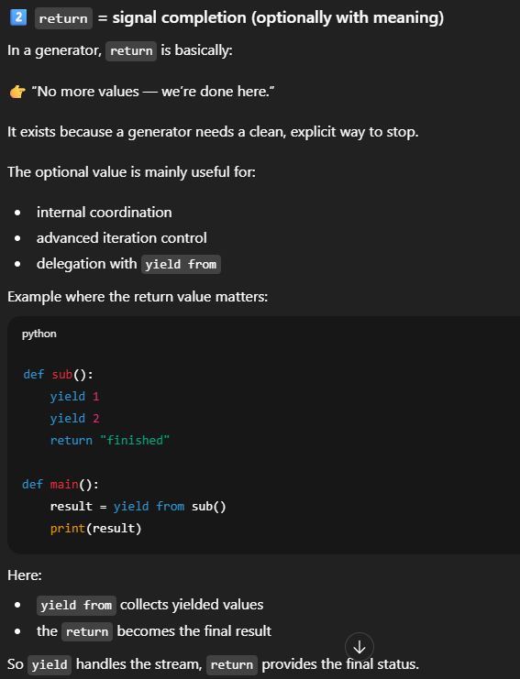
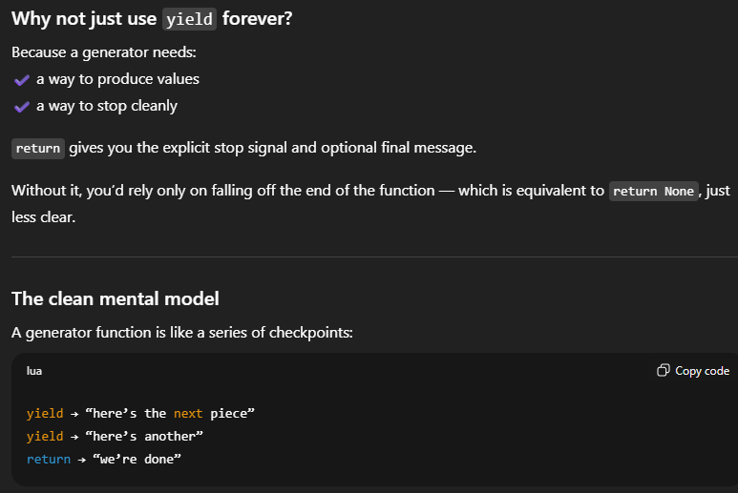

COPY, SHALLOW COPY AND DEEP COPY
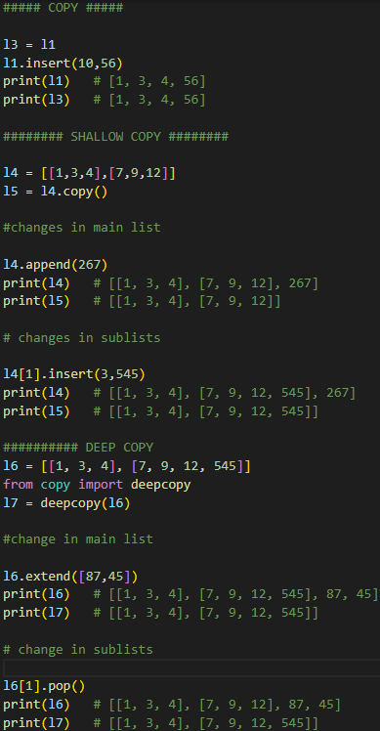
###### copy
It is done by ‘=’. Since the address in memory assigned for the new copy is the same and hence whatever the changes occur in the copy, will reflect in the original copy also.
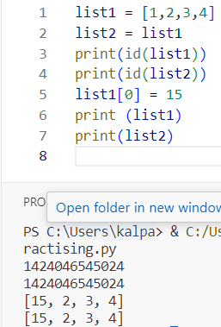
###### shallow copy
In case of single dimensioned list, the memory for original and copy are different so modifications won’t reflect in both.
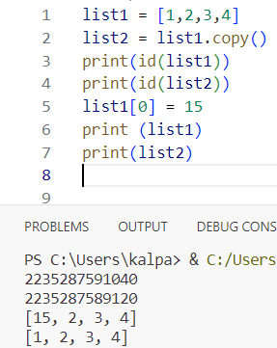
In case of nested lists, the memory address for both list1 and list2 is different but the ids of sublists inside the list1 and list2 will have same memory id and so if any operation is performed for sublists inside them, that will reflect in both list1 and list2.
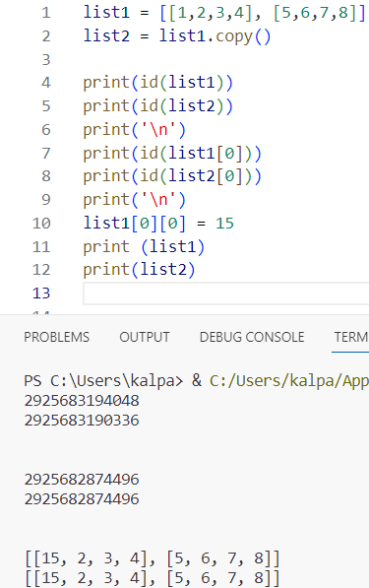
here we will append something new to the list1 which was not present in list2 and since the ids of both list1 and list2 are different, the appending operation is done in ids of list1 only so it will not reflect in list2
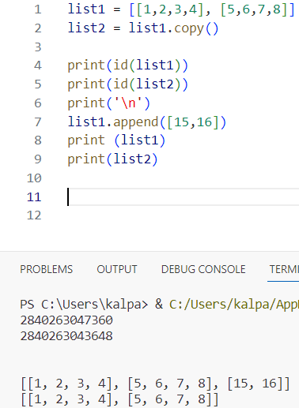
##### deep copy
In case of normal lists or nested lists, the memory addresses are different for both lists and the sublists inside them so any operation done on them doesn’t reflect in the other.
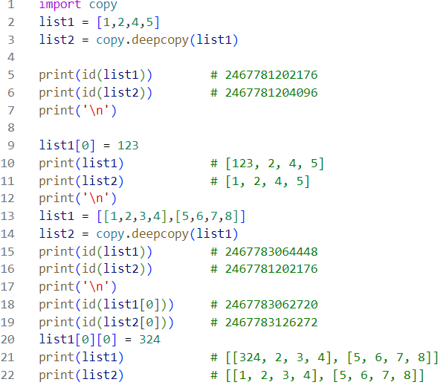

DIFFERENCE BETWEEN ‘==’ AND ‘IS’

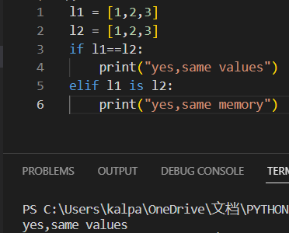

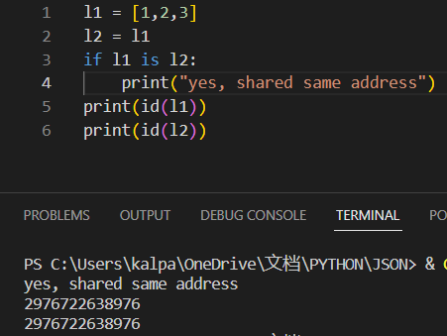
‘==’ Checks for equality of the thing or objects in terms of what they contain.
‘is’ checks whether their address in memory is same or not.
MULTITHREADING
DIFFERENCE AMONG MULTITHREADING, MULTIPROCESSING & ASYNCHRONOUS PROGRAMMING
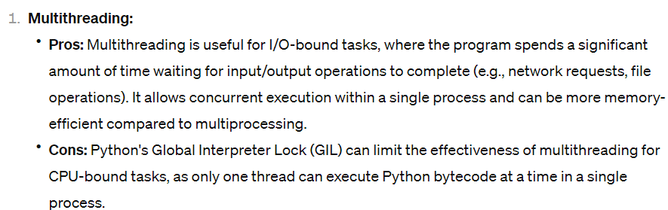
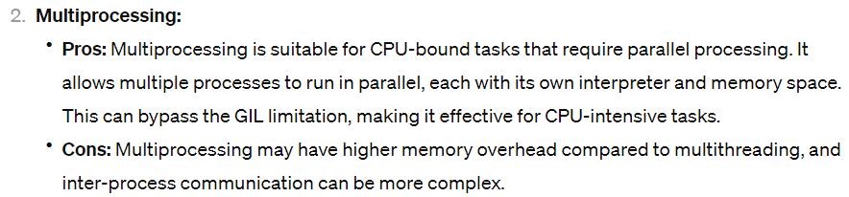
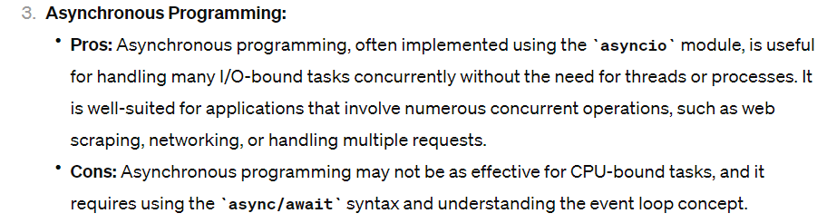
GLOBAL INTERPRETER LOCK

The Global Interpreter Lock (GIL) in Python is a mechanism designed to synchronize the execution of threads in a single process. It is a mutex (mutual exclusion) that protects access to Python objects, preventing multiple native threads from executing Python bytecodes at once. In other words, it ensures that only one thread executes Python bytecode in the interpreter at any given time.
The primary purpose of the GIL is to simplify memory management and avoid race conditions in the CPython interpreter (the default and most widely used implementation of Python). However, it comes with both advantages and disadvantages.
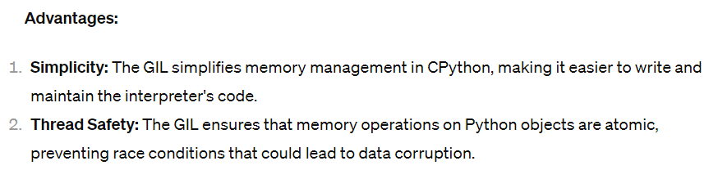
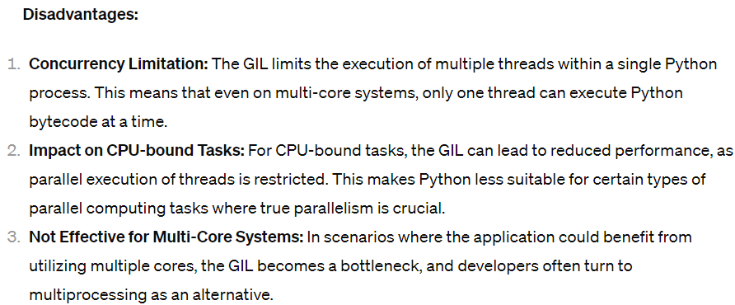
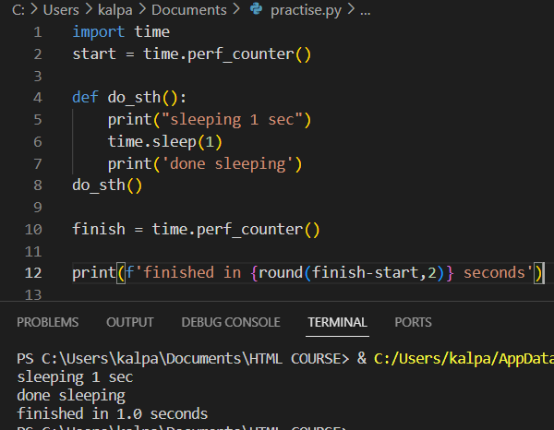
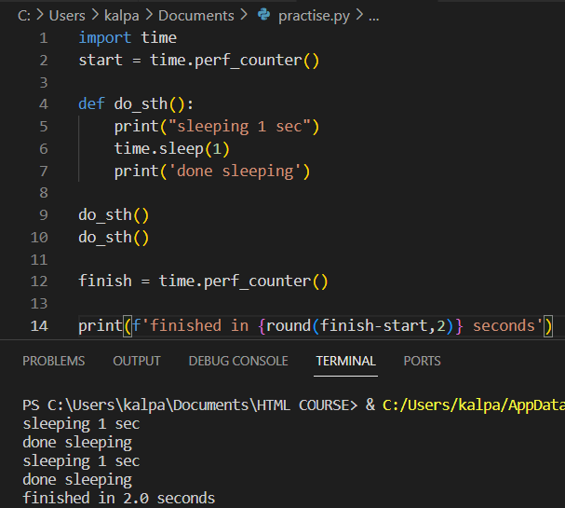
Function was called twice so went into sleep for 2 seconds totally.

Purpose of multi-threading:
To speed up the computer and is guaranteed based on the tasks we do and it’s about concurrency of the tasks
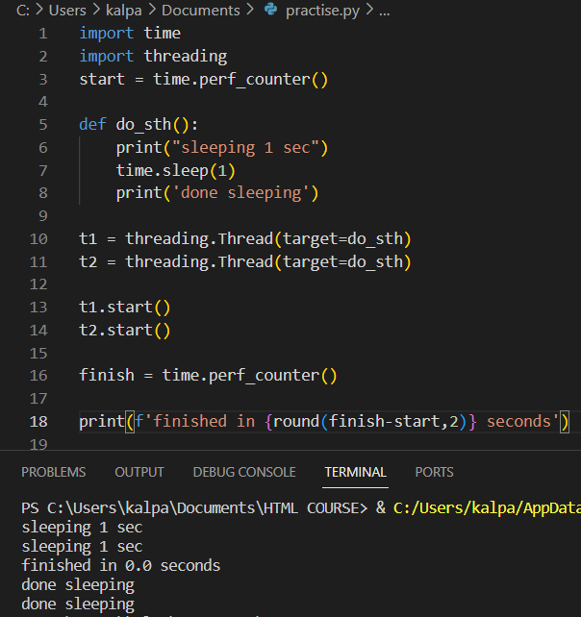
Both threads start concurrently and went into sleep and then our function has run, and threads came out of sleep and completed.
To run our thread before script we need to join the threads
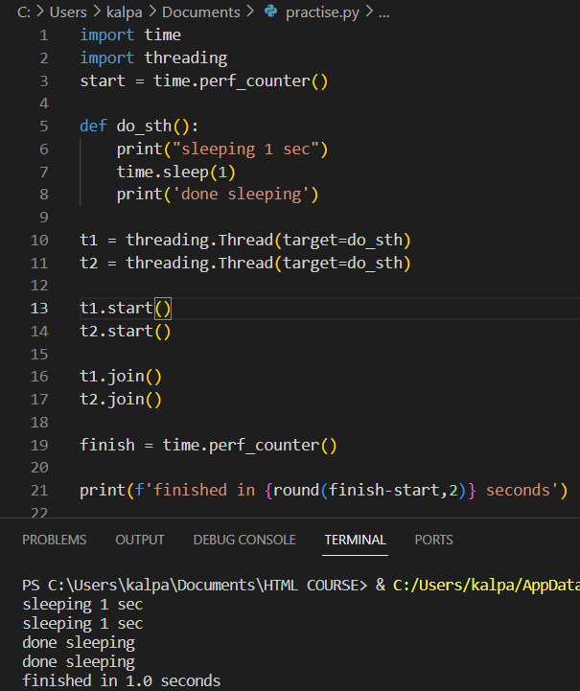
For running the function for multiple times using multiple threads we took empty thread list and started them in loop and joined in loop.

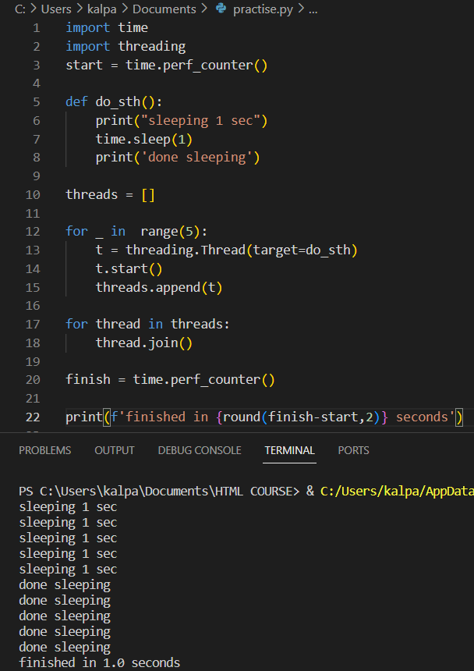
Now let’s pass sleep time in arguments to our function.

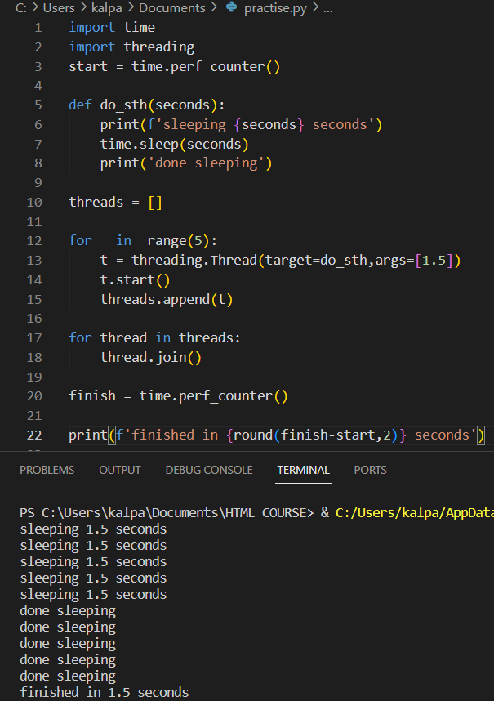
We passed sleep time in args keyword in thread.
The manual way of creating threads is by threadpool executor. It allows us to switch over multiple processes instead of threads as well depending on the problem we are solving. Import concurrent.futures module and use context manager
submit() method executes a function and returns a future object which basically encapsulates execution of our function and allows to check in once it’s been scheduled. We can check result or its running. result() is used to get the return output of the function
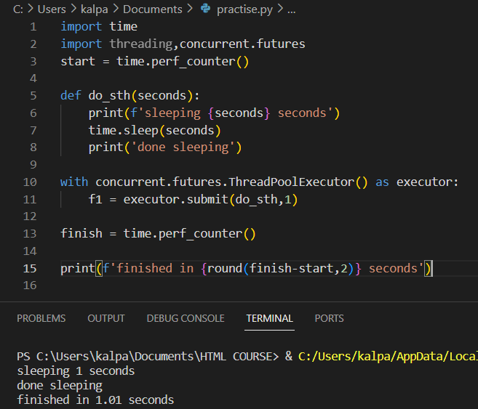
f1 is the future object.
We can go with a regular loop for running the function for multiple times but let’s use a list comprehension for that. In order to get the actual results, we can use another module from concurrent futures modules called as_completed()that gives an iterator that loops over the results of our threads as they completed.
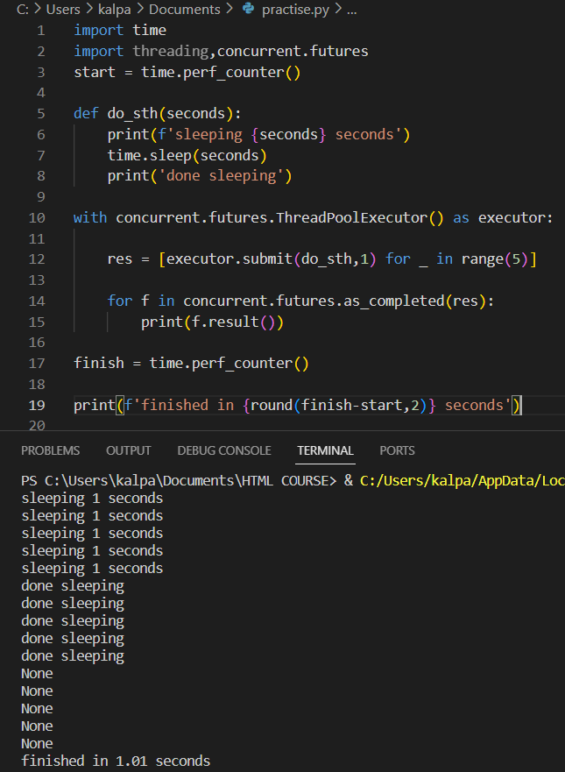
It’s done in just a second. In order to prove that they have been completed as they are coming in let’s pass different range of seconds for our threads to sleep.
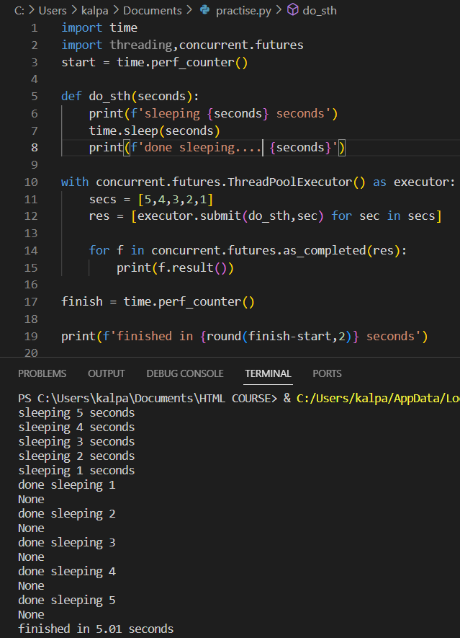
We actually started 5 seconds thread first, since we used as_completed method it printed the results in the order that they completed.
Submit() method submits each function once at a time. In order to run submit on entire list then we need to do a loop or a comprehension as done above or we can use map() to run function over the list of values. We are mapping our function over list of seconds. Map() returns the results whereas submit() returns the future object. Map is still going to run the threads concurrently but instead of returning the results as they completed like earlier, map is going to return the results in the order they started(NOTE: HERE IN OUTPUT THERE IS A MISTAKE. THE ACTUAL OUTPUT SHOULD BE ‘done sleeping 5 and so on till 1)
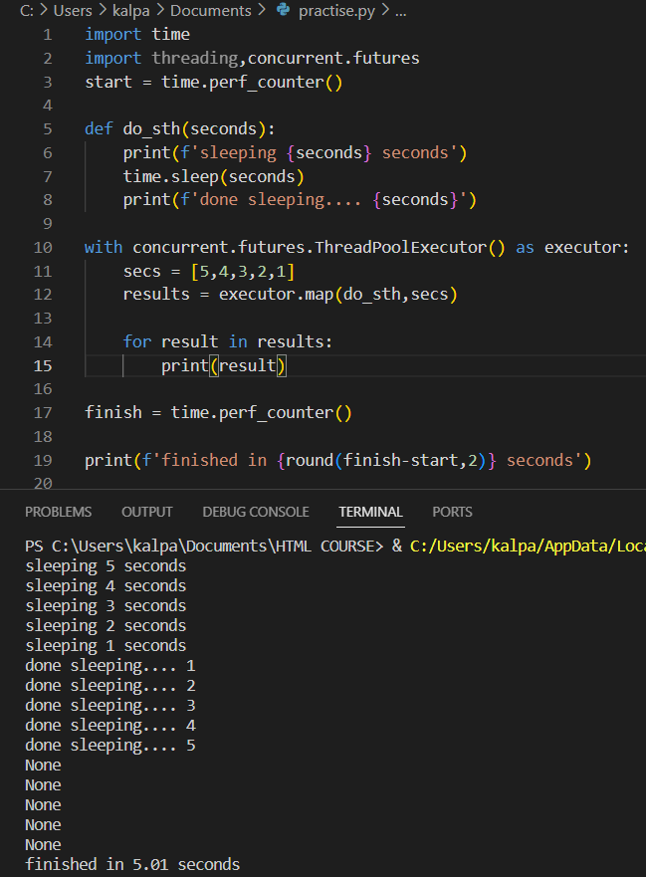
In case our function raises any exception, it won’t actually raise an exception while running the thread. The exception will be raised when its value is retrieved from the results iterator. So, if we need to handle exception, we need to do it within iterator. Now even if we don’t grab all our results within the context manager here it’s still going to join automatically all of those and let them finish after the context manager ends. This is understood by commenting out the results loop as followed

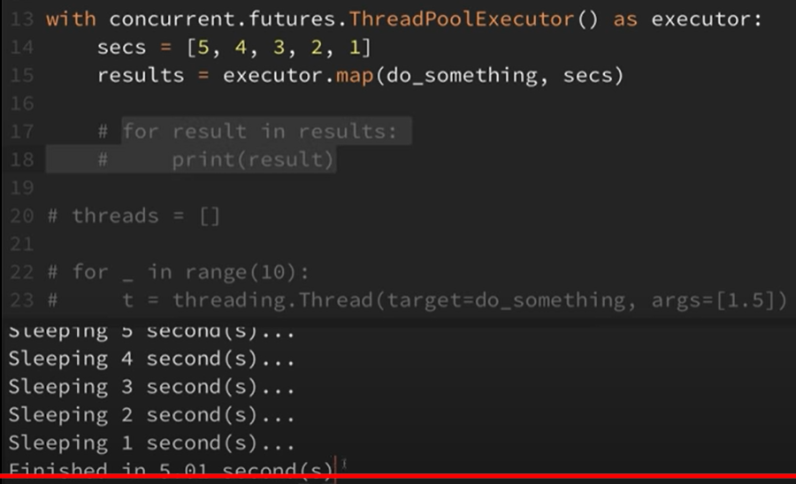
Let’s look at a real-world example for multithreading

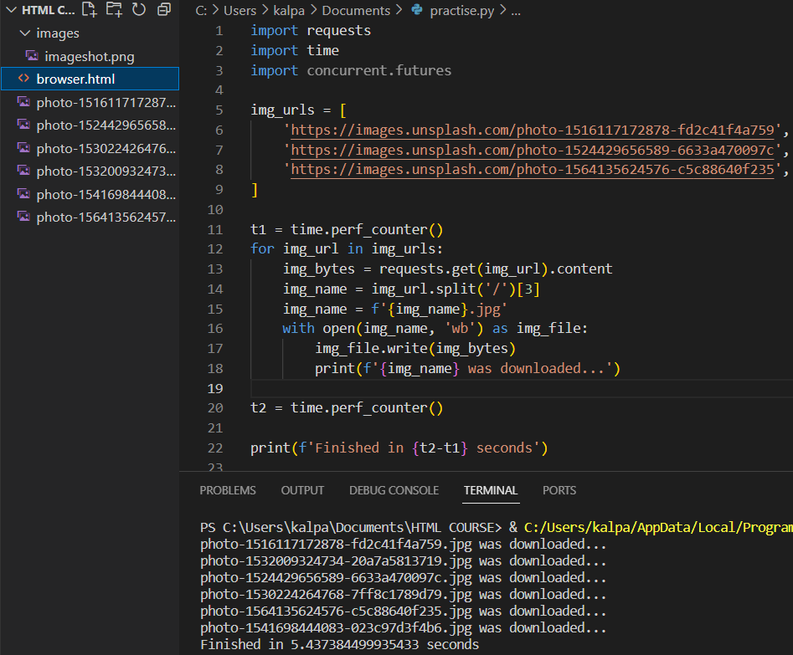
So far downloading has got finished in 23 seconds for downloading the 15 photos without using threading. Downloading the things online is a great case for threading because this is one of those i/o bound operations that is actually spending lot of time just waiting around. It’s going out and waiting for a response from the site and it’s not moving onto the next URL until that gets entire response back. So, if we use threads then it can go ahead and move onto the next URL while that’s waiting for a response, and we can make other requests at same time.
We use threading pool map method where we can pass in a function and a list and have that function run with every value in that list. Let’s create a function that downloads data from URL. Import concurrent.futures module

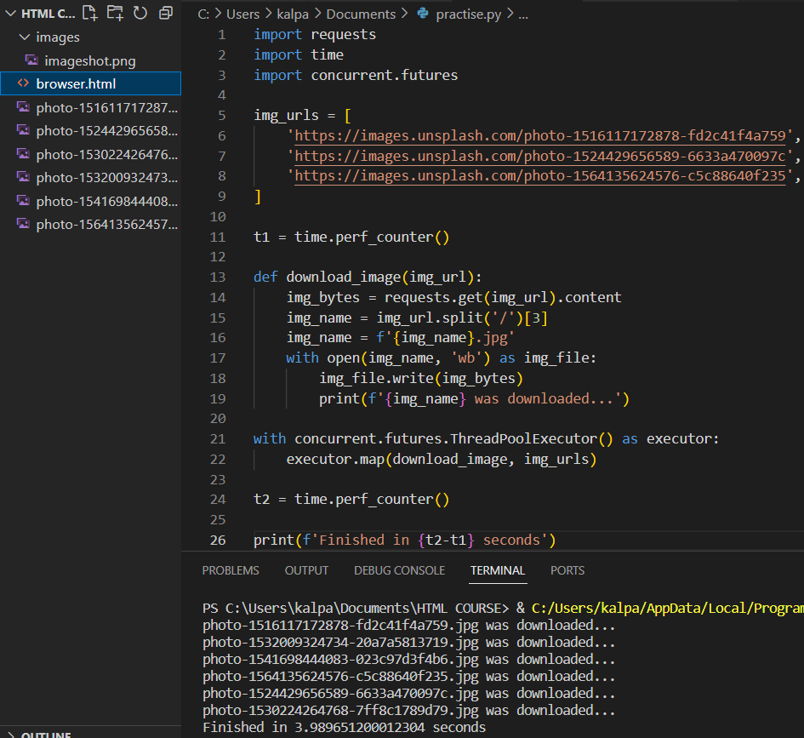
The task has finished in just 5 seconds around
MULTIPROCESSING
To speed up our program we use it and that speed up comes from different tasks running parallel. Let’s run simple sleep methods in parallel. If we have tasks which don’t need to be run synchronously, those can be run by multiprocessing module to split these tasks up onto the other CPUs and run them at same time. Tasks are either i/o bound (ex: file system operations and network operations like downloading stuff online, reading and writing to the disk) or CPU bound. CPU bound tasks are those that are crunching lot of numbers and I/O bound are those waiting for input and output operations for completion, and they are not really using the CPU at all. We don’t get speed if we do threading with CPU bound operations because those threads are still running one process. With multiprocessing we spread work out on the multiple processors on the machine and run those tasks at the same time so we can use this with both i/o bound and CPU bound tasks. Threading runs tasks concurrently but running concurrently doesn’t necessarily mean that they are running at the same time but with multiprocessing these tasks will run at same time on different processes. Refer https://chat.openai.com/c/c44fa4b1-9a5f-4fba-a595-cd55bb07396b for examples of CPU and I/O bound operations.
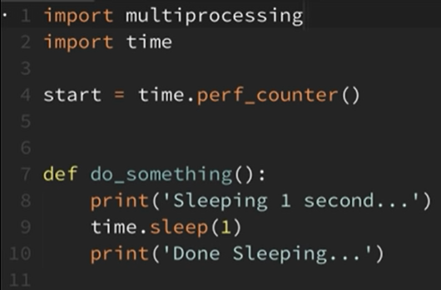
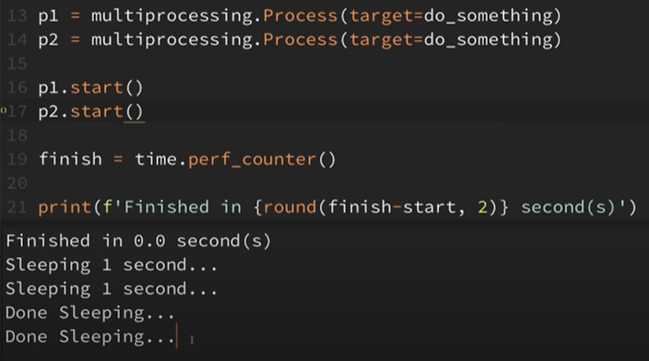
It doesn’t actually complete in zero seconds but took around 1 sec. because after it started both of the processes at a time and while those processes were sleeping our script continued running and came down and calculated and printed out zero sec and again it kicked off those processes and done. By using join() the process will finish before moving on in the script
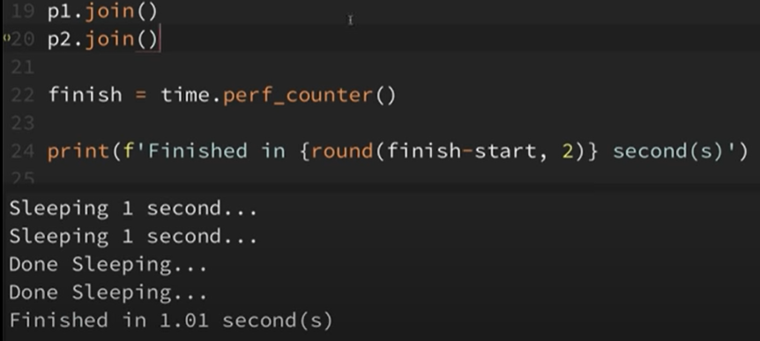
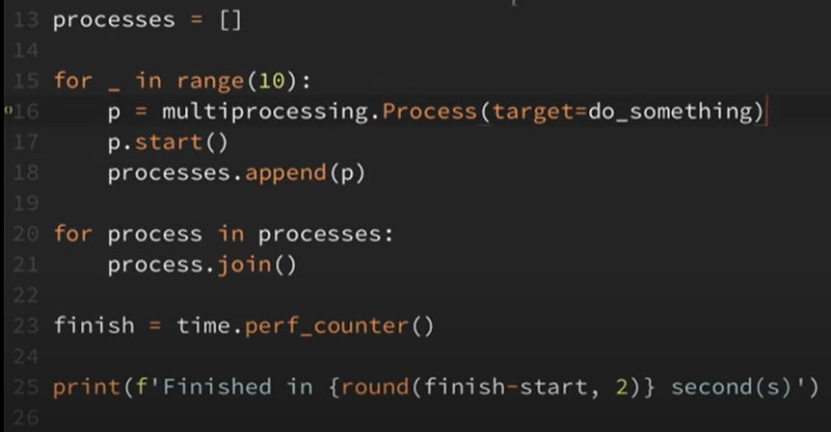
Let’s add couple of arguments to our function
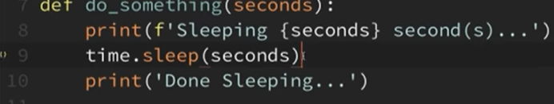
Unlike threads, in order to pass arguments in multiprocessing, the arguments must be able to be serializedusing PICKLE. Serializing something with pickle means we are converting python objects into a format that can be deconstructed and reconstructed in another python script
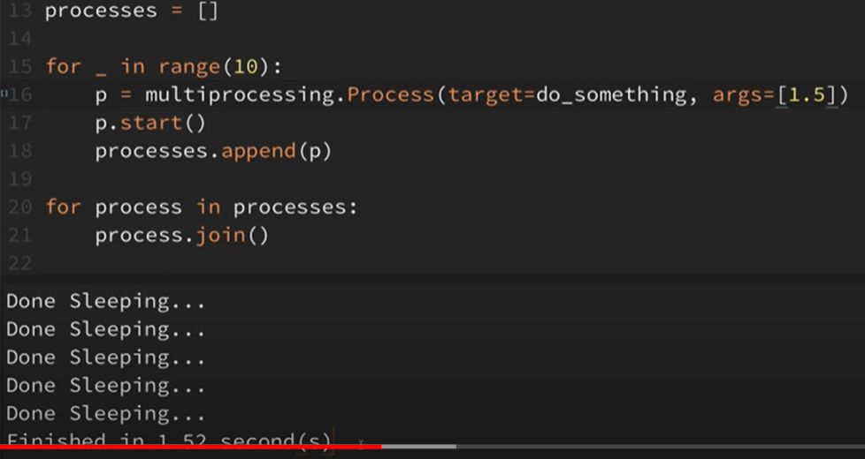
It’s a casual coding like we did in threads.
We use process pool executor for creating manual way of multiprocessing. it can easily switch between multithreading instead of multiprocessing if required. Import concurrent.futures module for thread pool executor.
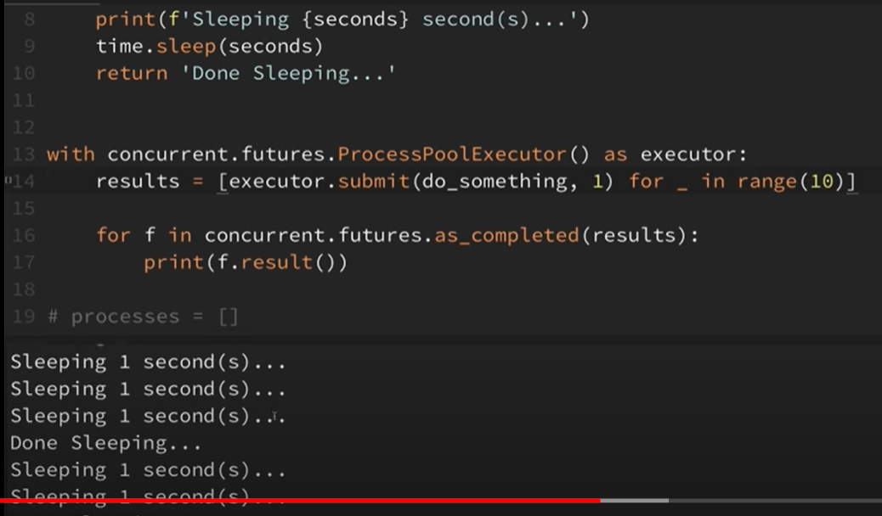
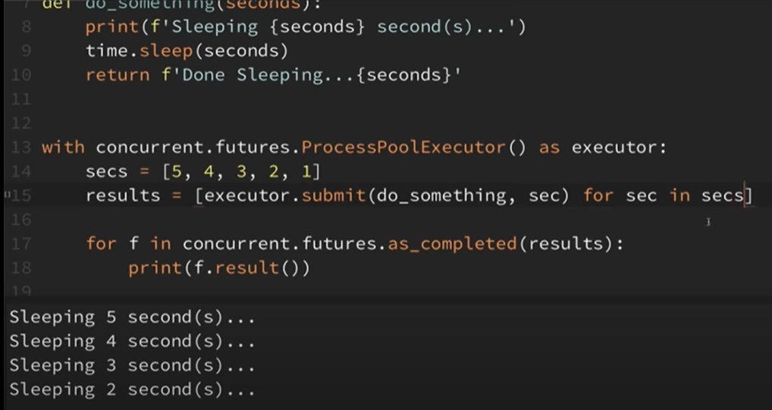
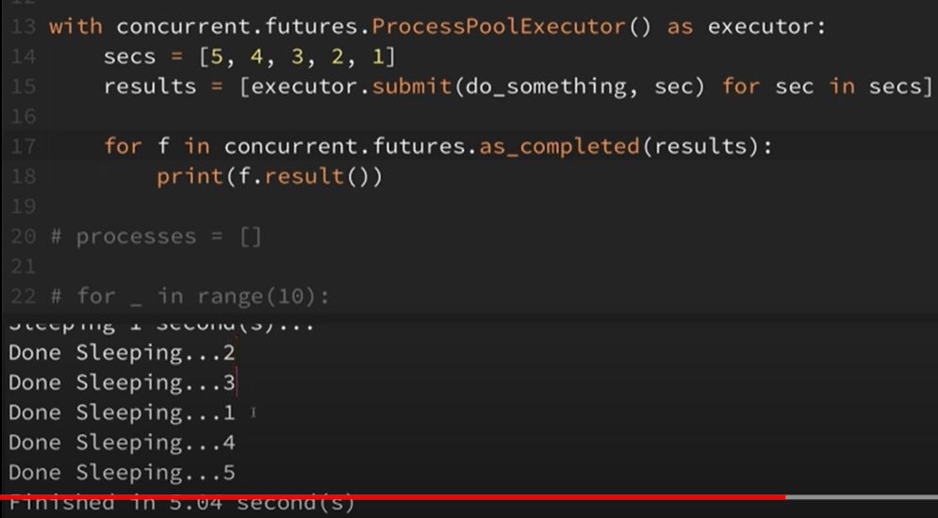
Here we observe a new thing that order of sleeping is disturbed due to 4 cores on that machine
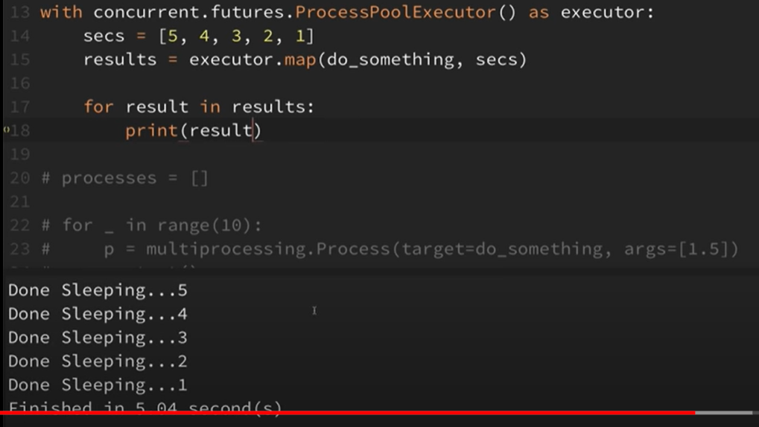
We used map() method and now we can observe the sequence of output
Let us do some image processing with multiprocessing
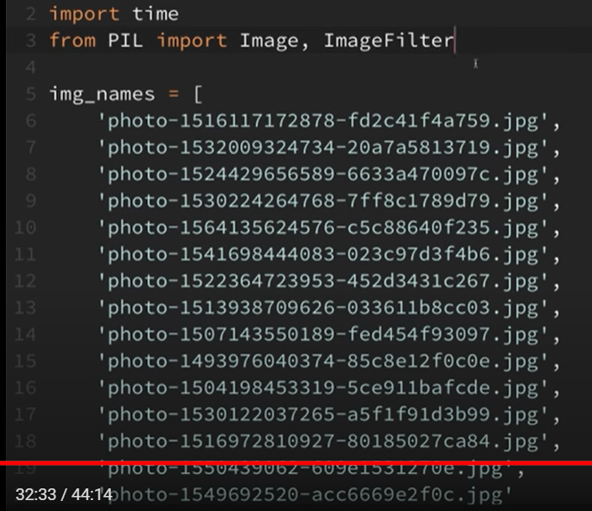
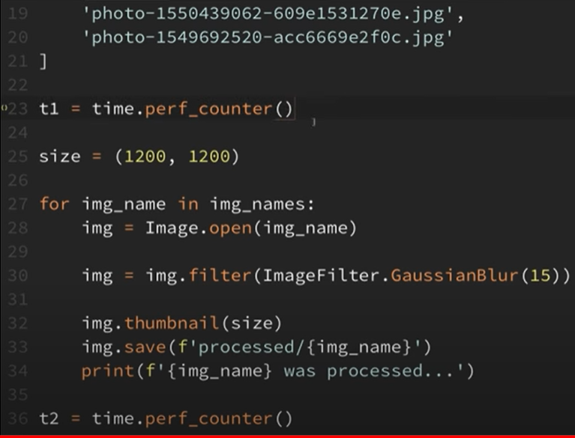
This is regular way of doing. Nothing efficient. That took 23 sec
The multiprocessing is efficient as it moves onto next image while the previous image is processing and even if this is i/o bound, unlike threading, its beneficial for i/o bound as well. Import processpool executor.
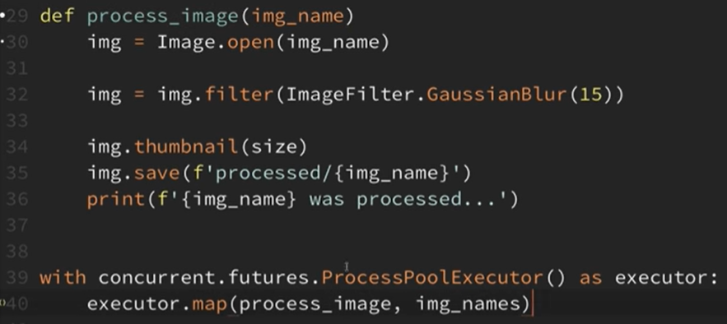

The script finished in 7 sec The advantage of concurrent.futures is that we can switch between multithreading and multiprocessing simply by switching from theadpoolexecutor() to processpoolexecutor() vice versa
VARIABLE SCOPE - UNDERSTANDING THE LEGB RULE AND GLOBAL/NONLOCAL
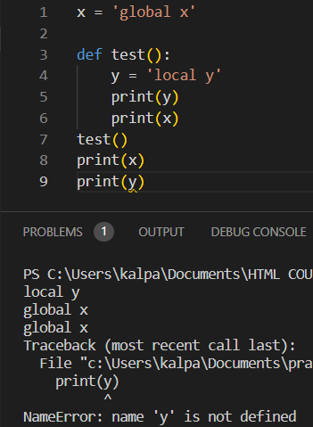

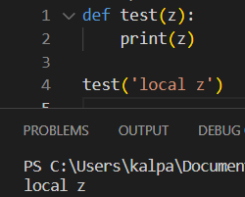
The arguments we pass to the function are treated as they have local scope
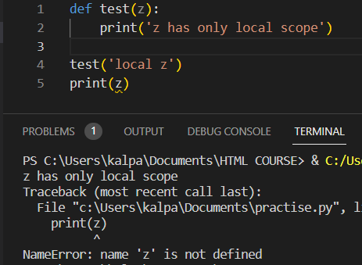
Z has local scope but we are trying to print in global scope so we got error

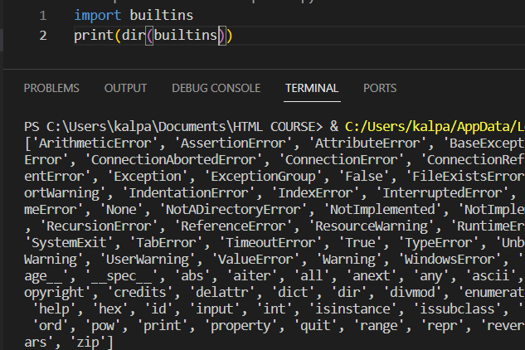
Dir returns all the attributes related to the object passed in
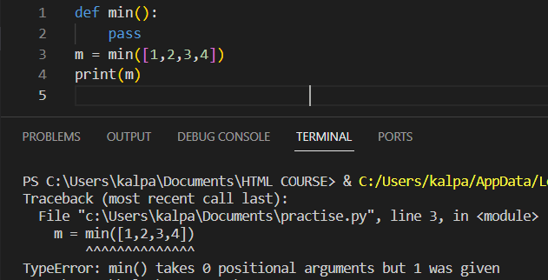
The error is because the python looks for global scope before the built in scope of min(). We gave zero arguments in global scope so it shown that error
So let us change our global function
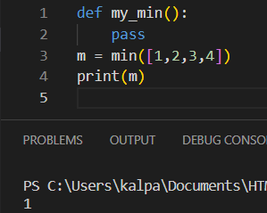
We changed our global function so we got output.
Now, Let’s discuss about enclosing scope which is related to nested functions.
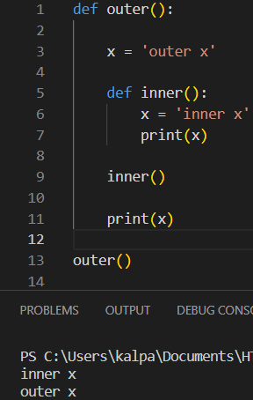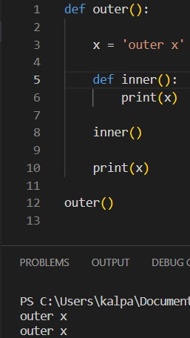

It first checked for local scope of x and not found. And then checked for enclosing scope and found it. We use global keyword to work with global variable inside a local function or scope. In the same way to work with enclosing scope variables we use nonlocal keyword.
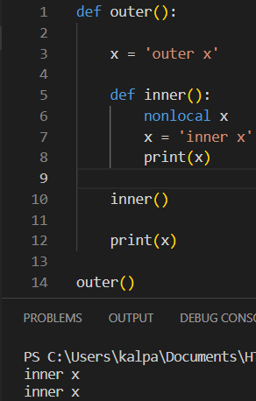
We changed the ‘outer x’ scope using the nonlocal keyword

FILE OBJECTS - READING AND WRITING TO FILES
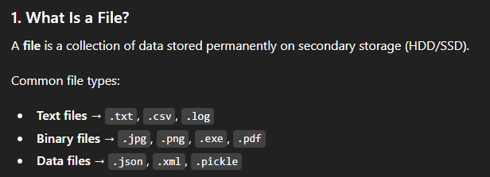
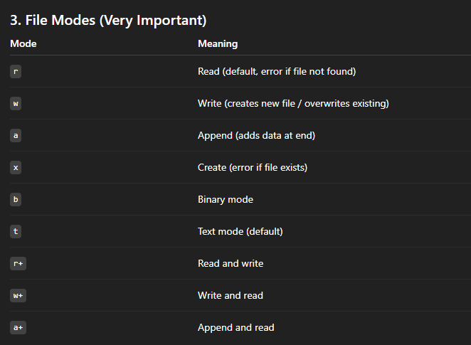
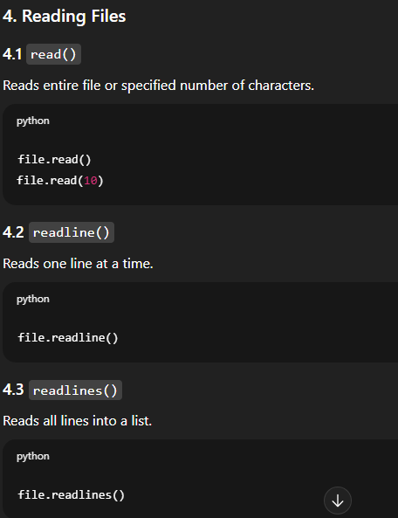
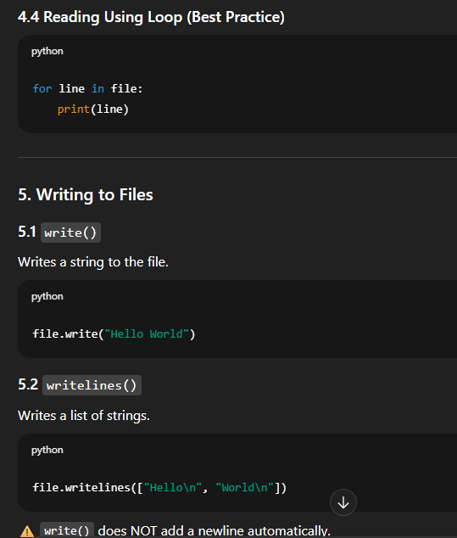
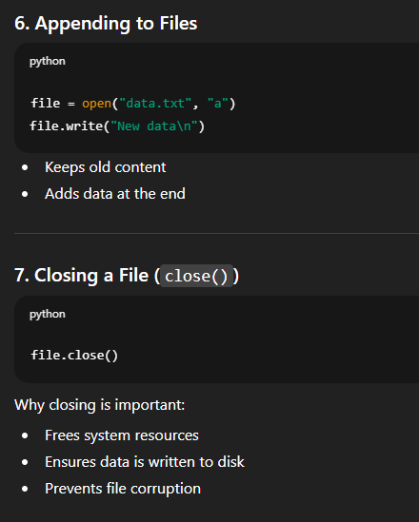

Let us open a file in the same folder and try to reat the contents of it
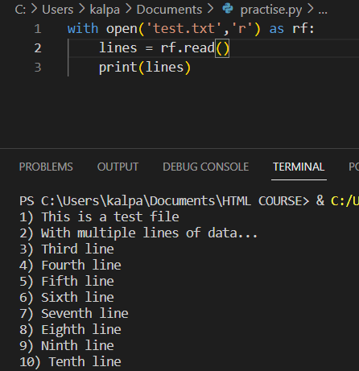
Read() prints the file output as text and readlines() prints out the lines of file as a list.
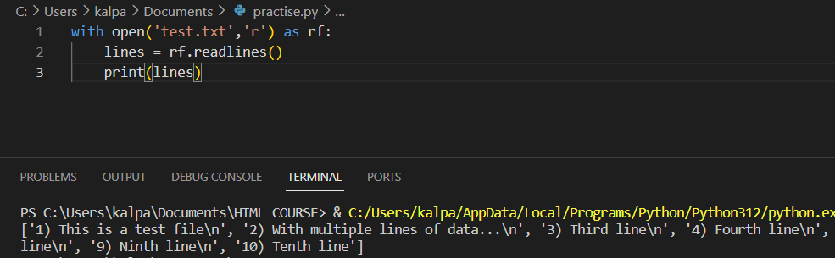
readline() prints out only one line at a time
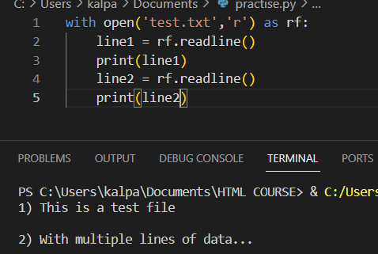
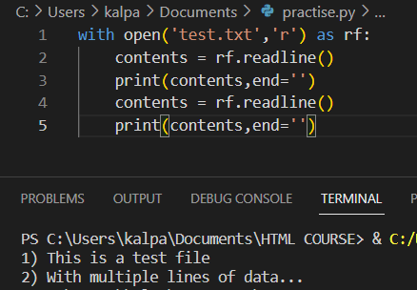
End=”” doesn’t add an extra new line while the content is printed in the output
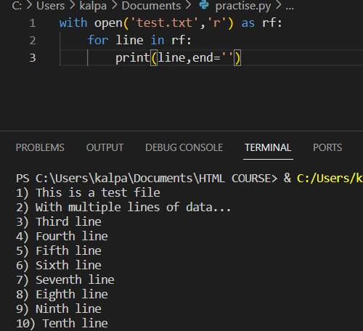
Instead of using readlines() or readline() we can simply loop through lines as coded above
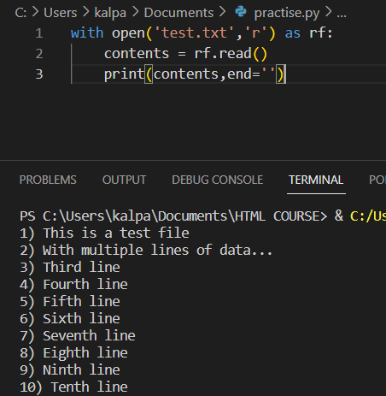
Read () method also prints out everything and we can also mention the particular quantity to be read
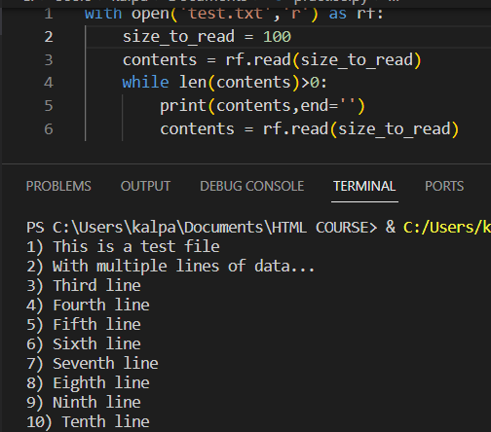
If we don’t pass 11, it becomes an infinite loop. So now it checks by coming back to while loop start and finished until read returns empty string
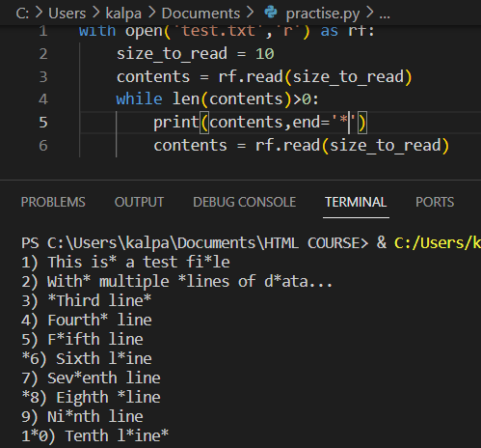
We passed asteric(*) for clear understading of every 10 characteristics
Now let us copy the file contents from one to the other
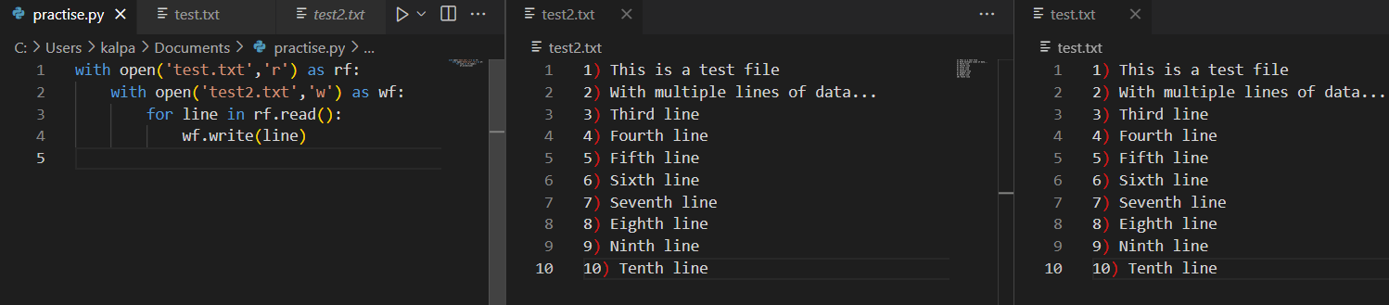

EXCEPTION HANDLING

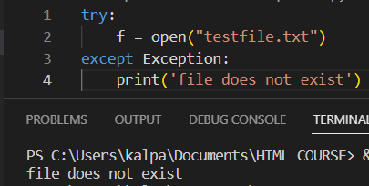
We tried to open that file doesn’t exist. So, the exception block has run
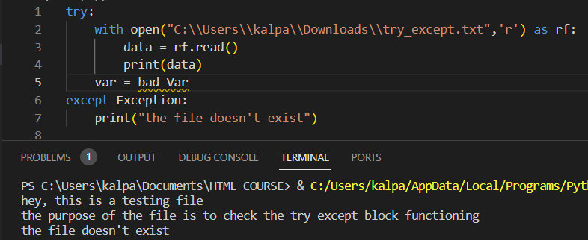
The code has run successfully (we opened the right file and printed the content in it) but it didn’t understand var error so exception block is run in general. The output is that general exception statement error.
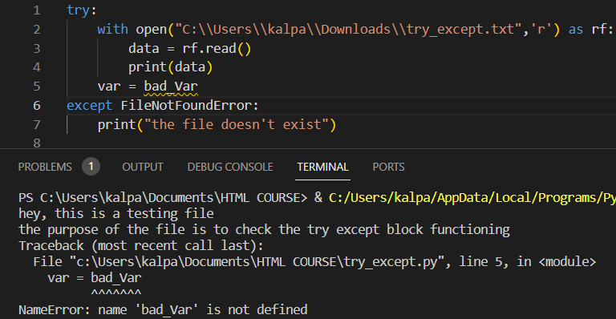
The code ran successfully, and python trace back name error is displayed because we mentioned FileNotFound error which didn’t get caught
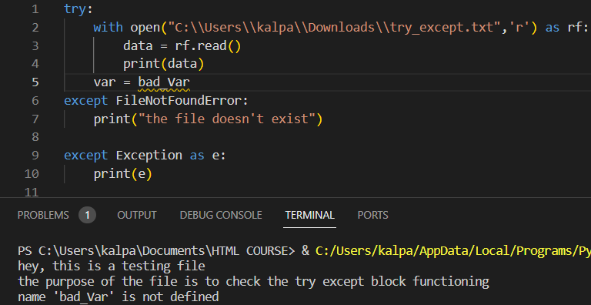
For making our exceptions more generalized, we added another exception block which ran successfully

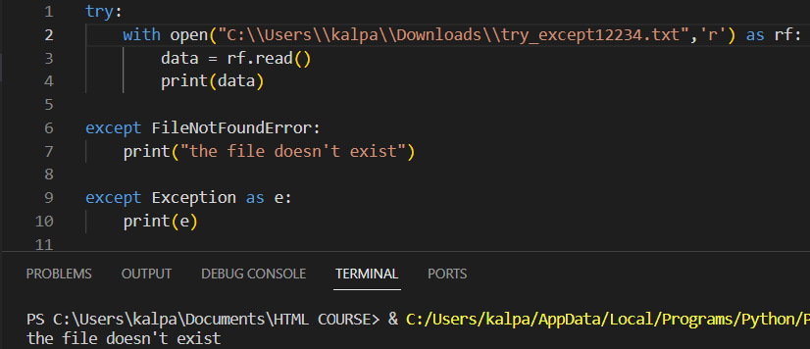

So always general exception block tries to run first
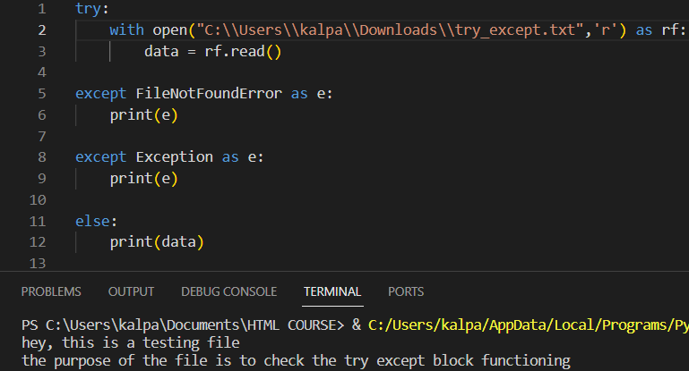
Else block runs when the try block doesn’t throw an exception i.e. the case try block runs successfully.
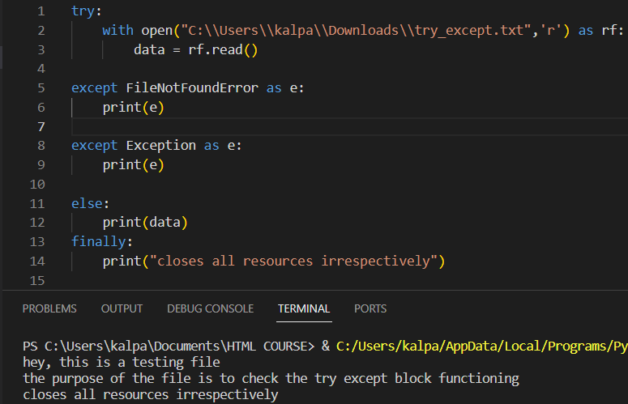
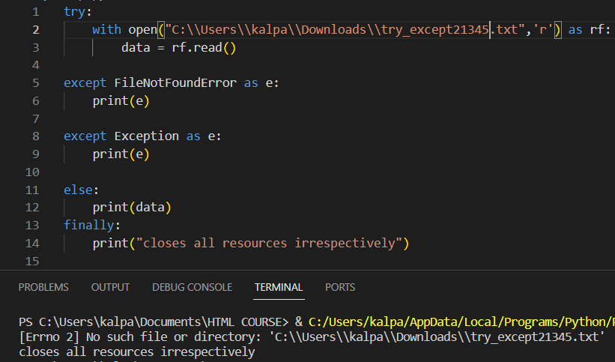
“finally” runs irrespective of the try and except blocks and release certain resources ex: working with database where we can close down.
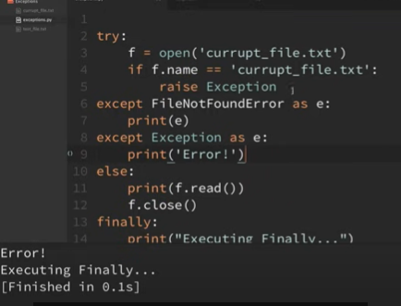
Since the file exists, raised exception and went to line 8 and printed
DUCK TYPING AND EAFP
It’s basically about the object that can do whatever we want irrespective of the class that object belongs to
First let us check with non duck type or non pythonic type
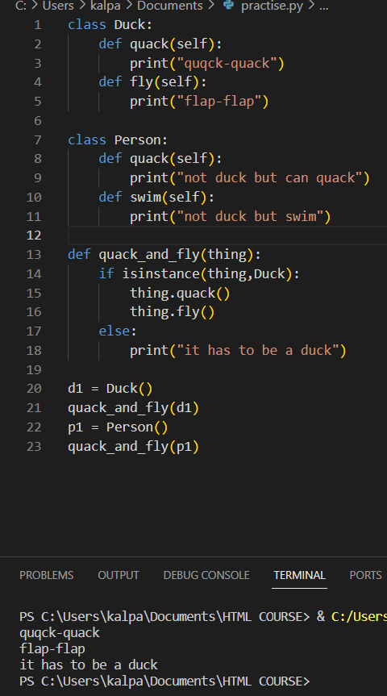
Since the thing is not an instance of duck, it’s saying the same in the result that it should be a duck.
Now let us see a pythonic (duck-type object) behaviour.
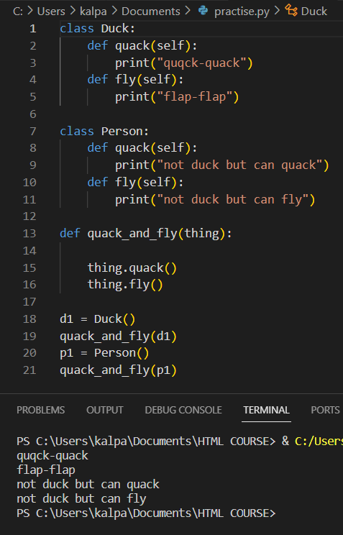
Now the object p1 does what we ask to do even though it’s not a duck type object.

MONKEY PATCHING IN PYTHON
In Python, the term monkey patch refers to dynamic (or run-time) modifications of a class or module. In Python, we can actually change the behaviour of code at run-time.
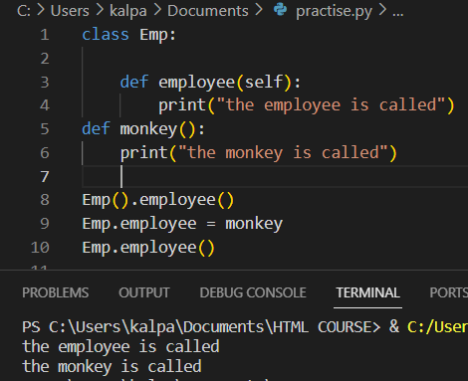
When we initially called the employee method of emp class, it printed “the employee is called” and when we assigned it to monkey function, the behaviour of employee method is changed it to monkey function. This is how we are modifying the behaviour of the Emp class.

LEAVE BEFORE YOU LOOK (NON PYTHONIC)

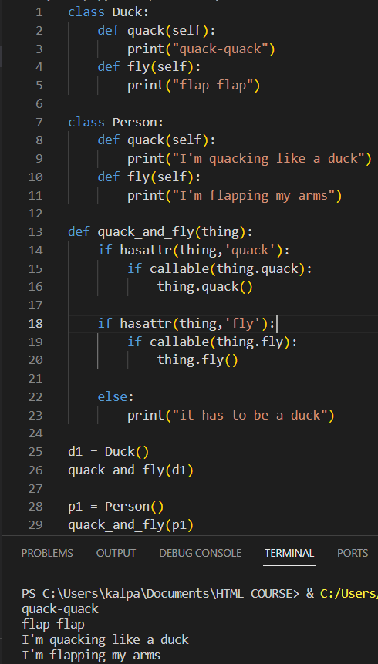
Every time we are checking whether the attribute has the method or not and then we are calling

EAFP
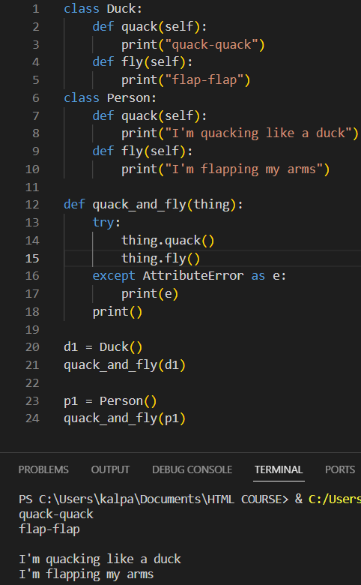
Here we are running the try and except blocks. Since the thing object has the methods so it runs safe
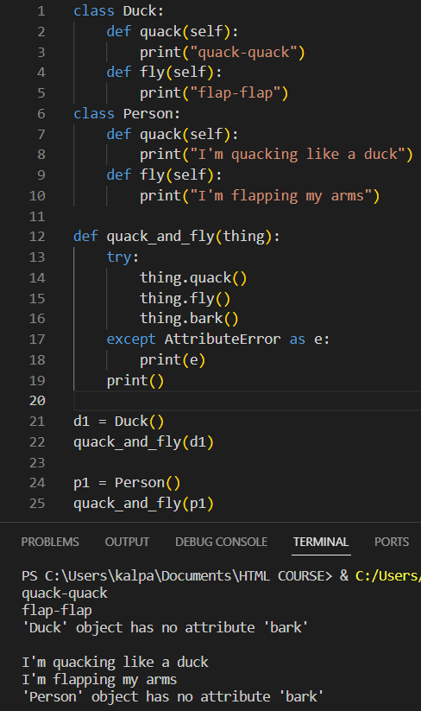
Now since there is no such method called bark, it displayed the error for the particular method.
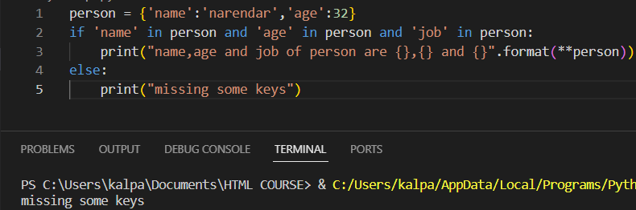
Since the job is missing in the dictionary, it raised exception.
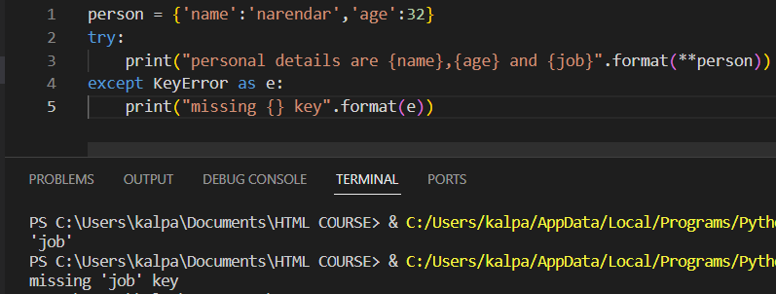
Doing the same in eafp method, we got exception message like this. The difference is from non-pythonic and this is that we are not doing any kind of checks over here and trying to execute.
Let’s look at another example in both pythonic and non-pythonic way.
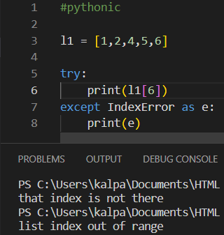
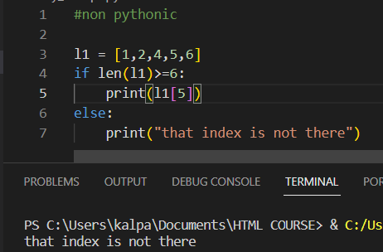

GENERATORS

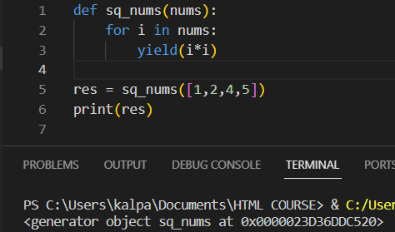
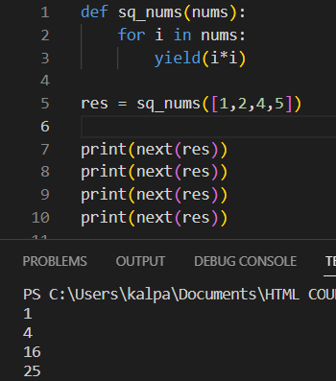
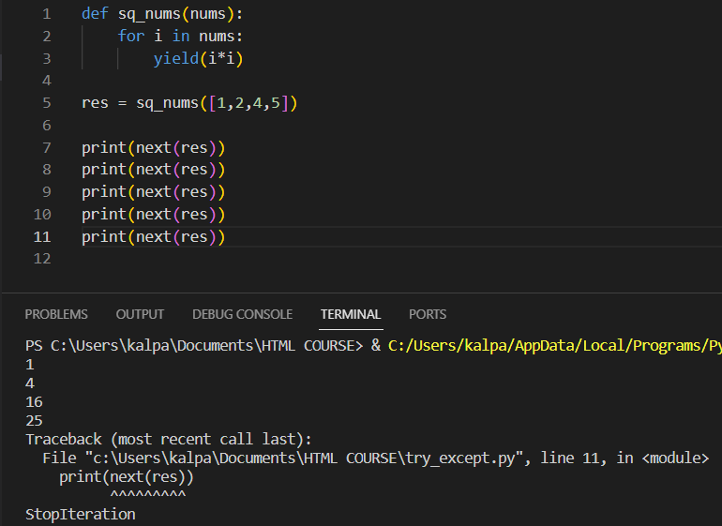
The generator has exhausted and so we got StopIteration message.
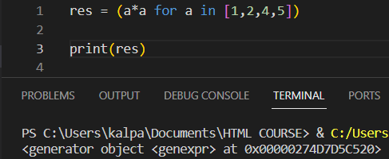
We have just generated generator object with parenthesis (). To get them we can do by listing them as followed in the next image below.
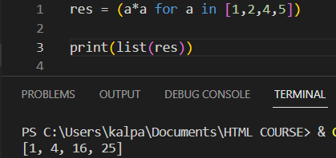

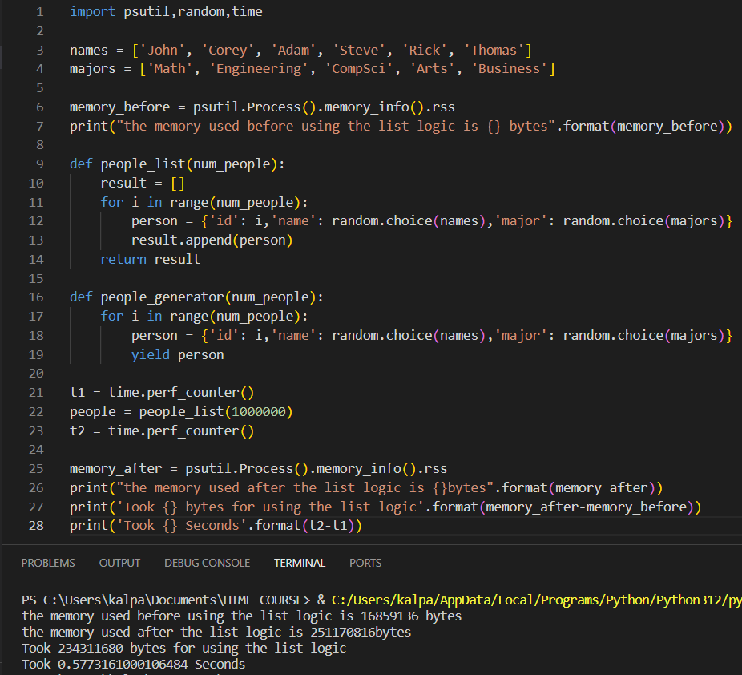
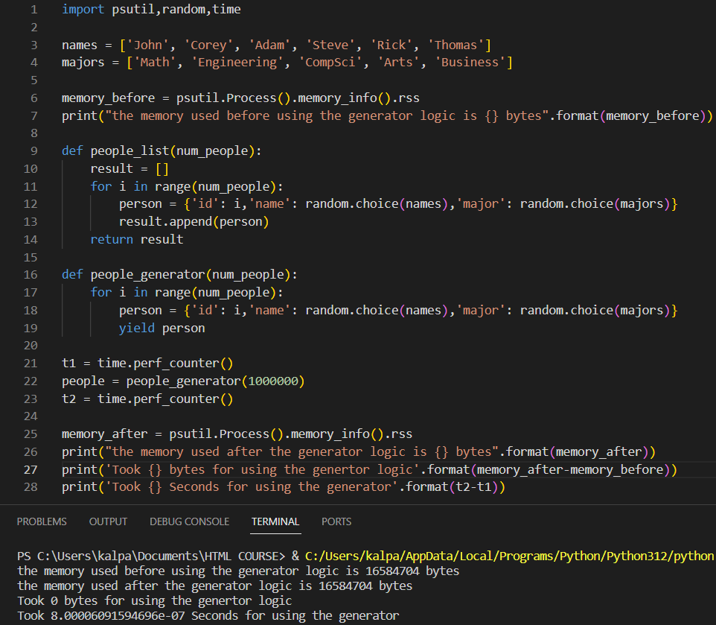
We handled the code with generator. And the output will be a generator object. Another Important thing to notice that we shouldn’t use for loop with generator. If we use so it becomes like a normal iterator. Check it by looking into the code below.
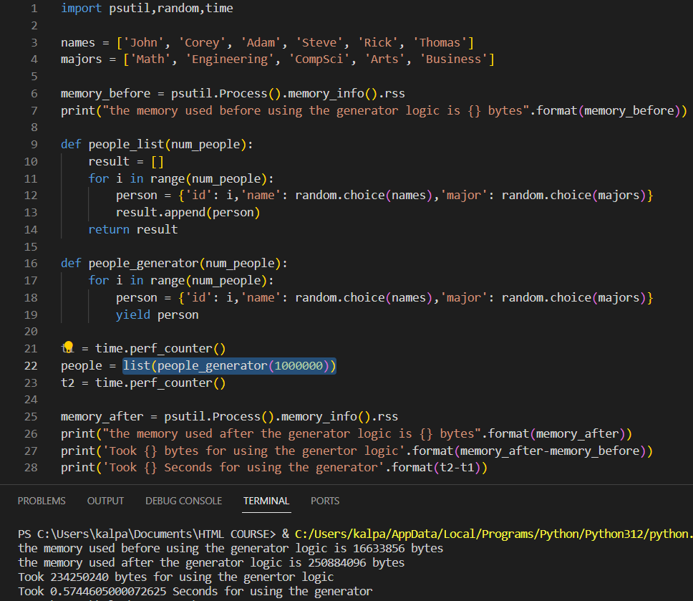
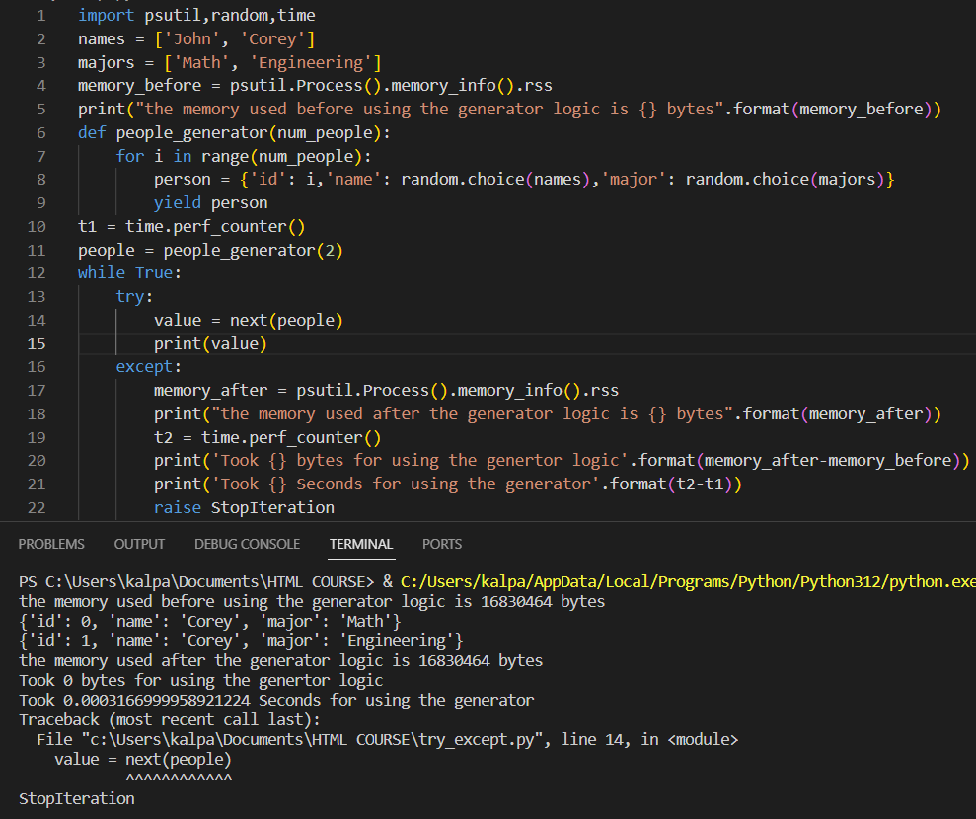

DECORATORS
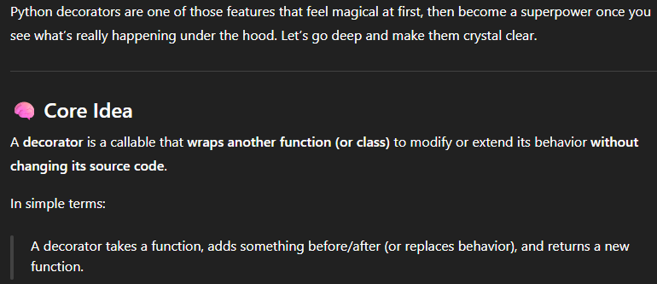
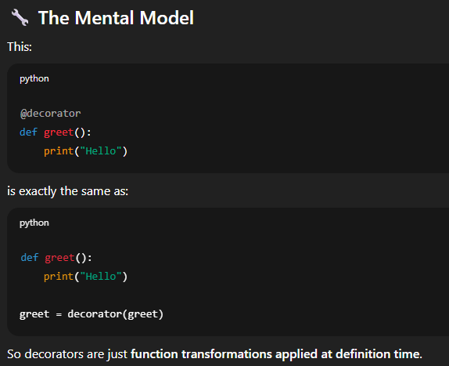
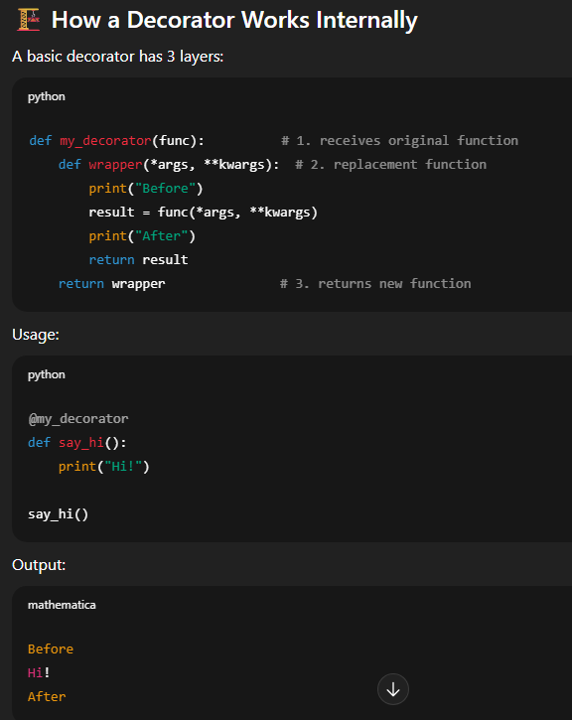
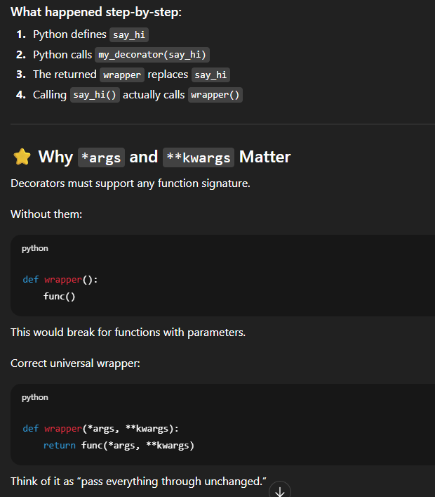
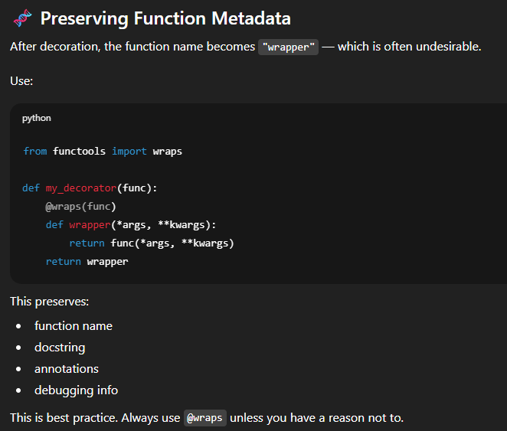
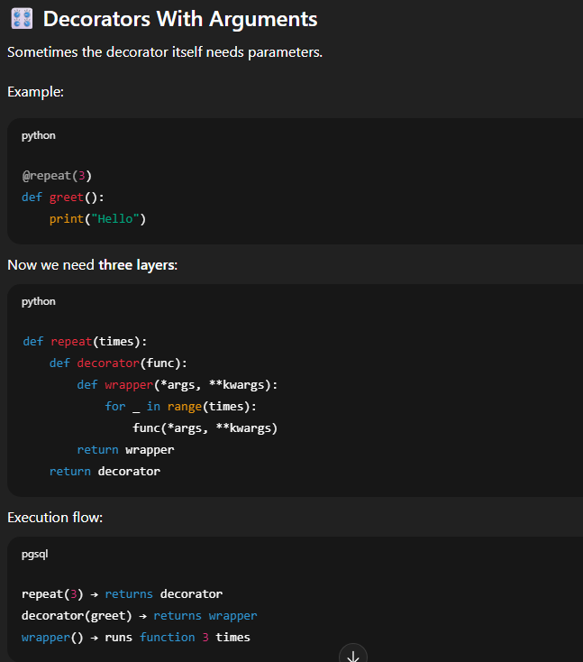
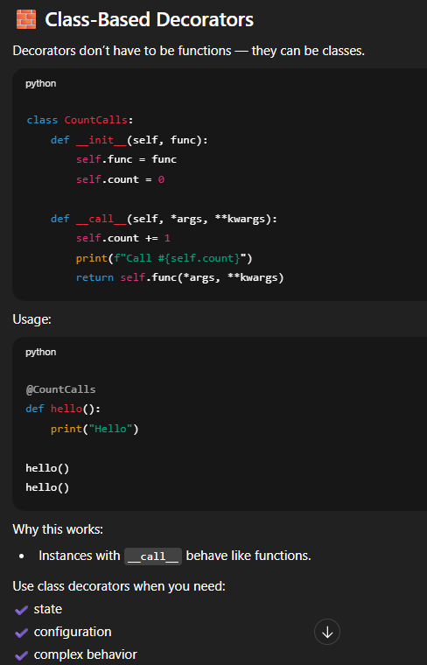
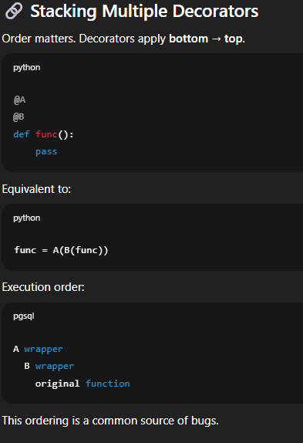
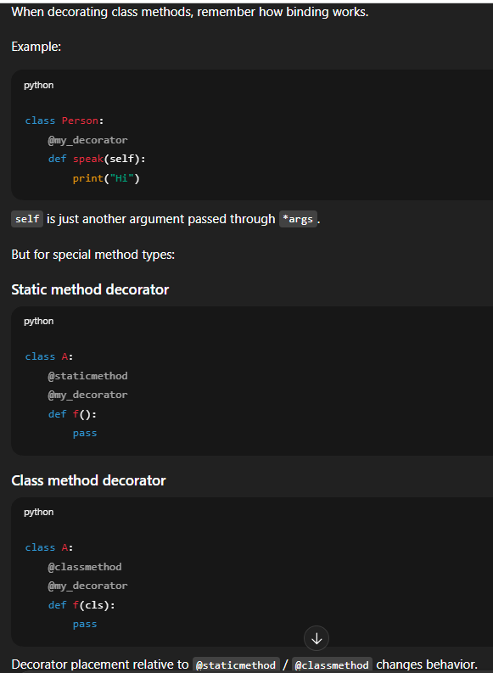
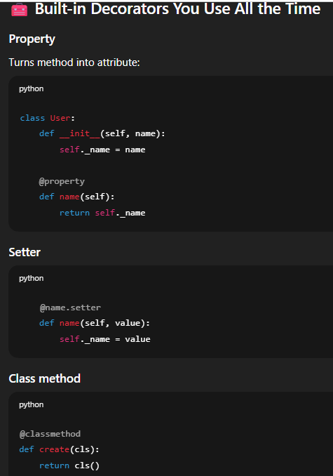
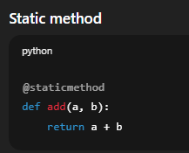
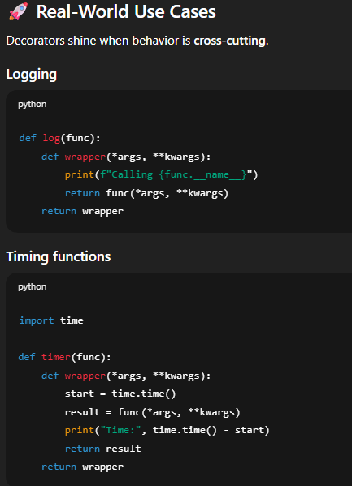
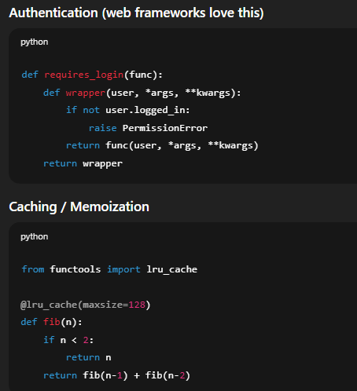
We can include one function inside another function.
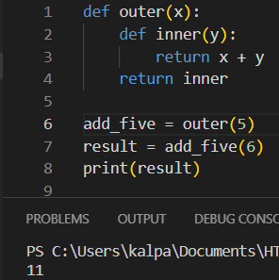
We can pass a function as an argument to another function in Python.
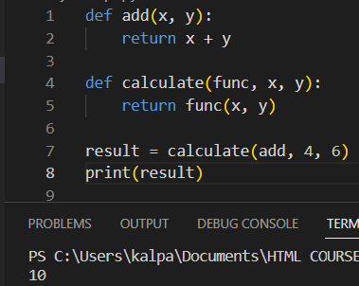
In python we can also return a function as output to another function.
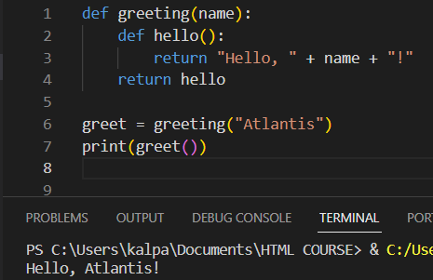
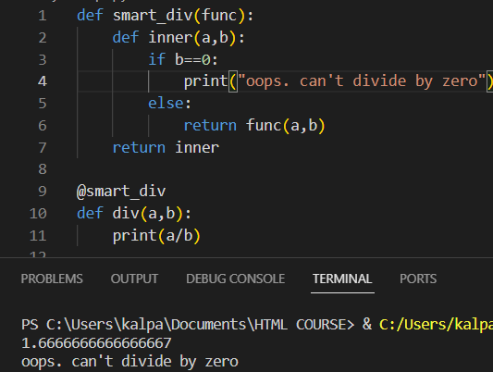

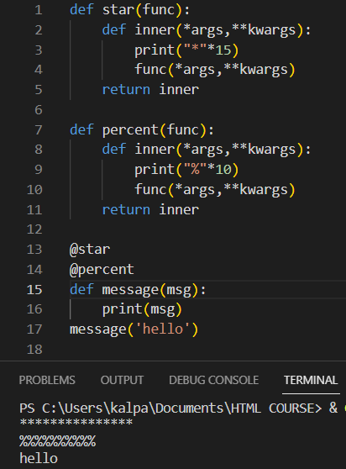
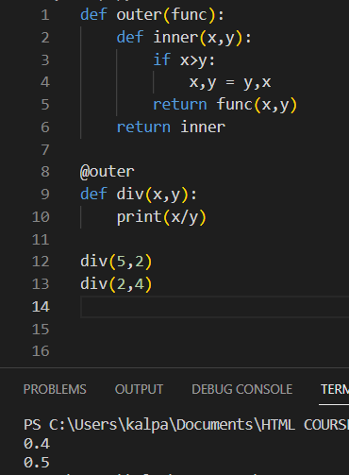

CLOSURES

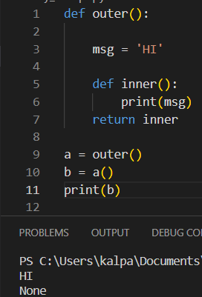
In the above, ‘HI’ should be printed if we call inner but inner is also returned further to outer (finally a return statement) so to get the output of outer, we assign a variable and further calling the variable by function calling syntax saying b = a(), once the output is over, b life is over so If we still try to get b, it will be invalid so we get None.

Inner function is waiting to be executed and so we assigned a variable for the outer func for getting the o/p of inner function.
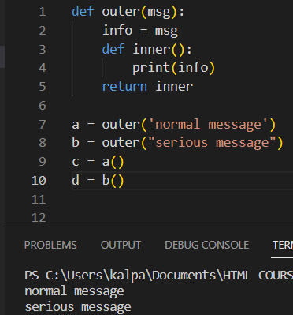
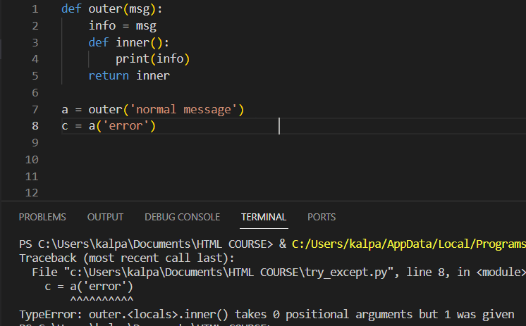
In the above we tried to get the output but it didn’t work due to the reason that the output of a() is stored as the print statement function(default to ‘normal message’) where we can imagine passing an extra argument to a print statement which doesn’t accept any more arguments so that’s the error message in terminal.
They have been executed putting a () as they are equal to function (i.e. inner function).

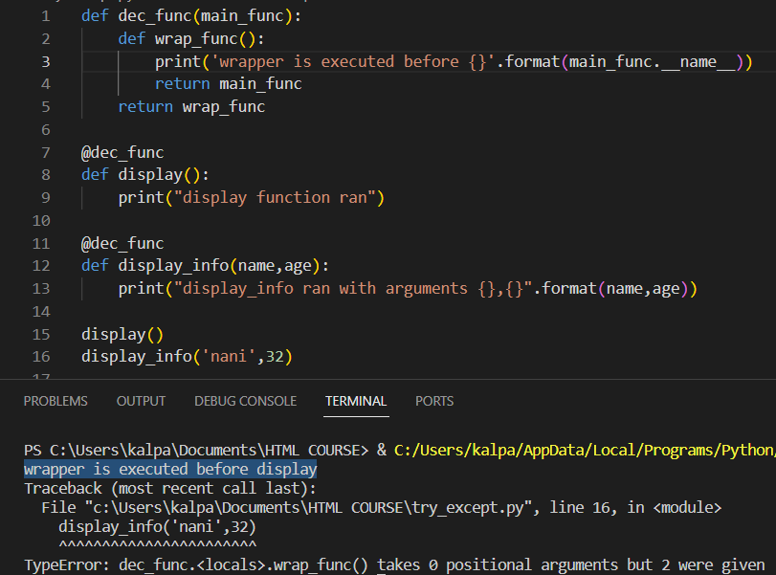
In the above if we see, we got output only for display() not for display info, this is due to not defining the wrapper accepting arguments but they are passed in display function so we need to pass args and kwags
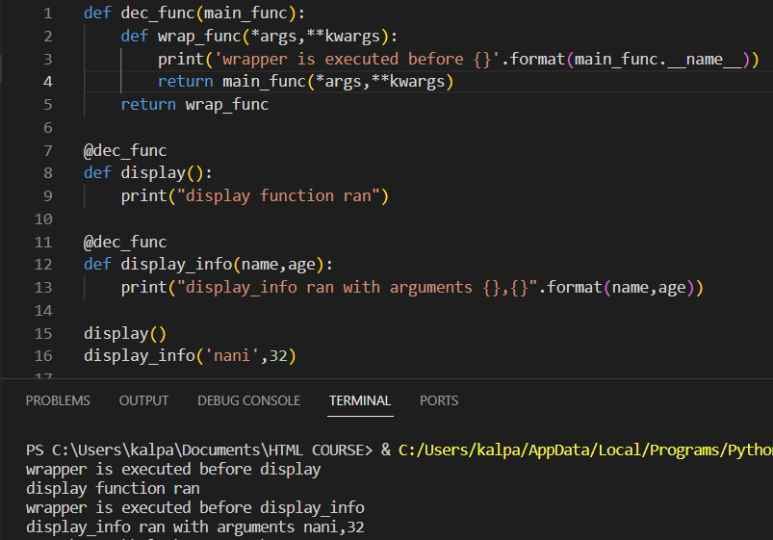
So, we passed arguments in wrapper function and original function as the wrapper function is returning the original function. So, the original function also should have these arguments in it.
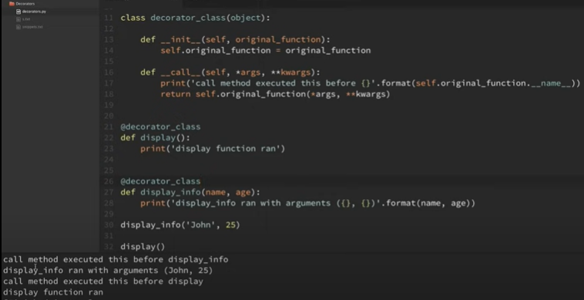
self.original_function = original_function ties our original function with instance of class. Call method behaves like how wrapper function did. We have to use self inside the call method when it is doing the same as wrapper function.

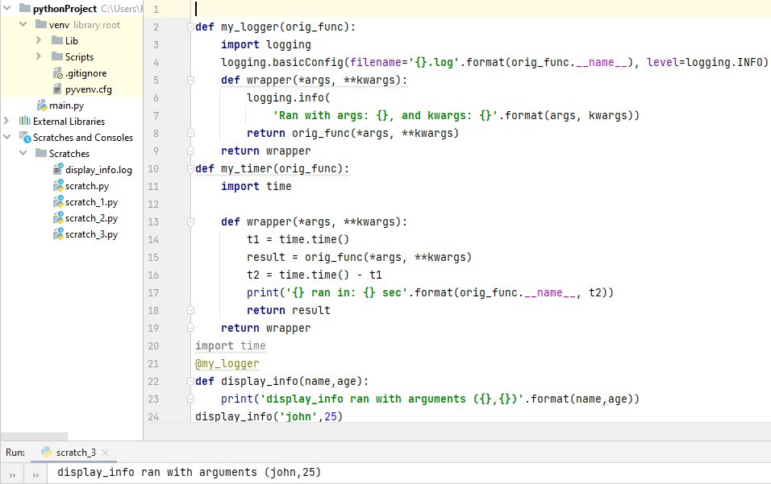
This created a display_info file.
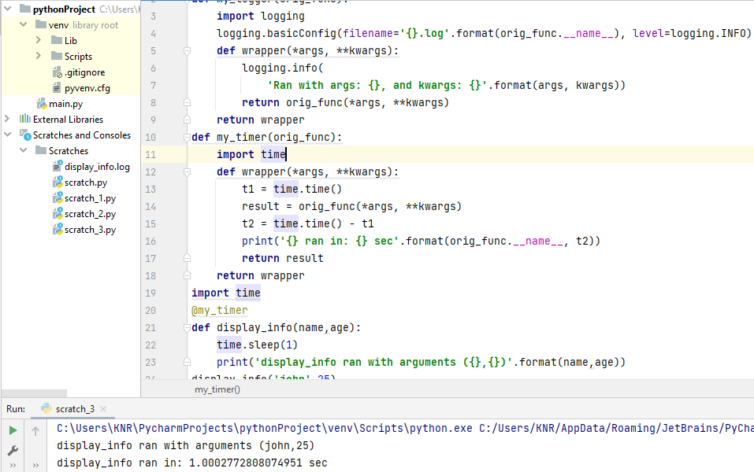
We used my timer decorator now with display info function.
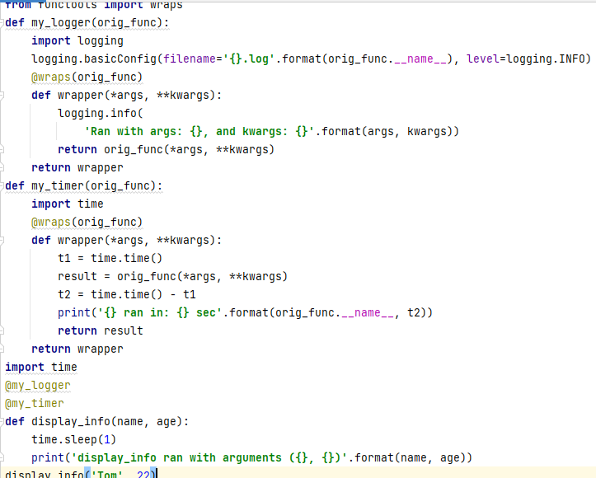

DECORATOR WITH ARGUMENTS
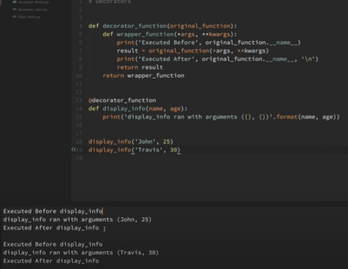
Its just an example of running with decorator without arguments to it.
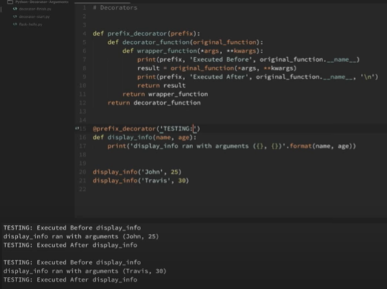
TESTING argument is passed in the prefix_decorator function and the same is seen in output in the places its used.

CLASSES AND INSTANCES

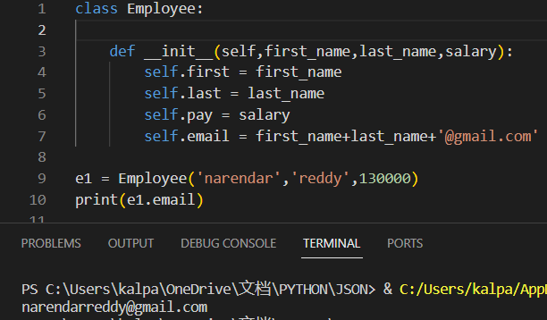
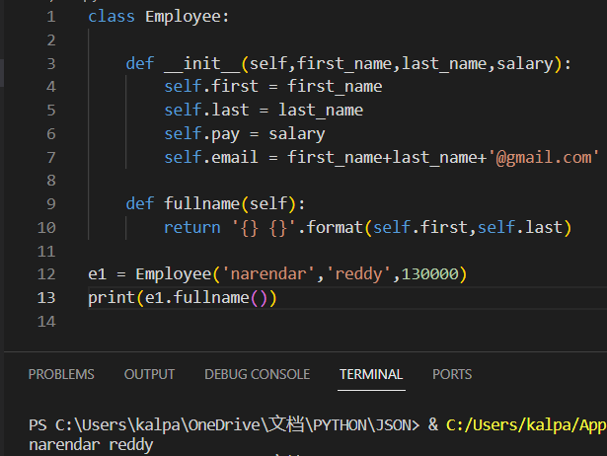
We got full name of emp1. Notice to use () for fullname as we mentioned it in the form of method
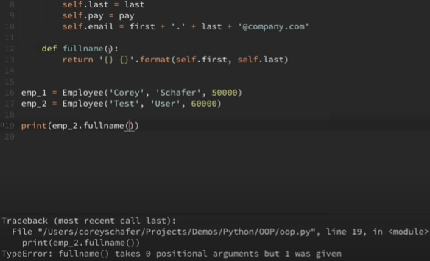
It seems that we didn’t pass any arguments inside the fullname function but it takes emp2 argument automatically so we had to mention self inside the fullname function definition
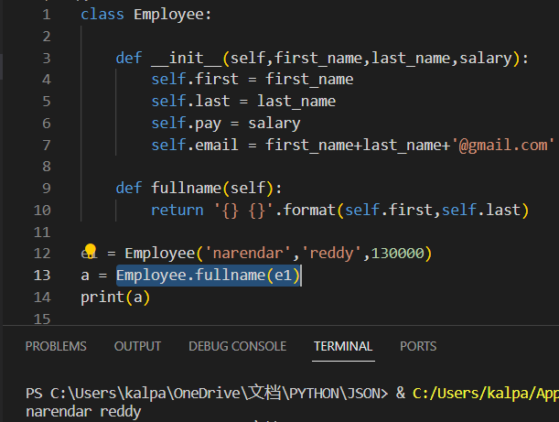
Here we mentioned another wat to get full name by calling the function with class name

CLASS VARIABLES
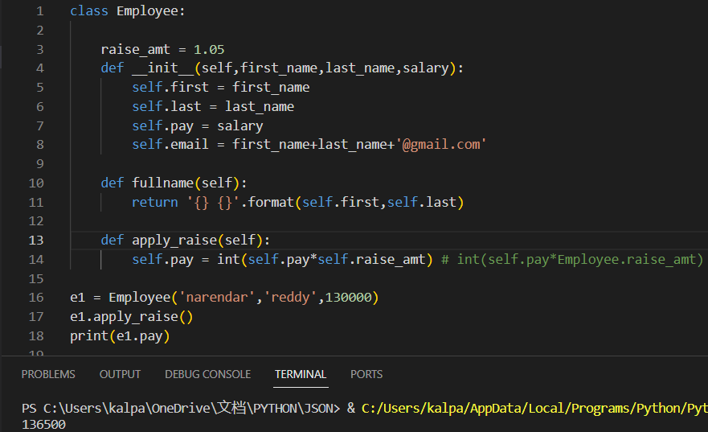
Class variables are accessed inside the methods using self.classvaribalename or classname.classvariablename
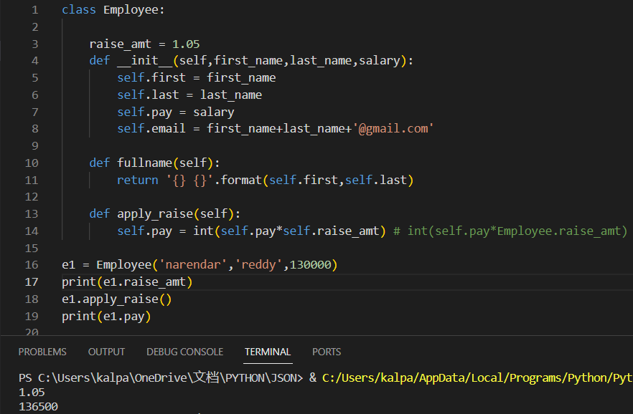

CLASS METHODS AND STATIC METHODS

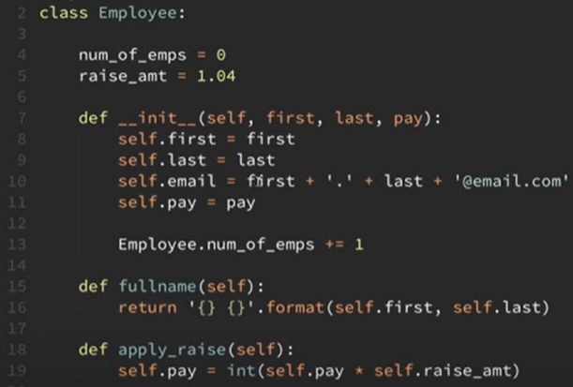
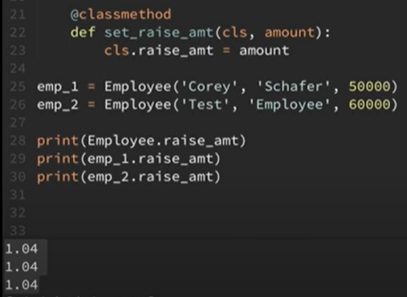
Class method has cls keyword like how regular or instance methods have self.
Here output is equal for all as we are changing in the class itself. So, instances also have the same value.=7

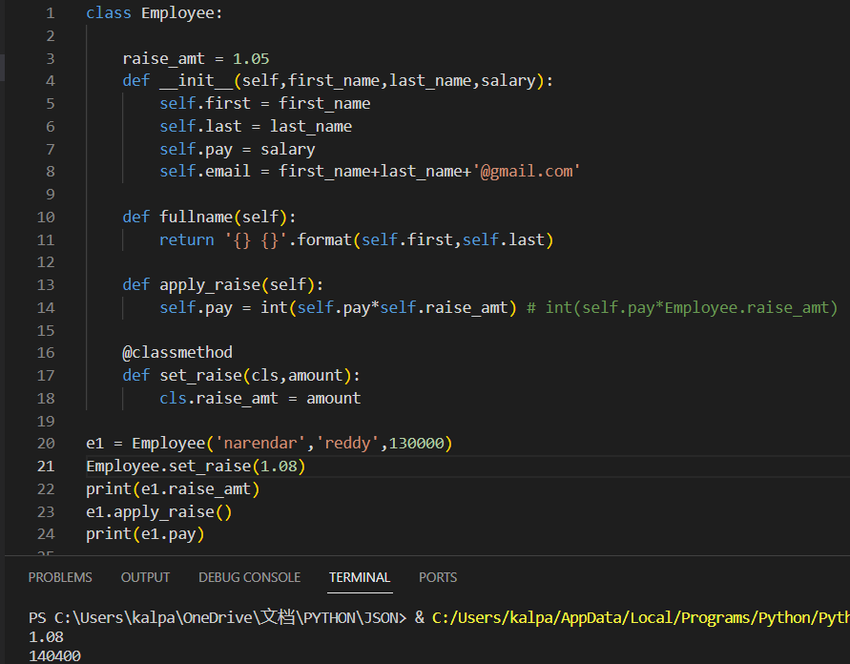

We didn’t specify cls in the set_raise_amt method in executing it because its default, as we ran a class method called set_raise_amt, it affected even the instance variables as well as. We can run the class methods even with the instances and the output will be same
Class methods are called as alternative constructors because they can be used to provide multiple ways for creating our objects. Let’s take an example as followed
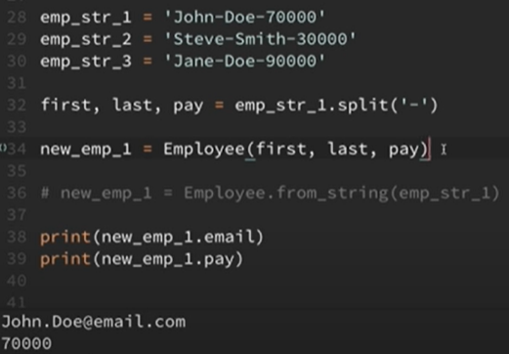
Here every time we need to write 32, 34 and 35 to get output for particular object which can be done by class method that is shown as below.
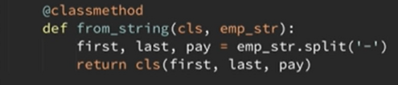
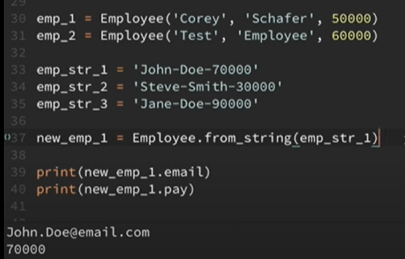

Static methods don’t pass anything automatically. Really, they behave just like regular functions except the fact that we include them in a class because they have some logical connection with the class. The method should be a static if it doesn’t access the instance (self) or the class (cls) anywhere within the function. We can access the static methods without creating an instance to the class.
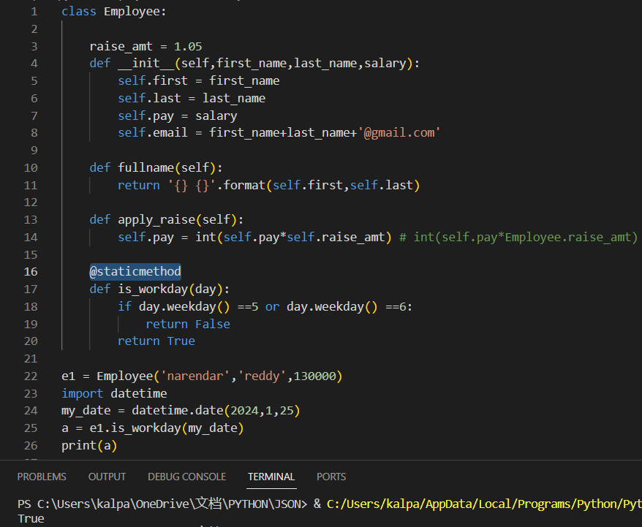

INHERITANCE - CREATING SUBCLASSES
Child class first looks for init method in it and if it doesn’t find, python walks up through a chain of inheritance until it finds what it is looking for. This chain is called method resolution order.

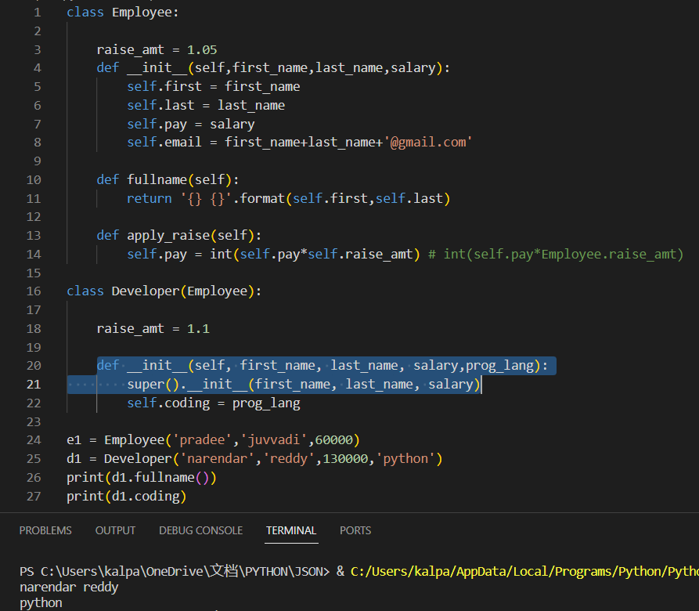
We accessed the employee class init method super (). And added an extra feature called prog_lang
and printed it out.
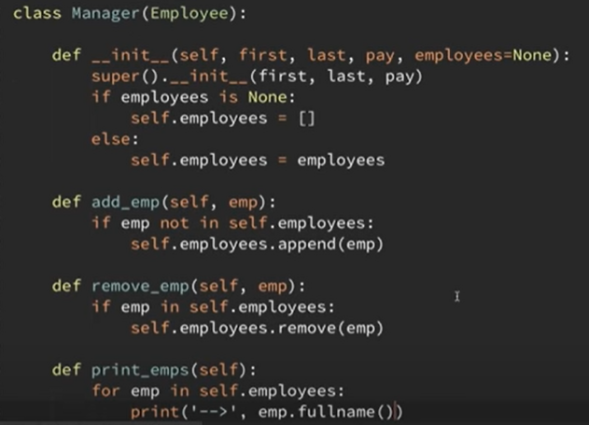
We created another child class called Manager. We didn’t pass employees list as empty list as default argument as we should never pass a mutable data type here
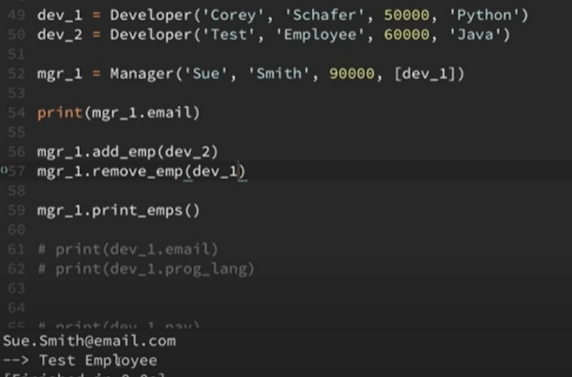
We could successfully add and remove employees to the manager class
isinstance() and issubclass methods can be used for knowing whether an object can be an instance to a particular class and whether a class is a subclass of a super class
ABSTRACT CLASS IN PYTHON:
In Python, an abstract class is a class that cannot be instantiated on its own and is meant to be subclassed by other classes. Abstract classes are created using the ABC (Abstract Base Class) module in Python. The primary purpose of abstract classes is to provide a common interface for all the classes that inherit from them. Here are some key reasons for using abstract classes in Python:
- Define a common interface: Abstract classes can define a set of methods that must be implemented by any concrete (sub)class. This ensures that all subclasses adhere to a common interface, making the code more predictable and maintainable.
- Enforce method implementation: Abstract classes can include abstract methods, which are methods without a body. Subclasses are then required to provide concrete implementations for these abstract methods. This helps in enforcing that certain methods must be implemented by the subclasses.
- Code reusability: Abstract classes can include both abstract and non-abstract (concrete) methods. Subclasses can inherit and reuse the concrete methods, promoting code reusability.
- Polymorphism: Abstract classes contribute to achieving polymorphism in Python. Since abstract classes define a common interface, objects of different subclasses can be treated interchangeably based on their common interface.
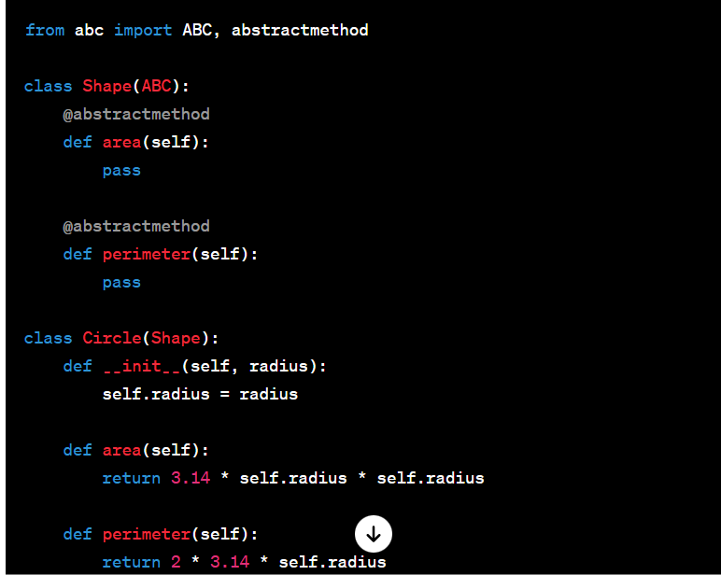
SPECIAL (MAGIC/DUNDER) METHODS

It would be nice if we can change the behaviour of built in methods and operators, that’s where magic methods work out. These methods enable developers to define specific behaviours for objects, such as customizing how objects respond to operators, built-in functions, and certain language constructs. And this is also how we implement operator overloading (i.e. when we add two strings together its different and when we add two operators together its different) so depending on the type of objects we work with, the operator behaviour is different.
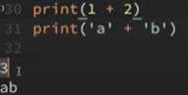
__repr__ is used for unambiguous representation of the objects and used for debugging purpose
and logging things like that, it’s really meant to be seen by other developers.
__str__ is meant to be for more readable representation of an object and meant to be used for displaying to the end user.
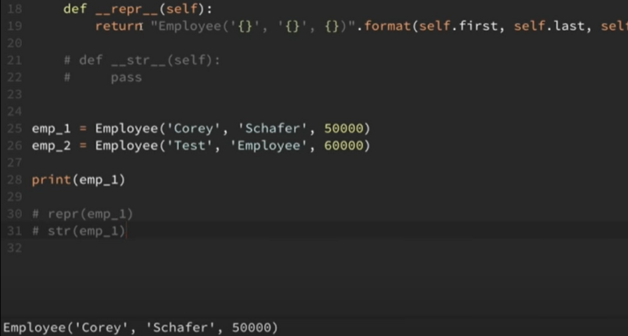
If we didn’t use repr and directly printed out emp_1, we would directly get it as Employee object in output
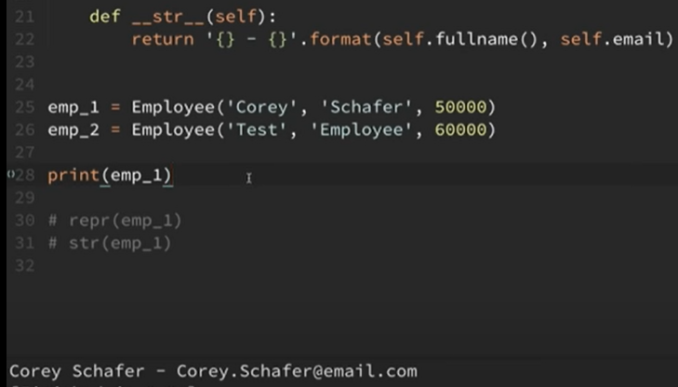

Property Decorators - Getters, Setters, and Deleters
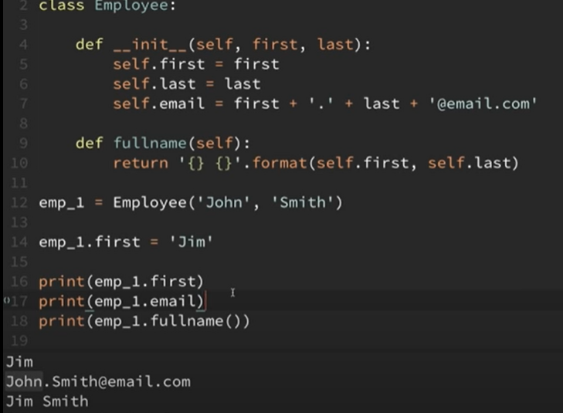
Getter
Every time we run the fullname () it runs on current first name and last name so there is no change. Email also should change when we change first and last names accordingly. Let us fix this. If we create fullname method just like email method, that will break the code for every one using the class. This could be done by getters and setters for other languages. Here in python we can use property decorators which allow defining a method but we can access like an attribute.

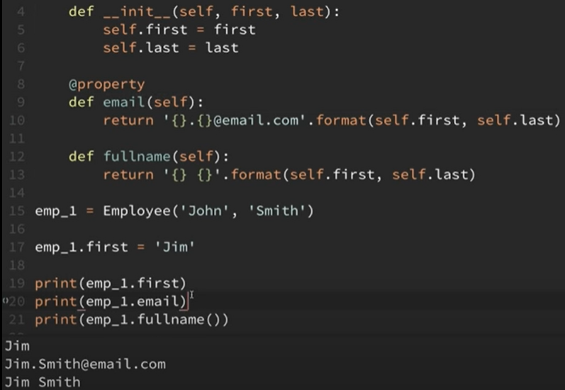

With the help of property decorator, though email is a method (line 9) we could access it as an attribute (line 20)
Setter
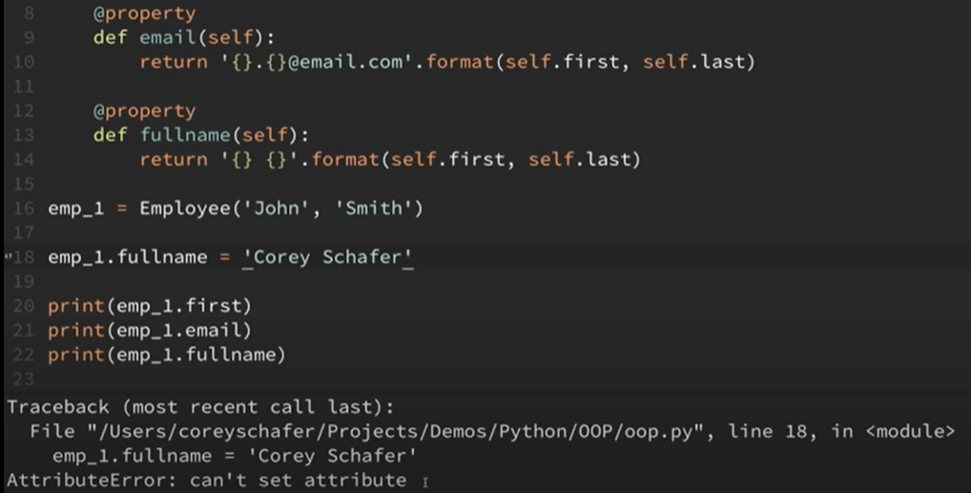
Since we set fullname with property decorator, if we try to set fullname to something, we get attribute error.
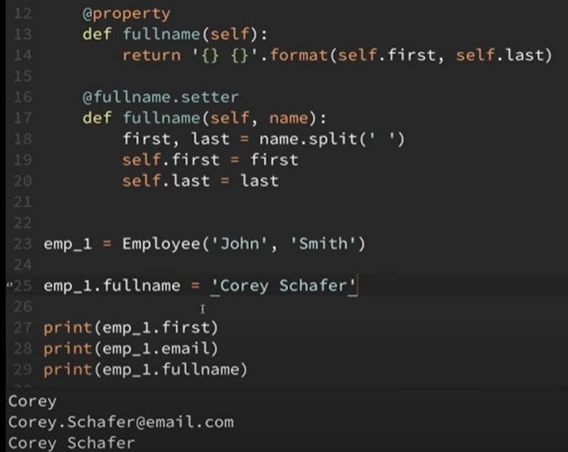
We have to mention the format clearly for setters as like in line 16 ,17 and we could run successfully
deleters

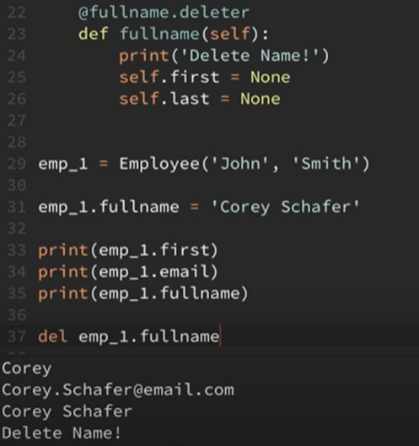

if __name__==’__main__’:
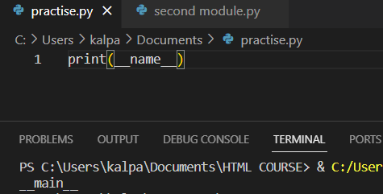

We are directly running the first_module file so output is __main__
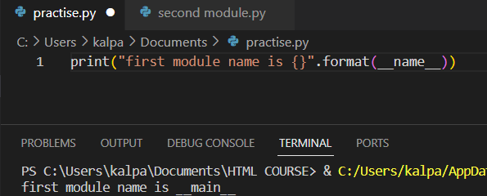
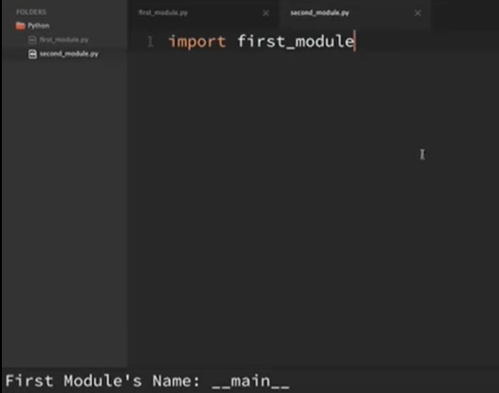
We ran second_module by importing first module.
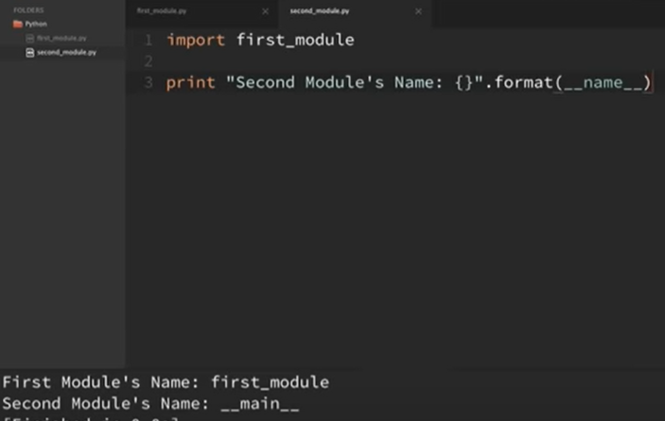
We got__ main__ for __name__ because we are running second module, it means that __name__ gives __main__ for the file that is running directly
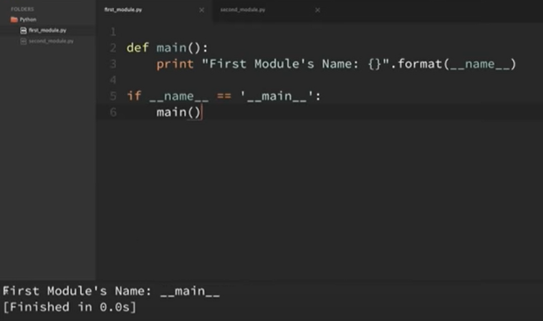
Since we are running it directly, if condition is true so it ran main()
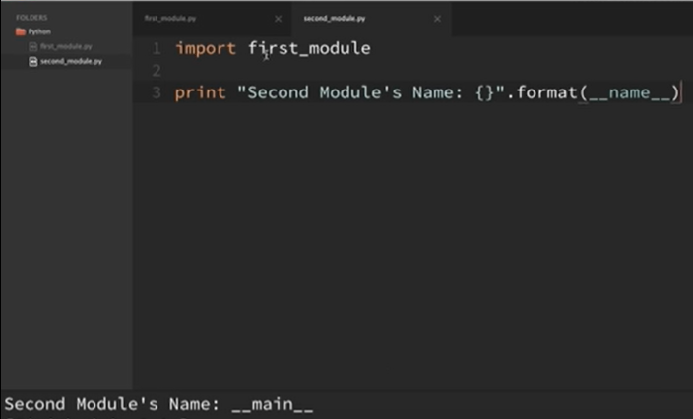
It didn’t run main() of first_module as we are not running the first module directly.
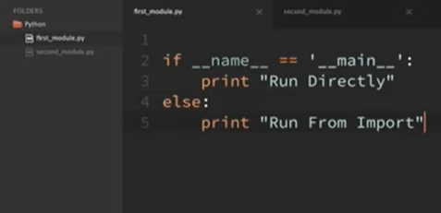
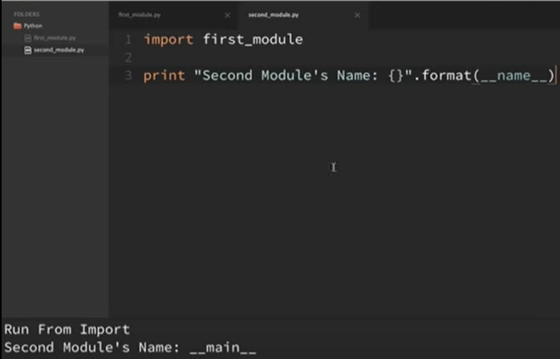
The reason behind __name__ is that we can put the code inside __name__ if we want to run it directly or outside of __name__ if we want to run the code indirectly.
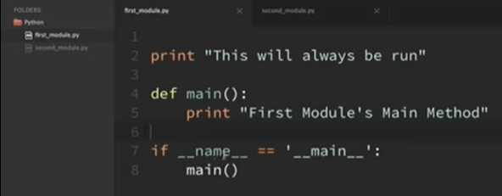
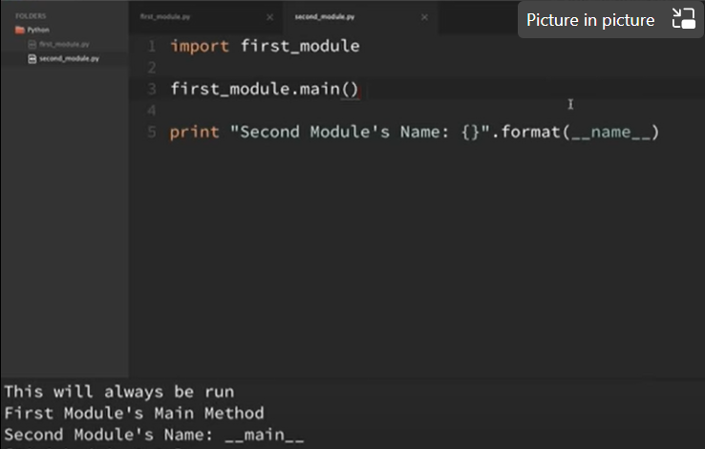
We wanted to run the main() of first_ module so we called it in the second_module file
ELSE CLAUSES ON LOOPS

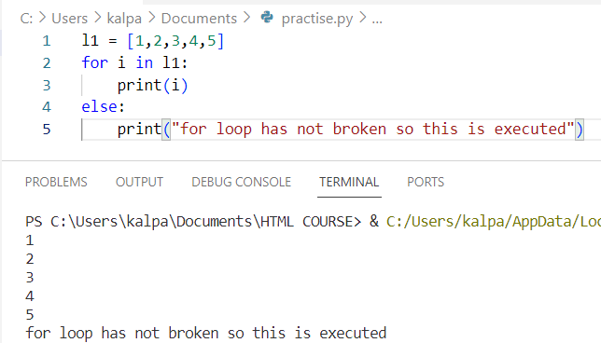
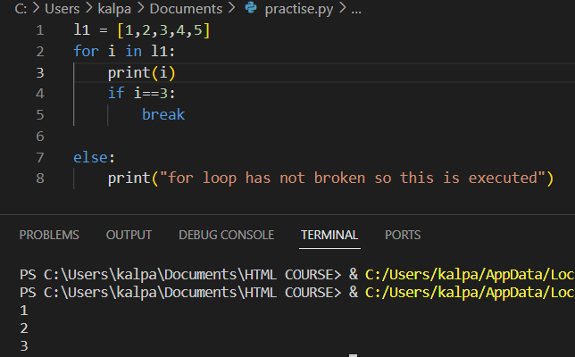
Else block after a for loop executes only if for loop doesn’t break
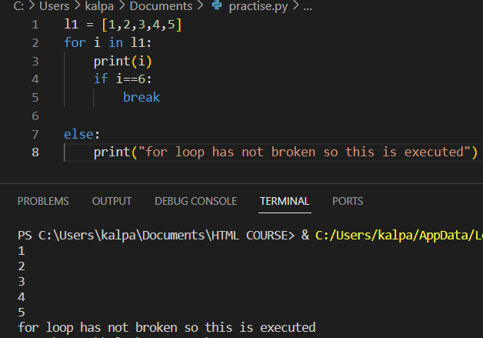
Here, for loop didn’t go to the “if” condition that has break statement, so else block also ran. The same is valid even for while too.
